Compound ID 0

[22, 23, 25, 26, 33, 34]

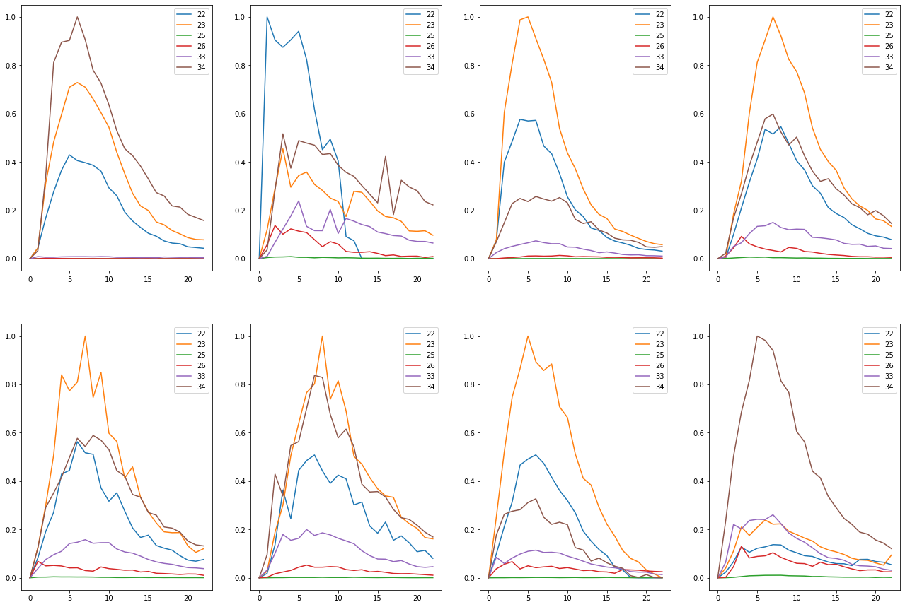

Train on detected 61 non-detected 451  
Train time in seconds: 5.907068490982056

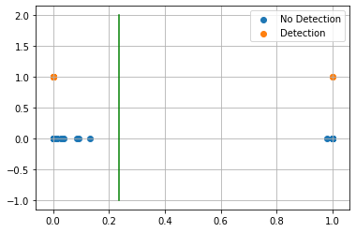

AUC 0.9743011886154629  
Predicted TPR 0.9508196721311475  
Predicted FPR 0.0022172949002217295  
Threshold 0.23654556274414062  
-----------------------End of training---------------------------

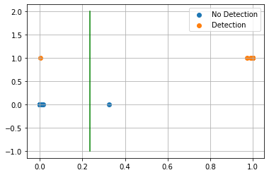

Test on detected 14 non-detected 115  
F0.5 92.86%  
  
Confusion Matrix:  
True Negative 99.13%  
False Positive 0.87%  
False Negative 7.14%  
True Positive 92.86%  
  
Classification Report  
 precision recall f1-score support  
  
 blank 0.991 0.991 0.991 115  
 detected 0.929 0.929 0.929 14  
  
 accuracy 0.984 129  
 macro avg 0.960 0.960 0.960 129  
weighted avg 0.984 0.984 0.984 129  
  
---------------------------end of testing--------------------------------  
  
Compound ID 3  
[20, 47, 49, 50]

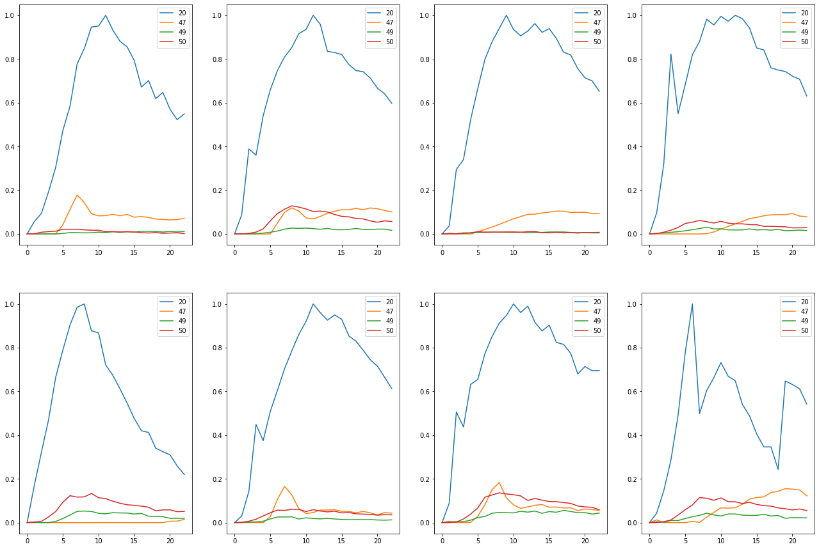

Train on detected 16 non-detected 496  
Train time in seconds: 2.2479968070983887

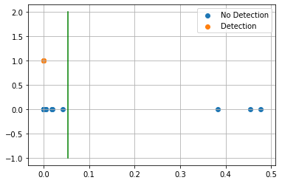

AUC 0.9647177419354839  
Predicted TPR 0.9375  
Predicted FPR 0.008064516129032258  
Threshold 0.053466856479644775  
-----------------------End of training---------------------------

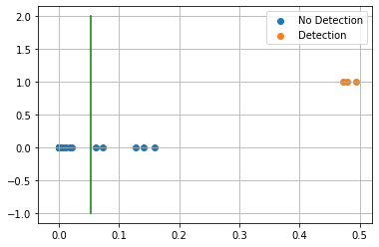

Test on detected 3 non-detected 126  
F0.5 42.86%  
  
Confusion Matrix:  
True Negative 96.03%  
False Positive 3.97%  
False Negative 0.00%  
True Positive 100.00%  
  
Classification Report  
 precision recall f1-score support  
  
 blank 1.000 0.960 0.980 126  
 detected 0.375 1.000 0.545 3  
  
 accuracy 0.961 129  
 macro avg 0.688 0.980 0.763 129  
weighted avg 0.985 0.961 0.970 129  
  
---------------------------end of testing--------------------------------  
  
Compound ID 4  
[2, 11]

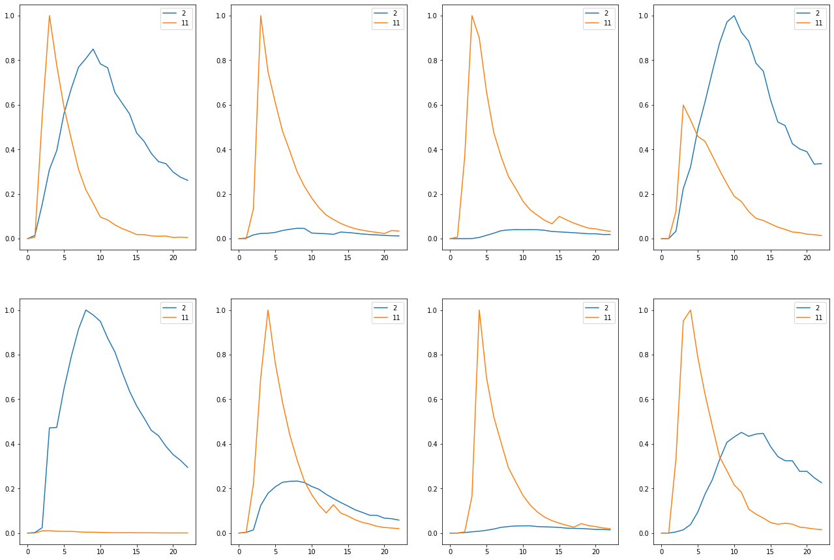

Train on detected 61 non-detected 451  
Train time in seconds: 3.14003849029541

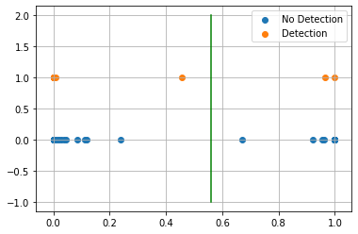

AUC 0.9977827050997783  
Predicted TPR 1.0  
Predicted FPR 0.004434589800443459  
Threshold 0.5586587190628052  
-----------------------End of training---------------------------

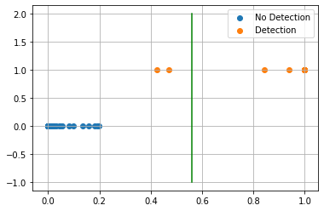

Test on detected 14 non-detected 115  
F0.5 96.77%  
  
Confusion Matrix:  
True Negative 100.00%  
False Positive 0.00%  
False Negative 14.29%  
True Positive 85.71%  
  
Classification Report  
 precision recall f1-score support  
  
 blank 0.983 1.000 0.991 115  
 detected 1.000 0.857 0.923 14  
  
 accuracy 0.984 129  
 macro avg 0.991 0.929 0.957 129  
weighted avg 0.985 0.984 0.984 129  
  
---------------------------end of testing--------------------------------  
  
Compound ID 7  
[16, 18, 27, 30, 46]

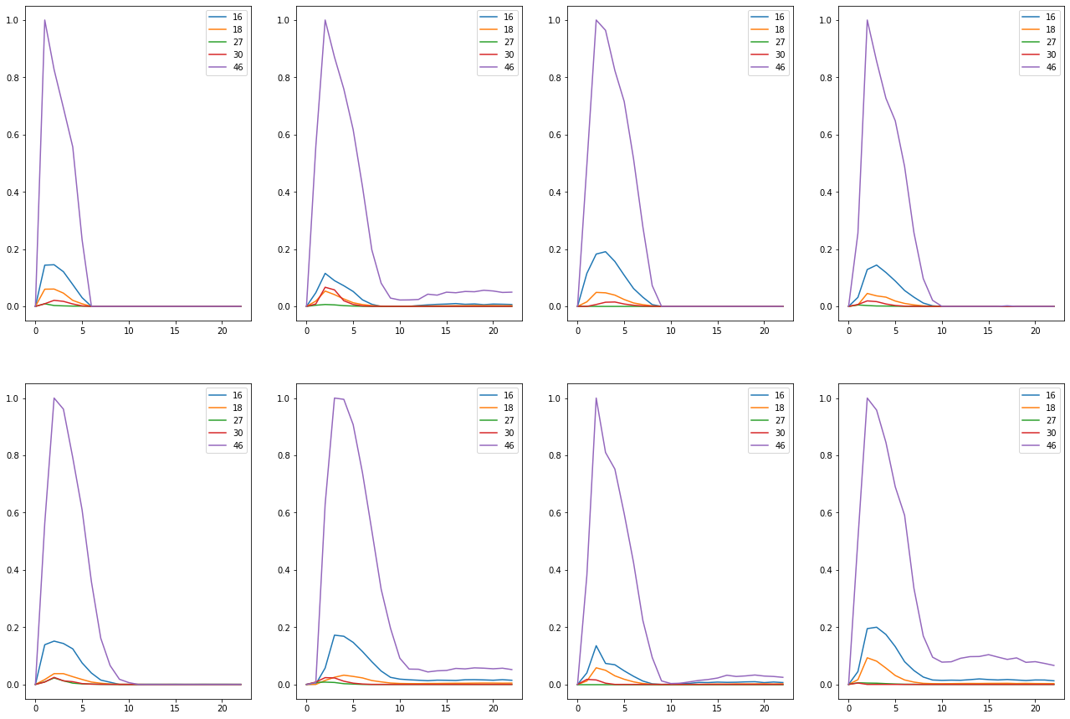

Train on detected 8 non-detected 504  
Train time in seconds: 2.295027017593384

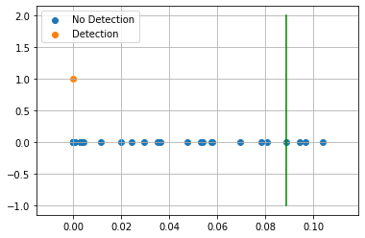

AUC 0.9940476190476191  
Predicted TPR 1.0  
Predicted FPR 0.011904761904761904  
Threshold 0.08863037824630737  
-----------------------End of training---------------------------

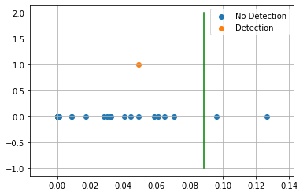

Test on detected 1 non-detected 128  
F0.5 0.00%  
  
Confusion Matrix:  
True Negative 98.44%  
False Positive 1.56%  
False Negative 100.00%  
True Positive 0.00%  
  
Classification Report  
 precision recall f1-score support  
  
 blank 0.992 0.984 0.988 128  
 detected 0.000 0.000 0.000 1  
  
 accuracy 0.977 129  
 macro avg 0.496 0.492 0.494 129  
weighted avg 0.984 0.977 0.981 129  
  
---------------------------end of testing--------------------------------  
  
Compound ID 8  
[16, 18, 39, 46]

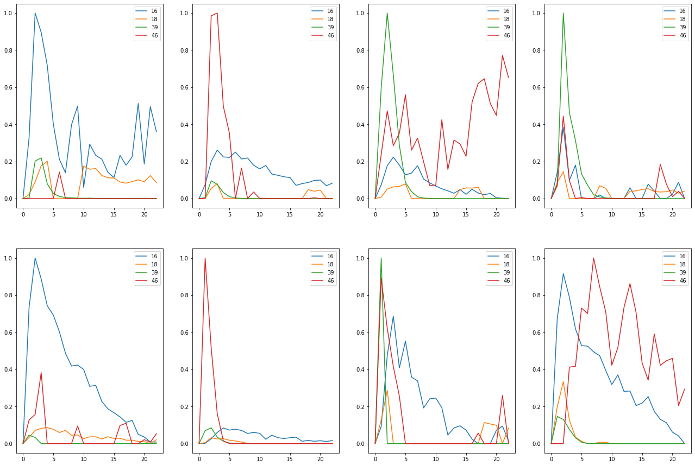

Train on detected 47 non-detected 465  
Train time in seconds: 2.3570141792297363

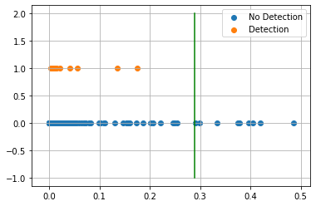

AUC 0.6839624799816975  
Predicted TPR 0.3829787234042553  
Predicted FPR 0.015053763440860216  
Threshold 0.28877729177474976  
-----------------------End of training---------------------------

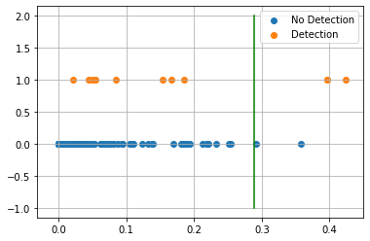

Test on detected 11 non-detected 118  
F0.5 48.39%  
  
Confusion Matrix:  
True Negative 98.31%  
False Positive 1.69%  
False Negative 72.73%  
True Positive 27.27%  
  
Classification Report  
 precision recall f1-score support  
  
 blank 0.935 0.983 0.959 118  
 detected 0.600 0.273 0.375 11  
  
 accuracy 0.922 129  
 macro avg 0.768 0.628 0.667 129  
weighted avg 0.907 0.922 0.909 129  
  
---------------------------end of testing--------------------------------  
  
Compound ID 10  
[0, 3, 4, 19, 20, 22, 23]

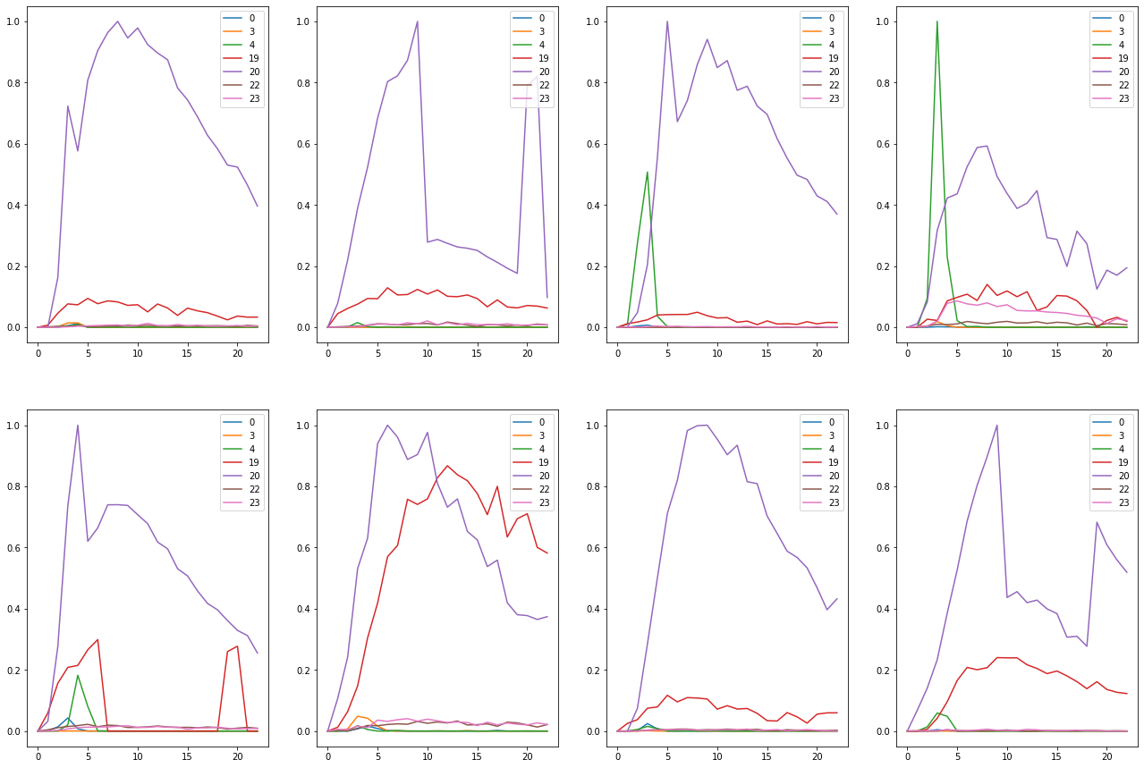

Train on detected 47 non-detected 465  
Train time in seconds: 2.5869998931884766

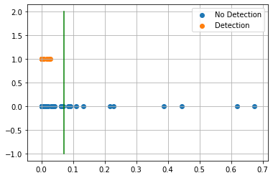

AUC 0.8520247083047356  
Predicted TPR 0.723404255319149  
Predicted FPR 0.01935483870967742  
Threshold 0.07070311903953552  
-----------------------End of training---------------------------

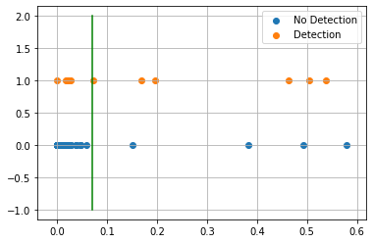

Test on detected 11 non-detected 118  
F0.5 58.82%  
  
Confusion Matrix:  
True Negative 96.61%  
False Positive 3.39%  
False Negative 45.45%  
True Positive 54.55%  
  
Classification Report  
 precision recall f1-score support  
  
 blank 0.958 0.966 0.962 118  
 detected 0.600 0.545 0.571 11  
  
 accuracy 0.930 129  
 macro avg 0.779 0.756 0.767 129  
weighted avg 0.927 0.930 0.929 129  
  
---------------------------end of testing--------------------------------  
  
Compound ID 13  
[41, 42, 46]

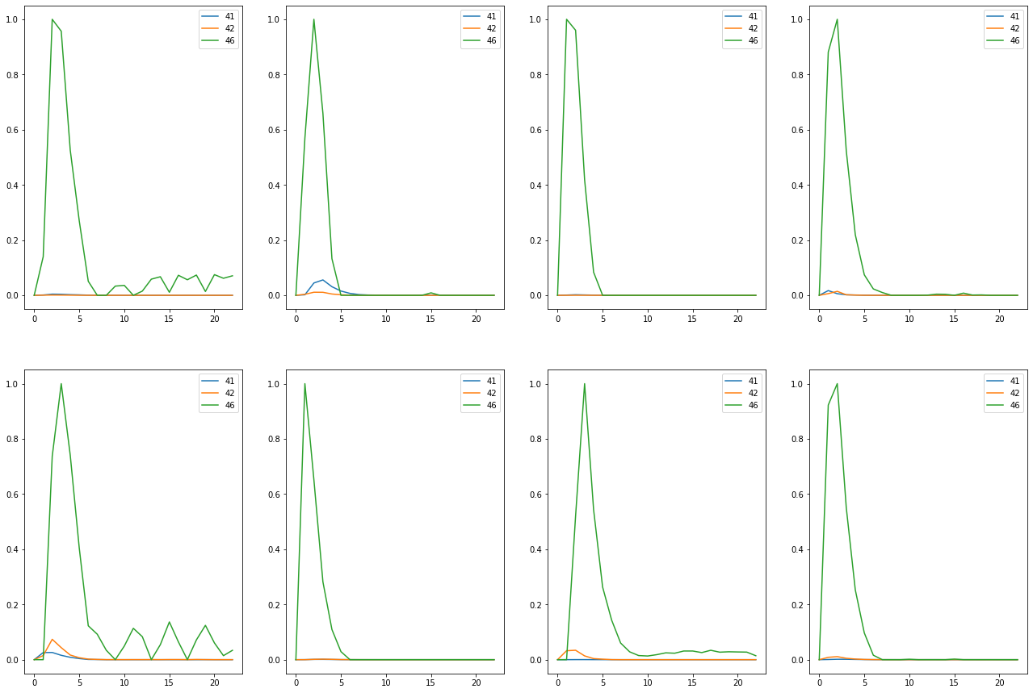

Train on detected 56 non-detected 456  
Train time in seconds: 3.278041362762451

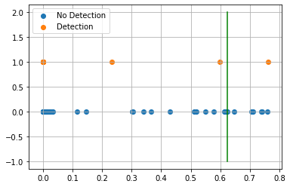

AUC 0.7958959899749374  
Predicted TPR 0.6071428571428571  
Predicted FPR 0.015350877192982455  
Threshold 0.6227623820304871  
-----------------------End of training---------------------------

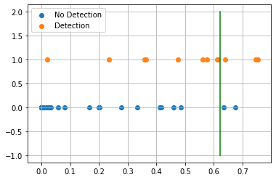

Test on detected 12 non-detected 117  
F0.5 46.88%  
  
Confusion Matrix:  
True Negative 98.29%  
False Positive 1.71%  
False Negative 75.00%  
True Positive 25.00%  
  
Classification Report  
 precision recall f1-score support  
  
 blank 0.927 0.983 0.954 117  
 detected 0.600 0.250 0.353 12  
  
 accuracy 0.915 129  
 macro avg 0.764 0.616 0.654 129  
weighted avg 0.897 0.915 0.898 129  
  
---------------------------end of testing--------------------------------  
  
Compound ID 14  
[16, 18, 46]

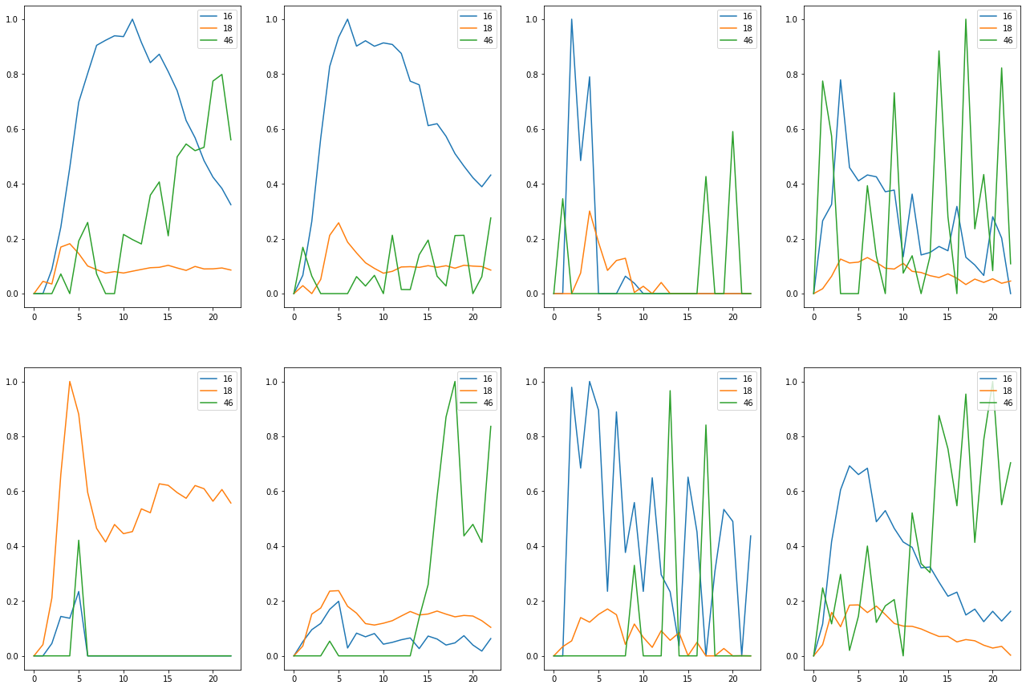

Train on detected 31 non-detected 481  
Train time in seconds: 3.044036865234375

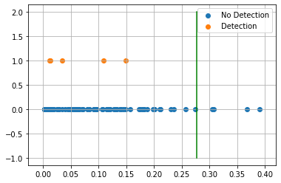

AUC 0.6852323787807659  
Predicted TPR 0.3870967741935484  
Predicted FPR 0.016632016632016633  
Threshold 0.27672097086906433  
-----------------------End of training---------------------------

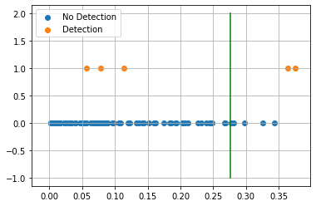

Test on detected 5 non-detected 124  
F0.5 30.30%  
  
Confusion Matrix:  
True Negative 95.97%  
False Positive 4.03%  
False Negative 60.00%  
True Positive 40.00%  
  
Classification Report  
 precision recall f1-score support  
  
 blank 0.975 0.960 0.967 124  
 detected 0.286 0.400 0.333 5  
  
 accuracy 0.938 129  
 macro avg 0.631 0.680 0.650 129  
weighted avg 0.949 0.938 0.943 129  
  
---------------------------end of testing--------------------------------  
  
Compound ID 15  
[36, 39, 46]

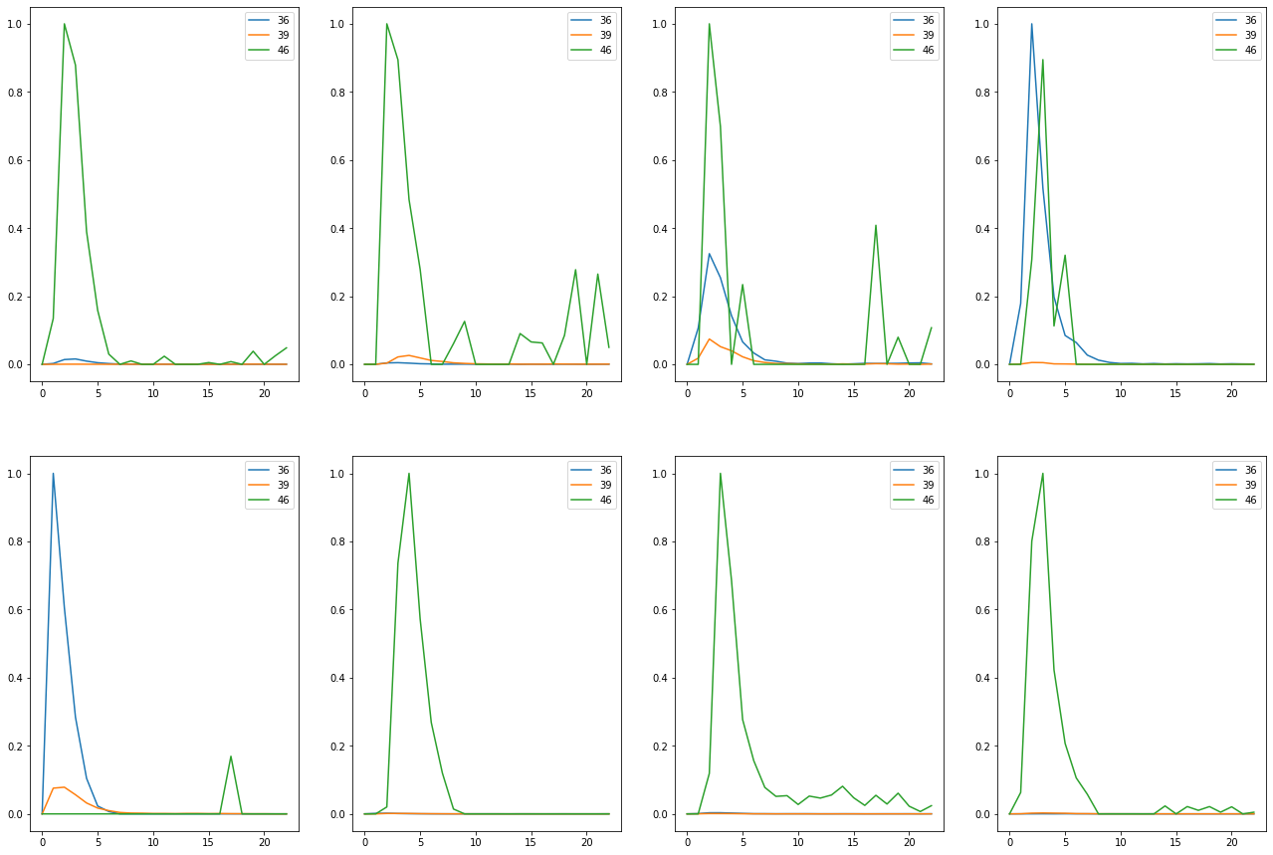

Train on detected 56 non-detected 456  
Train time in seconds: 4.639067888259888

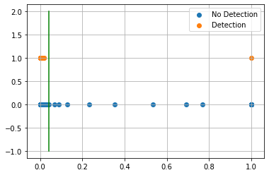

AUC 0.9822994987468672  
Predicted TPR 0.9821428571428571  
Predicted FPR 0.017543859649122806  
Threshold 0.04157072305679321  
-----------------------End of training---------------------------

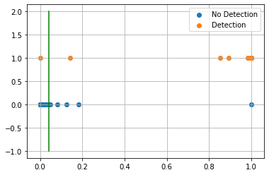

Test on detected 12 non-detected 117  
F0.5 72.37%  
  
Confusion Matrix:  
True Negative 95.73%  
False Positive 4.27%  
False Negative 8.33%  
True Positive 91.67%  
  
Classification Report  
 precision recall f1-score support  
  
 blank 0.991 0.957 0.974 117  
 detected 0.688 0.917 0.786 12  
  
 accuracy 0.953 129  
 macro avg 0.839 0.937 0.880 129  
weighted avg 0.963 0.953 0.956 129  
  
---------------------------end of testing--------------------------------  
  
Compound ID 18  
[19, 20, 21, 40]

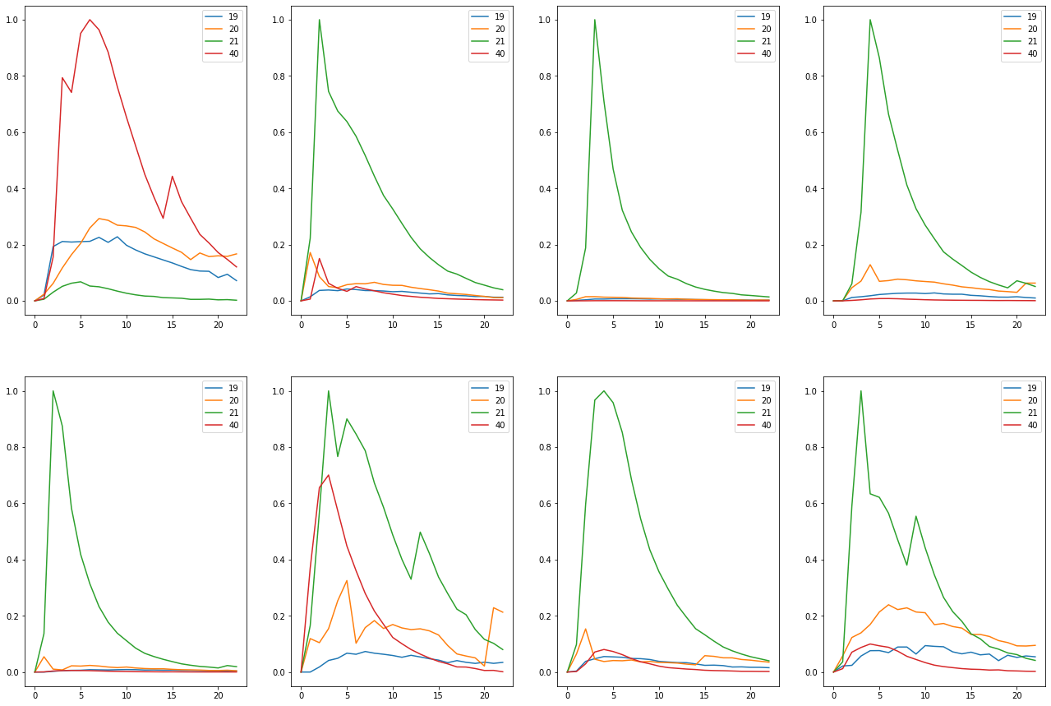

Train on detected 63 non-detected 449  
Train time in seconds: 4.823078393936157

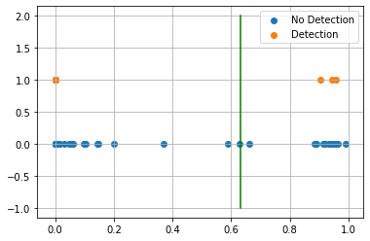

AUC 0.9514087743486406  
Predicted TPR 0.9206349206349206  
Predicted FPR 0.017817371937639197  
Threshold 0.6336321234703064  
-----------------------End of training---------------------------

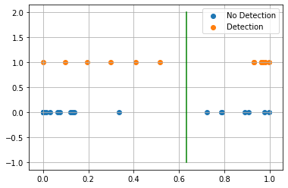

Test on detected 14 non-detected 115  
F0.5 54.05%  
  
Confusion Matrix:  
True Negative 93.91%  
False Positive 6.09%  
False Negative 42.86%  
True Positive 57.14%  
  
Classification Report  
 precision recall f1-score support  
  
 blank 0.947 0.939 0.943 115  
 detected 0.533 0.571 0.552 14  
  
 accuracy 0.899 129  
 macro avg 0.740 0.755 0.747 129  
weighted avg 0.902 0.899 0.901 129  
  
---------------------------end of testing--------------------------------  
  
Compound ID 19  
[7, 8]

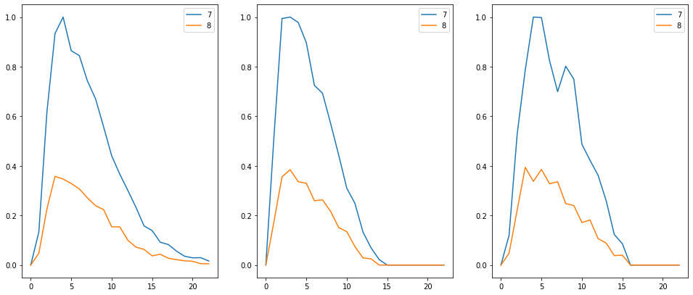

Train on detected 3 non-detected 509  
Train time in seconds: 2.877002000808716

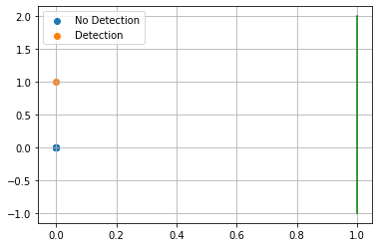

AUC 0.5  
Predicted TPR 0.0  
Predicted FPR 0.0  
Threshold 1.0000001192092896  
-----------------------End of training---------------------------



Test on detected 1 non-detected 128  
F0.5 0.00%  
  
Confusion Matrix:  
True Negative 100.00%  
False Positive 0.00%  
False Negative 100.00%  
True Positive 0.00%  
  
Classification Report  
 precision recall f1-score support  
  
 blank 0.992 1.000 0.996 128  
 detected 0.000 0.000 0.000 1  
  
 accuracy 0.992 129  
 macro avg 0.496 0.500 0.498 129  
weighted avg 0.985 0.992 0.988 129  
  
---------------------------end of testing--------------------------------  
  
Compound ID 21  
[22, 23, 25, 26, 33, 34]



Train on detected 61 non-detected 451  
Train time in seconds: 3.7140309810638428

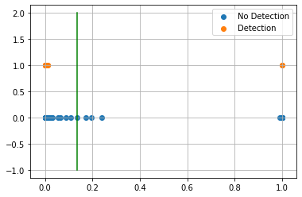

AUC 0.9736287303260515  
Predicted TPR 0.9672131147540983  
Predicted FPR 0.019955654101995565  
Threshold 0.13487306237220764  
-----------------------End of training---------------------------

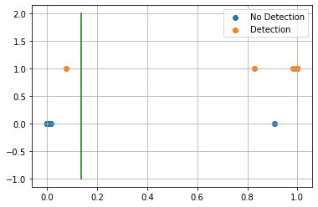

Test on detected 14 non-detected 115  
F0.5 92.86%  
  
Confusion Matrix:  
True Negative 99.13%  
False Positive 0.87%  
False Negative 7.14%  
True Positive 92.86%  
  
Classification Report  
 precision recall f1-score support  
  
 blank 0.991 0.991 0.991 115  
 detected 0.929 0.929 0.929 14  
  
 accuracy 0.984 129  
 macro avg 0.960 0.960 0.960 129  
weighted avg 0.984 0.984 0.984 129  
  
---------------------------end of testing--------------------------------  
  
Compound ID 22  
[35, 37, 38]

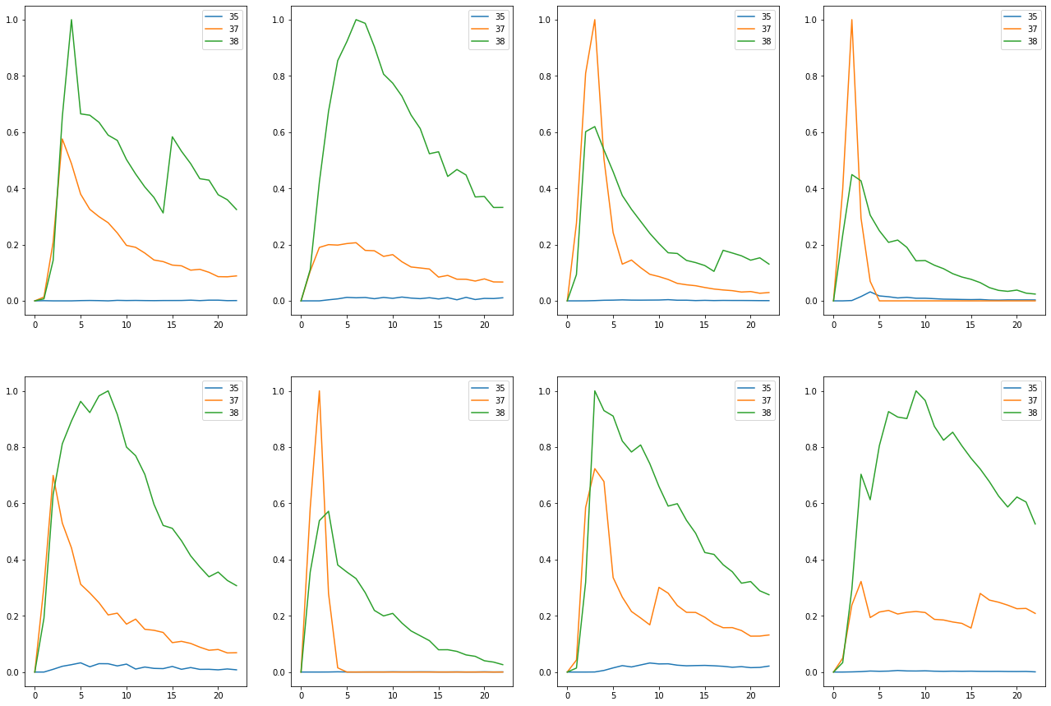

Train on detected 65 non-detected 447  
Train time in seconds: 3.2630701065063477

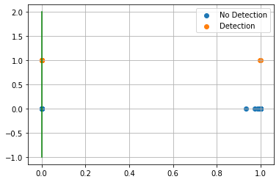

AUC 0.9966442953020135  
Predicted TPR 1.0  
Predicted FPR 0.006711409395973154  
Threshold 0.0003542900085449219  
-----------------------End of training---------------------------

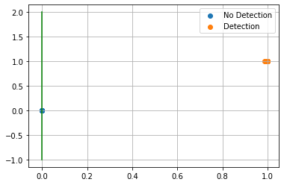

Test on detected 14 non-detected 115  
F0.5 100.00%  
  
Confusion Matrix:  
True Negative 100.00%  
False Positive 0.00%  
False Negative 0.00%  
True Positive 100.00%  
  
Classification Report  
 precision recall f1-score support  
  
 blank 1.000 1.000 1.000 115  
 detected 1.000 1.000 1.000 14  
  
 accuracy 1.000 129  
 macro avg 1.000 1.000 1.000 129  
weighted avg 1.000 1.000 1.000 129  
  
---------------------------end of testing--------------------------------  
 Compounds Tr-TPR Tr-FPR Threshold ROC AUC Score Test-TPR Test-FPR  
 0 95.08% 0.22% 23.65% 97.43% 92.86% 0.87%   
 3 93.75% 0.81% 5.35% 96.47% 100.00% 3.97%   
 4 100.00% 0.44% 55.87% 99.78% 85.71% 0.00%   
 7 100.00% 1.19% 8.86% 99.40% 0.00% 1.56%   
 8 38.30% 1.51% 28.88% 68.40% 27.27% 1.69%   
 10 72.34% 1.94% 7.07% 85.20% 54.55% 3.39%   
 13 60.71% 1.54% 62.28% 79.59% 25.00% 1.71%   
 14 38.71% 1.66% 27.67% 68.52% 40.00% 4.03%   
 15 98.21% 1.75% 4.16% 98.23% 91.67% 4.27%   
 18 92.06% 1.78% 63.36% 95.14% 57.14% 6.09%   
 19 0.00% 0.00% 100.00% 50.00% 0.00% 0.00%   
 21 96.72% 2.00% 13.49% 97.36% 92.86% 0.87%   
 22 100.00% 0.67% 0.04% 99.66% 100.00% 0.00%

## Refinement¶

Compounds 0, 21, 22 currently meet our goal.

The rest need more data or further refinement to meet our goal.

Compound 7 and 19 do not have enough sample data so we will discard them for now.

I will go through each one and see if some improvements can be made by removing some associated mass pair data that might be hurting our results. I also need to consider the noise of a signal. If the mass pair intensity is too noisy then I will not be able to learn the shape. I will probably need to apply some sort of noise filtering per mass pair intensity to achieve consistent results. Let's try filtering first.

Compound ID 0  
[22, 23, 25, 26, 33, 34]

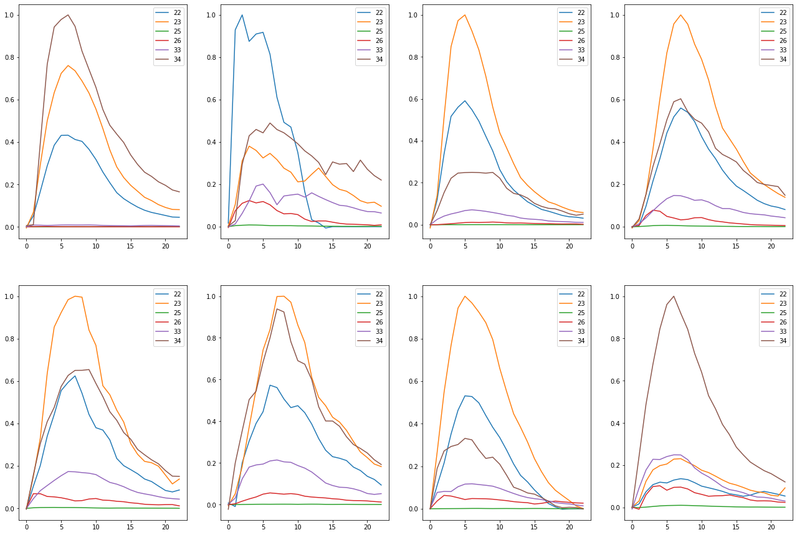

Train on detected 61 non-detected 451  
Train time in seconds: 3.8510384559631348

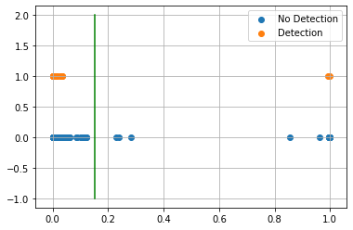

AUC 0.9665406564646868  
Predicted TPR 0.9508196721311475  
Predicted FPR 0.017738359201773836  
Threshold 0.15136251  
-----------------------End of training---------------------------

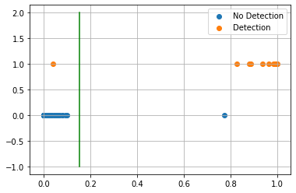

Test on detected 14 non-detected 115  
F0.5 92.86%  
  
Confusion Matrix:  
True Negative 99.13%  
False Positive 0.87%  
False Negative 7.14%  
True Positive 92.86%  
  
Classification Report  
 precision recall f1-score support  
  
 blank 0.991 0.991 0.991 115  
 detected 0.929 0.929 0.929 14  
  
 accuracy 0.984 129  
 macro avg 0.960 0.960 0.960 129  
weighted avg 0.984 0.984 0.984 129  
  
---------------------------end of testing--------------------------------  
  
Compound ID 3  
[20, 47, 49, 50]

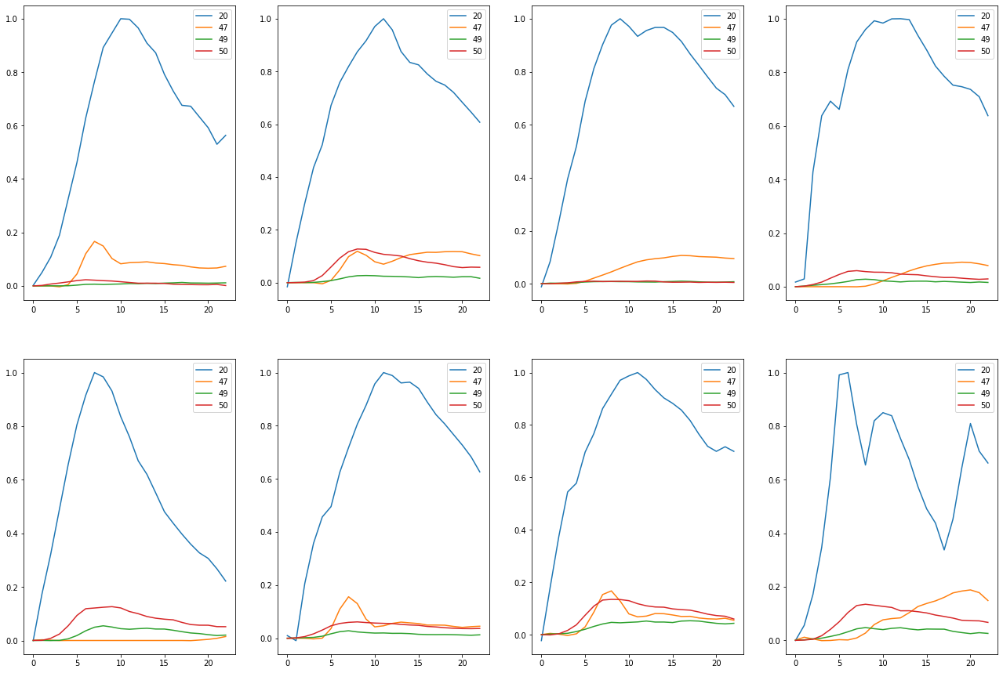

Train on detected 16 non-detected 496  
Train time in seconds: 4.27203893661499

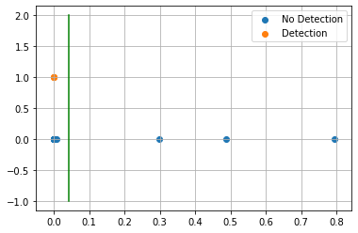

AUC 0.9667338709677419  
Predicted TPR 0.9375  
Predicted FPR 0.004032258064516129  
Threshold 0.042612135  
-----------------------End of training---------------------------

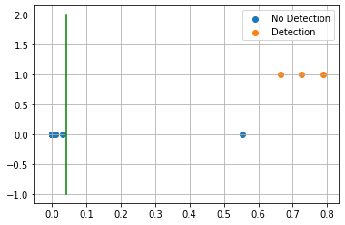

Test on detected 3 non-detected 126  
F0.5 78.95%  
  
Confusion Matrix:  
True Negative 99.21%  
False Positive 0.79%  
False Negative 0.00%  
True Positive 100.00%  
  
Classification Report  
 precision recall f1-score support  
  
 blank 1.000 0.992 0.996 126  
 detected 0.750 1.000 0.857 3  
  
 accuracy 0.992 129  
 macro avg 0.875 0.996 0.927 129  
weighted avg 0.994 0.992 0.993 129  
  
---------------------------end of testing--------------------------------  
  
Compound ID 4  
[2, 11]

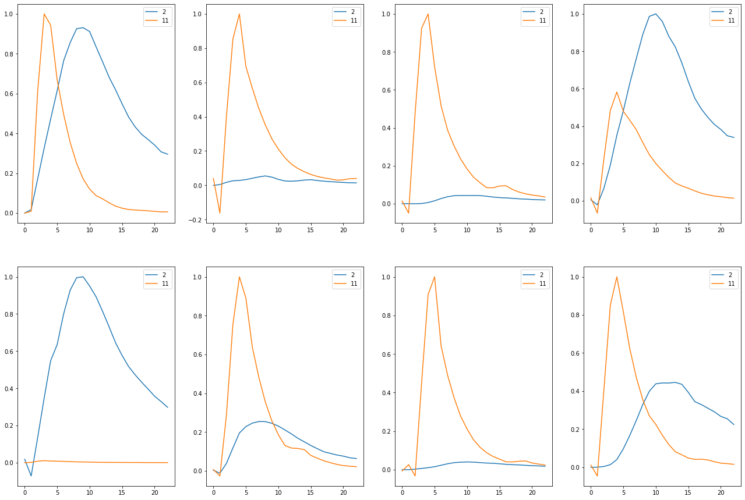

Train on detected 61 non-detected 451  
Train time in seconds: 3.4109888076782227

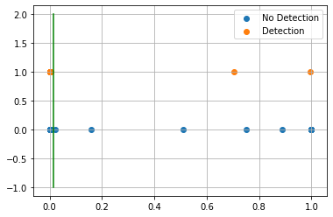

AUC 0.9780633201264948  
Predicted TPR 0.9672131147540983  
Predicted FPR 0.011086474501108648  
Threshold 0.014654726  
-----------------------End of training---------------------------

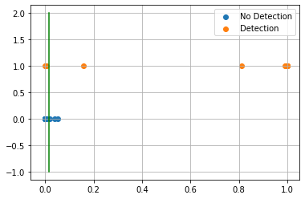

Test on detected 14 non-detected 115  
F0.5 78.57%  
  
Confusion Matrix:  
True Negative 97.39%  
False Positive 2.61%  
False Negative 21.43%  
True Positive 78.57%  
  
Classification Report  
 precision recall f1-score support  
  
 blank 0.974 0.974 0.974 115  
 detected 0.786 0.786 0.786 14  
  
 accuracy 0.953 129  
 macro avg 0.880 0.880 0.880 129  
weighted avg 0.953 0.953 0.953 129  
  
---------------------------end of testing--------------------------------  
  
Compound ID 7  
[16, 18, 27, 30, 46]

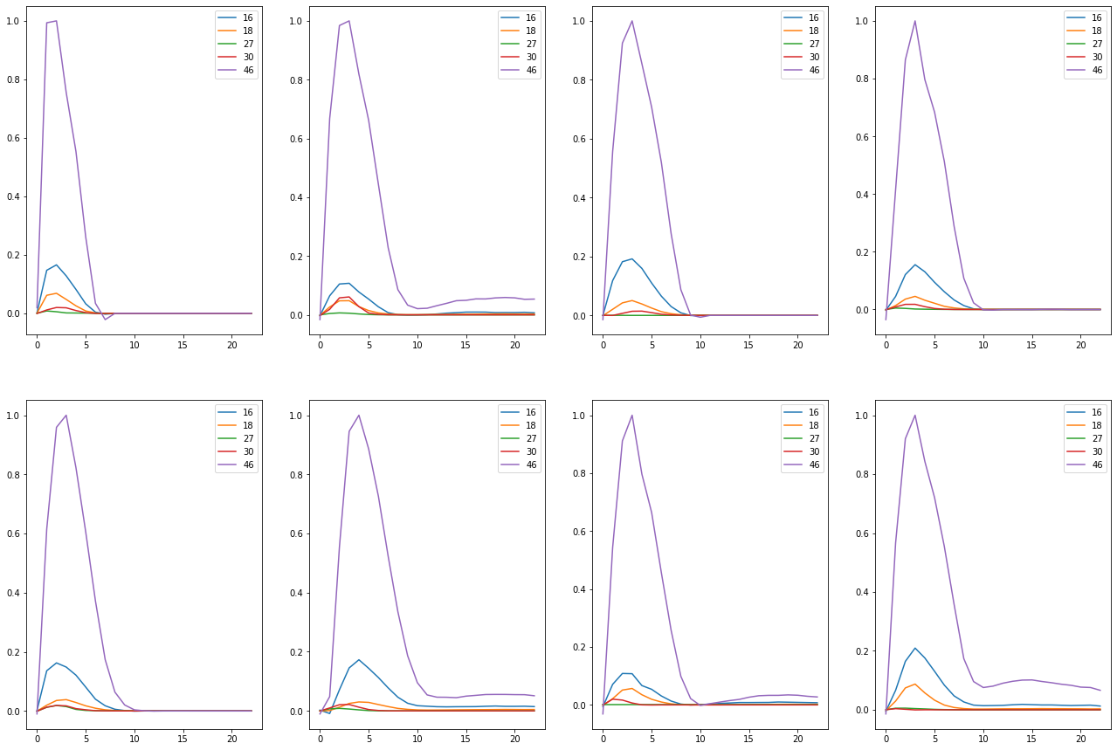

Train on detected 8 non-detected 504  
Train time in seconds: 3.376046895980835

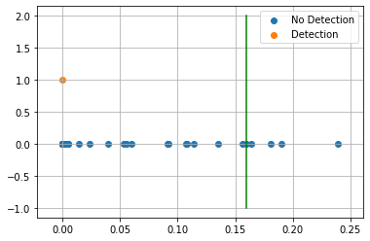

AUC 0.9910714285714285  
Predicted TPR 1.0  
Predicted FPR 0.017857142857142856  
Threshold 0.15965581  
-----------------------End of training---------------------------

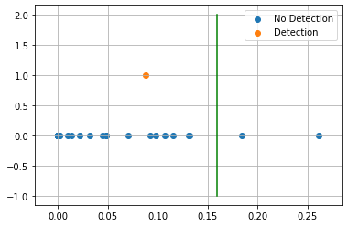

Test on detected 1 non-detected 128  
F0.5 0.00%  
  
Confusion Matrix:  
True Negative 98.44%  
False Positive 1.56%  
False Negative 100.00%  
True Positive 0.00%  
  
Classification Report  
 precision recall f1-score support  
  
 blank 0.992 0.984 0.988 128  
 detected 0.000 0.000 0.000 1  
  
 accuracy 0.977 129  
 macro avg 0.496 0.492 0.494 129  
weighted avg 0.984 0.977 0.981 129  
  
---------------------------end of testing--------------------------------  
  
Compound ID 8  
[16, 18, 39, 46]

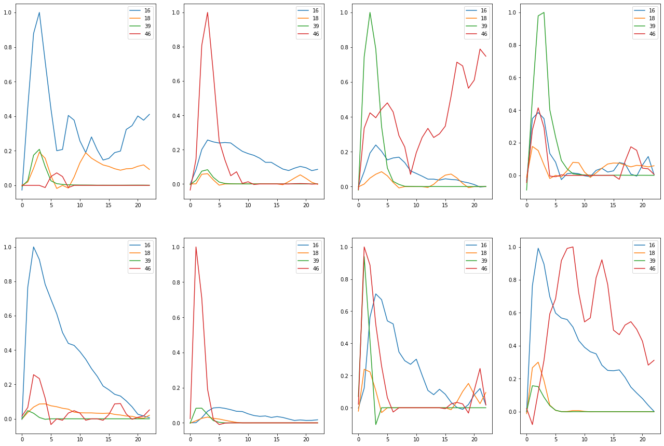

Train on detected 47 non-detected 465  
Train time in seconds: 3.6280601024627686

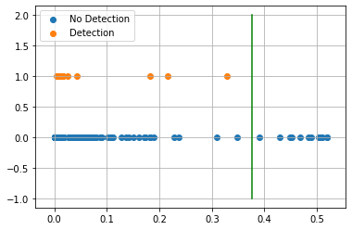

AUC 0.8009837565774423  
Predicted TPR 0.6170212765957447  
Predicted FPR 0.015053763440860216  
Threshold 0.37696257  
-----------------------End of training---------------------------

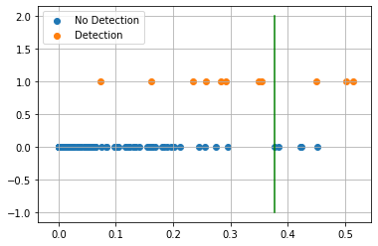

Test on detected 11 non-detected 118  
F0.5 38.46%  
  
Confusion Matrix:  
True Negative 96.61%  
False Positive 3.39%  
False Negative 72.73%  
True Positive 27.27%  
  
Classification Report  
 precision recall f1-score support  
  
 blank 0.934 0.966 0.950 118  
 detected 0.429 0.273 0.333 11  
  
 accuracy 0.907 129  
 macro avg 0.681 0.619 0.642 129  
weighted avg 0.891 0.907 0.897 129  
  
---------------------------end of testing--------------------------------  
  
Compound ID 10  
[0, 3, 4, 19, 20, 22, 23]

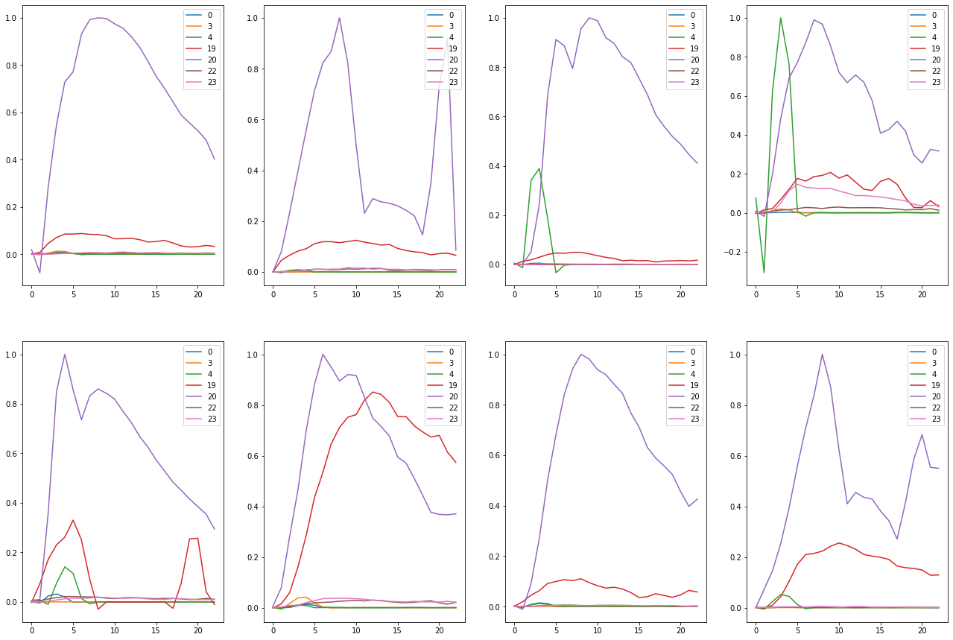

Train on detected 47 non-detected 465  
Train time in seconds: 5.364048480987549

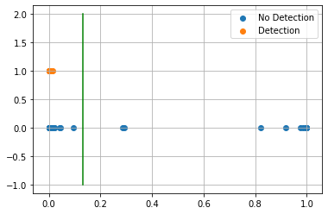

AUC 0.9754975978037064  
Predicted TPR 0.9574468085106383  
Predicted FPR 0.0064516129032258064  
Threshold 0.13210067  
-----------------------End of training---------------------------

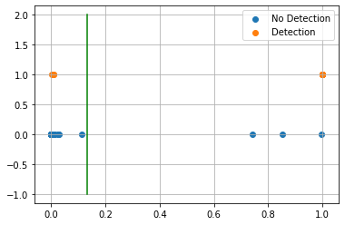

Test on detected 11 non-detected 118  
F0.5 72.73%  
  
Confusion Matrix:  
True Negative 97.46%  
False Positive 2.54%  
False Negative 27.27%  
True Positive 72.73%  
  
Classification Report  
 precision recall f1-score support  
  
 blank 0.975 0.975 0.975 118  
 detected 0.727 0.727 0.727 11  
  
 accuracy 0.953 129  
 macro avg 0.851 0.851 0.851 129  
weighted avg 0.953 0.953 0.953 129  
  
---------------------------end of testing--------------------------------  
  
Compound ID 13  
[41, 42, 46]

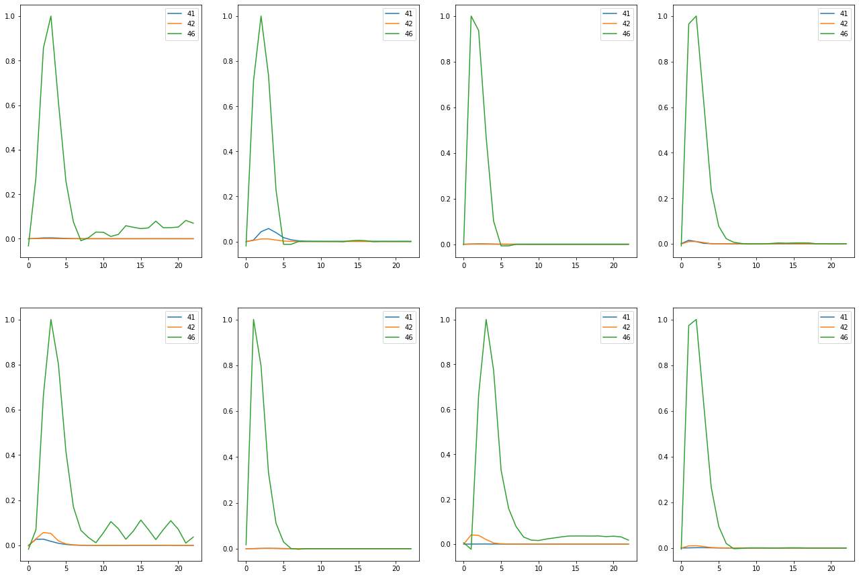

Train on detected 56 non-detected 456  
Train time in seconds: 8.213072299957275

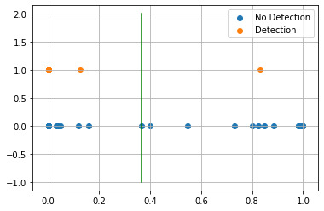

AUC 0.9956140350877193  
Predicted TPR 1.0  
Predicted FPR 0.008771929824561403  
Threshold 0.36573362  
-----------------------End of training---------------------------

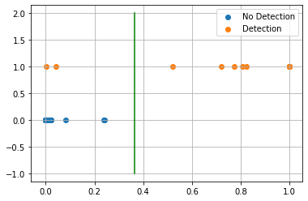

Test on detected 12 non-detected 117  
F0.5 96.15%  
  
Confusion Matrix:  
True Negative 100.00%  
False Positive 0.00%  
False Negative 16.67%  
True Positive 83.33%  
  
Classification Report  
 precision recall f1-score support  
  
 blank 0.983 1.000 0.992 117  
 detected 1.000 0.833 0.909 12  
  
 accuracy 0.984 129  
 macro avg 0.992 0.917 0.950 129  
weighted avg 0.985 0.984 0.984 129  
  
---------------------------end of testing--------------------------------  
  
Compound ID 14  
[16, 18, 46]

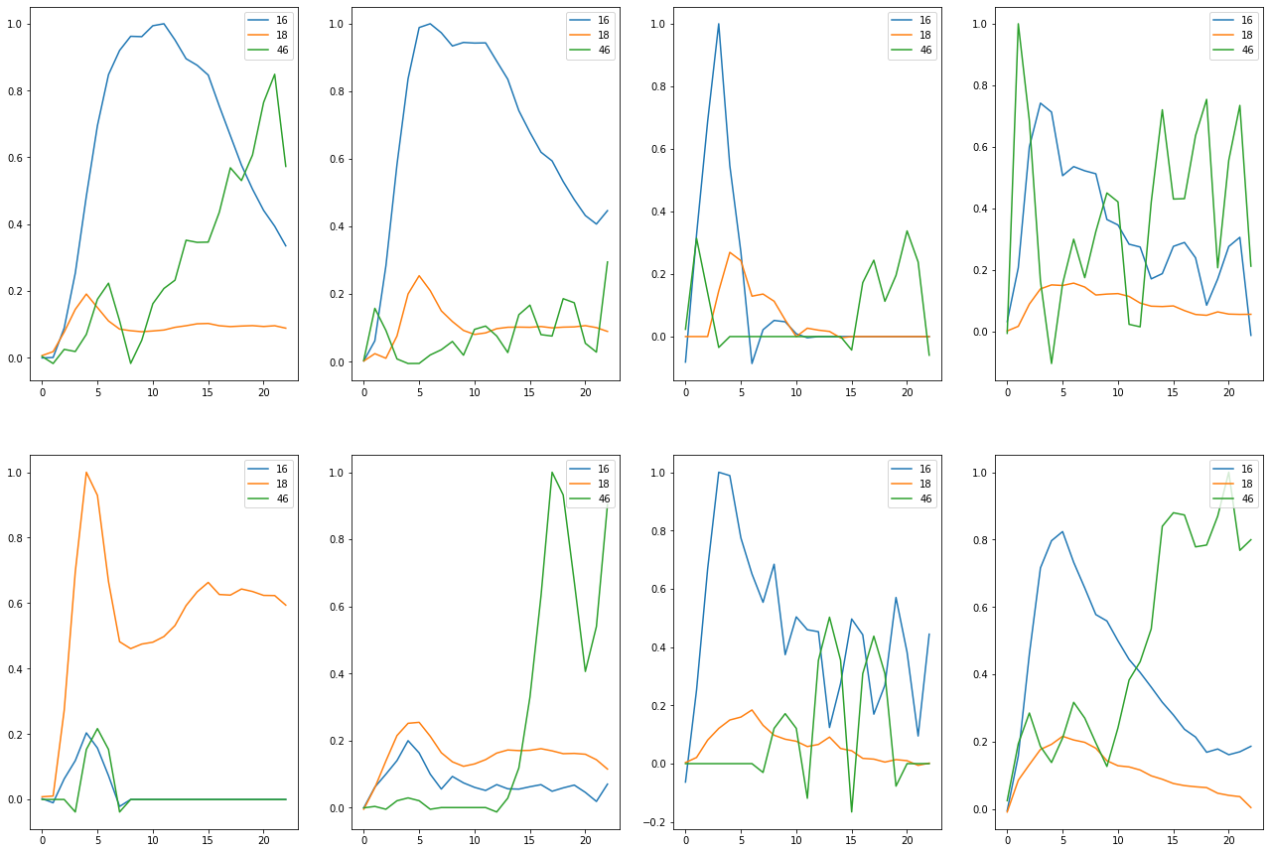

Train on detected 31 non-detected 481  
Train time in seconds: 3.7210330963134766

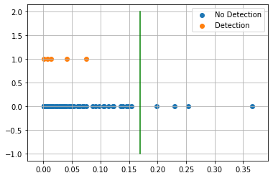

AUC 0.6701428475622024  
Predicted TPR 0.3548387096774194  
Predicted FPR 0.014553014553014554  
Threshold 0.1694431  
-----------------------End of training---------------------------

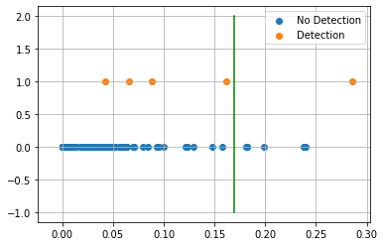

Test on detected 5 non-detected 124  
F0.5 13.51%  
  
Confusion Matrix:  
True Negative 94.35%  
False Positive 5.65%  
False Negative 80.00%  
True Positive 20.00%  
  
Classification Report  
 precision recall f1-score support  
  
 blank 0.967 0.944 0.955 124  
 detected 0.125 0.200 0.154 5  
  
 accuracy 0.915 129  
 macro avg 0.546 0.572 0.554 129  
weighted avg 0.934 0.915 0.924 129  
  
---------------------------end of testing--------------------------------  
  
Compound ID 15  
[36, 39, 46]

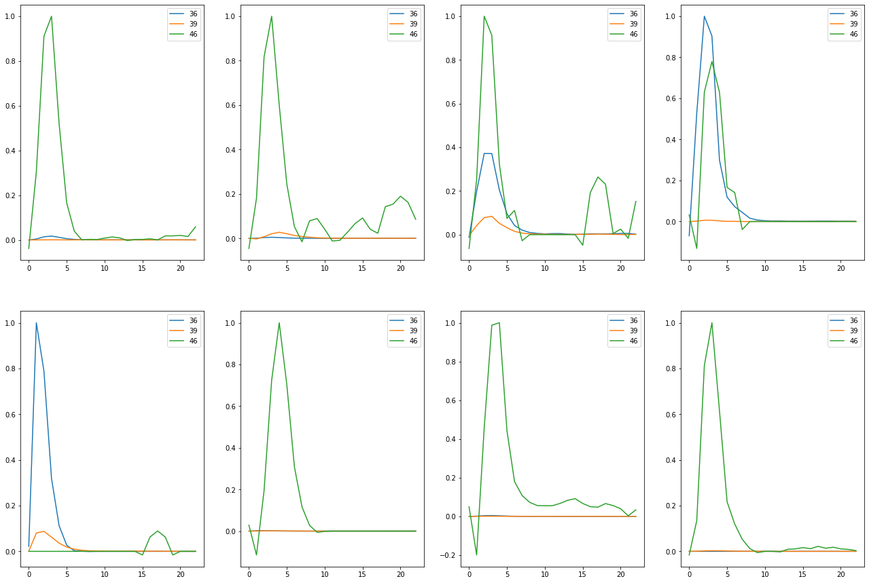

Train on detected 56 non-detected 456  
Train time in seconds: 5.788061141967773

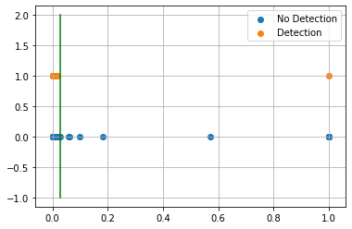

AUC 0.9732142857142857  
Predicted TPR 0.9464285714285714  
Predicted FPR 0.0  
Threshold 0.028430492  
-----------------------End of training---------------------------

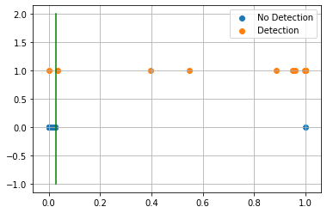

Test on detected 12 non-detected 117  
F0.5 91.67%  
  
Confusion Matrix:  
True Negative 99.15%  
False Positive 0.85%  
False Negative 8.33%  
True Positive 91.67%  
  
Classification Report  
 precision recall f1-score support  
  
 blank 0.991 0.991 0.991 117  
 detected 0.917 0.917 0.917 12  
  
 accuracy 0.984 129  
 macro avg 0.954 0.954 0.954 129  
weighted avg 0.984 0.984 0.984 129  
  
---------------------------end of testing--------------------------------  
  
Compound ID 18  
[19, 20, 21, 40]

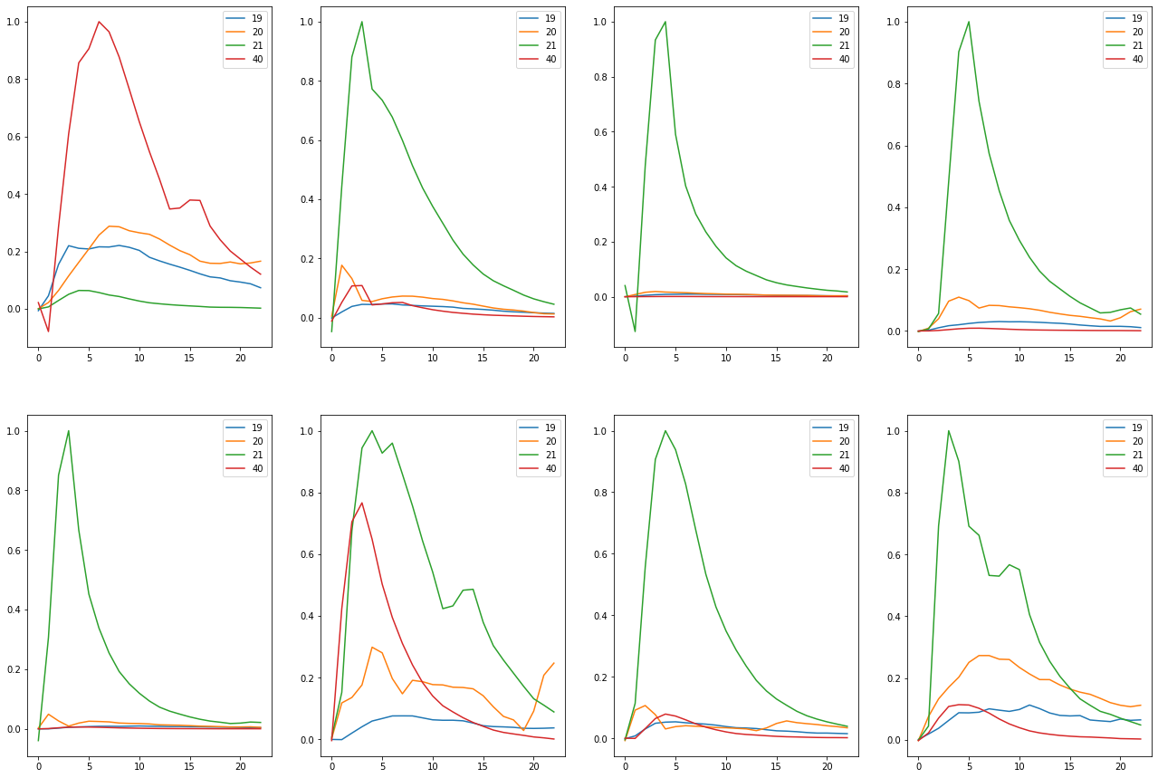

Train on detected 63 non-detected 449  
Train time in seconds: 5.159041404724121

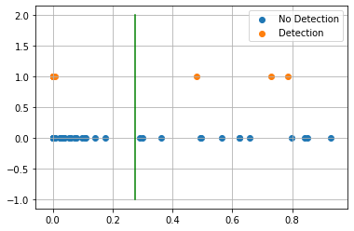

AUC 0.8720436949835613  
Predicted TPR 0.7619047619047619  
Predicted FPR 0.017817371937639197  
Threshold 0.2757141  
-----------------------End of training---------------------------

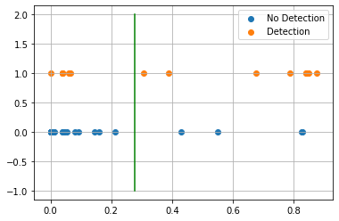

Test on detected 14 non-detected 115  
F0.5 64.52%  
  
Confusion Matrix:  
True Negative 96.52%  
False Positive 3.48%  
False Negative 42.86%  
True Positive 57.14%  
  
Classification Report  
 precision recall f1-score support  
  
 blank 0.949 0.965 0.957 115  
 detected 0.667 0.571 0.615 14  
  
 accuracy 0.922 129  
 macro avg 0.808 0.768 0.786 129  
weighted avg 0.918 0.922 0.920 129  
  
---------------------------end of testing--------------------------------  
  
Compound ID 19  
[7, 8]

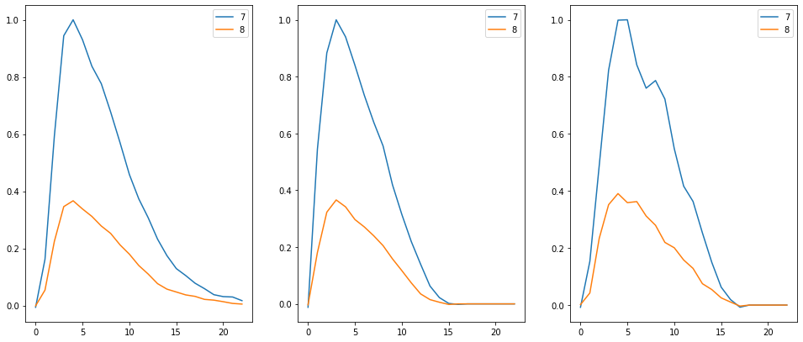

Train on detected 3 non-detected 509  
Train time in seconds: 3.950998306274414



AUC 0.5  
Predicted TPR 0.0  
Predicted FPR 0.0  
Threshold 1.0  
-----------------------End of training---------------------------



Test on detected 1 non-detected 128  
F0.5 0.00%  
  
Confusion Matrix:  
True Negative 100.00%  
False Positive 0.00%  
False Negative 100.00%  
True Positive 0.00%  
  
Classification Report  
 precision recall f1-score support  
  
 blank 0.992 1.000 0.996 128  
 detected 0.000 0.000 0.000 1  
  
 accuracy 0.992 129  
 macro avg 0.496 0.500 0.498 129  
weighted avg 0.985 0.992 0.988 129  
  
---------------------------end of testing--------------------------------  
  
Compound ID 21  
[22, 23, 25, 26, 33, 34]



Train on detected 61 non-detected 451  
Train time in seconds: 4.663042306900024

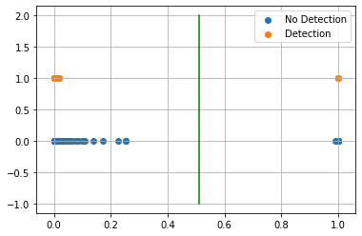

AUC 0.9720838937152412  
Predicted TPR 0.9508196721311475  
Predicted FPR 0.0066518847006651885  
Threshold 0.50970143  
-----------------------End of training---------------------------

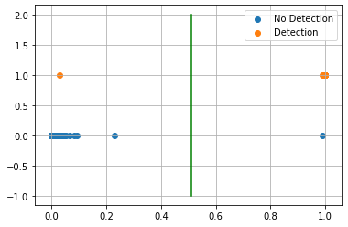

Test on detected 14 non-detected 115  
F0.5 92.86%  
  
Confusion Matrix:  
True Negative 99.13%  
False Positive 0.87%  
False Negative 7.14%  
True Positive 92.86%  
  
Classification Report  
 precision recall f1-score support  
  
 blank 0.991 0.991 0.991 115  
 detected 0.929 0.929 0.929 14  
  
 accuracy 0.984 129  
 macro avg 0.960 0.960 0.960 129  
weighted avg 0.984 0.984 0.984 129  
  
---------------------------end of testing--------------------------------  
  
Compound ID 22  
[35, 37, 38]

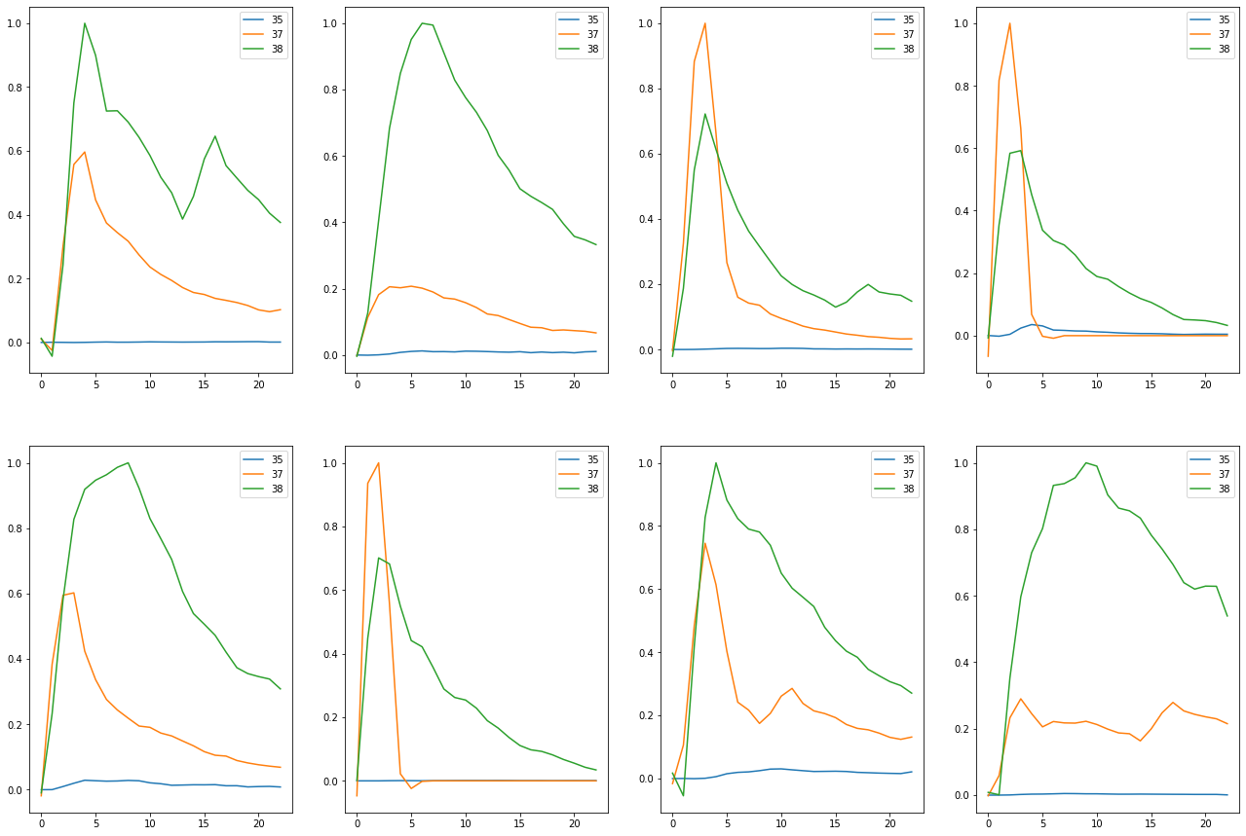

Train on detected 65 non-detected 447  
Train time in seconds: 4.226991653442383

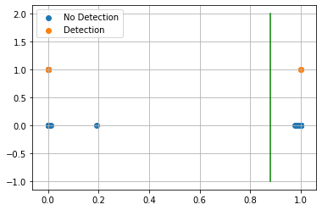

AUC 1.0  
Predicted TPR 1.0  
Predicted FPR 0.0  
Threshold 0.87788785  
-----------------------End of training---------------------------

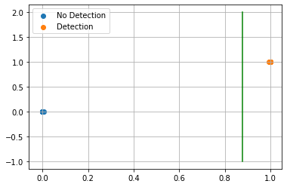

Test on detected 14 non-detected 115  
F0.5 100.00%  
  
Confusion Matrix:  
True Negative 100.00%  
False Positive 0.00%  
False Negative 0.00%  
True Positive 100.00%  
  
Classification Report  
 precision recall f1-score support  
  
 blank 1.000 1.000 1.000 115  
 detected 1.000 1.000 1.000 14  
  
 accuracy 1.000 129  
 macro avg 1.000 1.000 1.000 129  
weighted avg 1.000 1.000 1.000 129  
  
---------------------------end of testing--------------------------------

Compound ID 8  
[16, 18, 39, 46]

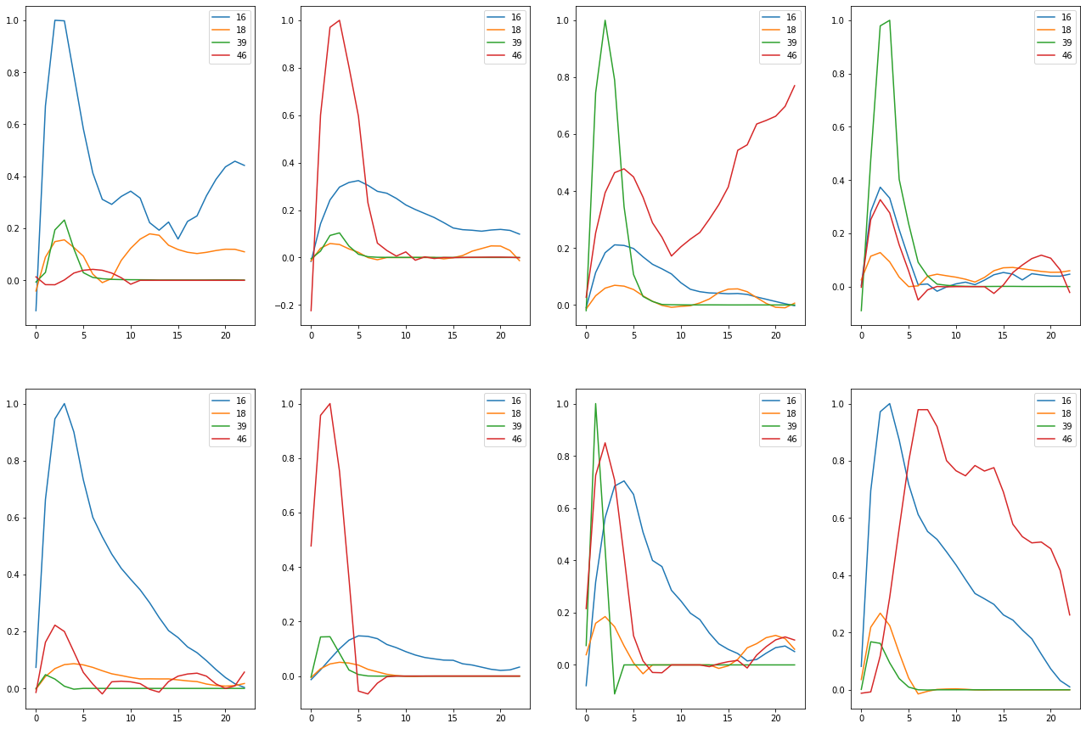

Train on detected 47 non-detected 465  
Train time in seconds: 4.230085849761963

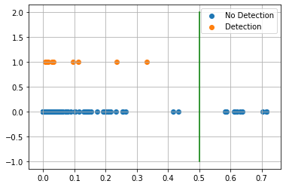

AUC 0.735003431708991  
Predicted TPR 0.48936170212765956  
Predicted FPR 0.01935483870967742  
Threshold 0.50073355  
-----------------------End of training---------------------------

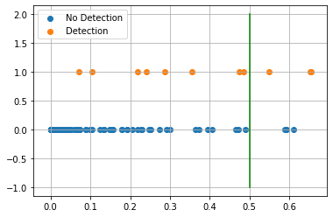

Test on detected 11 non-detected 118  
F0.5 42.86%  
  
Confusion Matrix:  
True Negative 97.46%  
False Positive 2.54%  
False Negative 72.73%  
True Positive 27.27%  
  
Classification Report  
 precision recall f1-score support  
  
 blank 0.935 0.975 0.954 118  
 detected 0.500 0.273 0.353 11  
  
 accuracy 0.915 129  
 macro avg 0.717 0.624 0.654 129  
weighted avg 0.898 0.915 0.903 129  
  
---------------------------end of testing--------------------------------  
  
Compound ID 13  
[41, 42, 46]

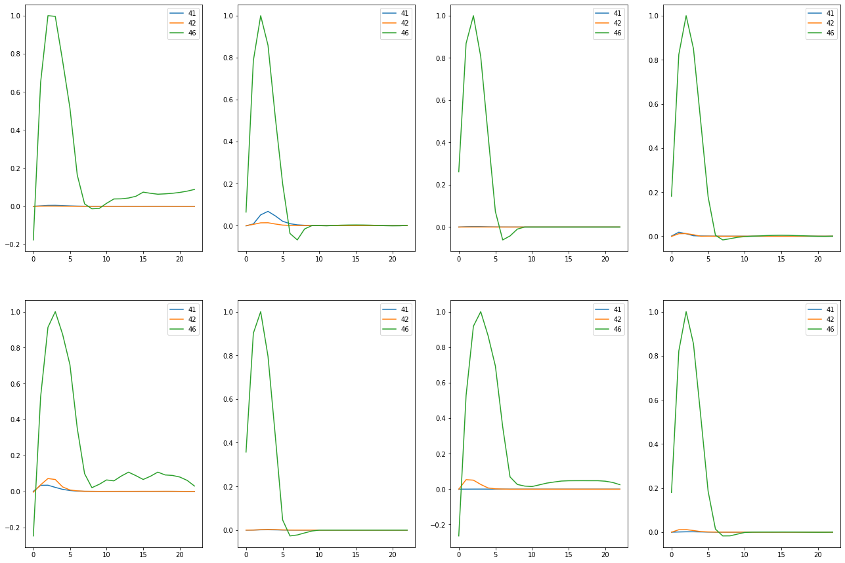

Train on detected 56 non-detected 456  
Train time in seconds: 6.7220165729522705

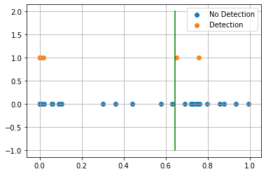

AUC 0.9097744360902257  
Predicted TPR 0.8392857142857143  
Predicted FPR 0.019736842105263157  
Threshold 0.6448144  
-----------------------End of training---------------------------

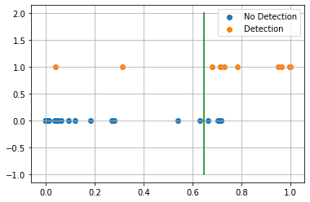

Test on detected 12 non-detected 117  
F0.5 73.53%  
  
Confusion Matrix:  
True Negative 96.58%  
False Positive 3.42%  
False Negative 16.67%  
True Positive 83.33%  
  
Classification Report  
 precision recall f1-score support  
  
 blank 0.983 0.966 0.974 117  
 detected 0.714 0.833 0.769 12  
  
 accuracy 0.953 129  
 macro avg 0.848 0.900 0.872 129  
weighted avg 0.958 0.953 0.955 129  
  
---------------------------end of testing--------------------------------  
  
Compound ID 15  
[36, 39, 46]

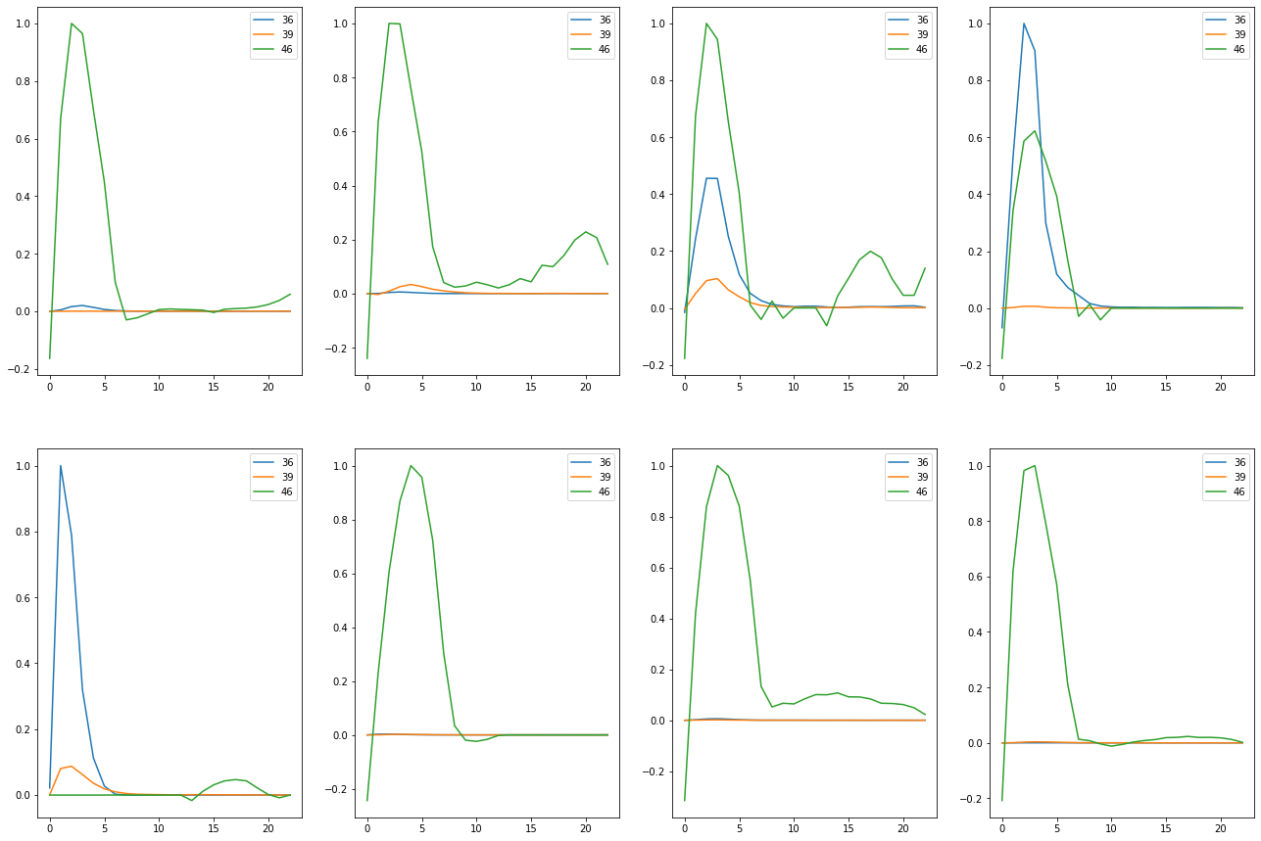

Train on detected 56 non-detected 456  
Train time in seconds: 6.775054693222046

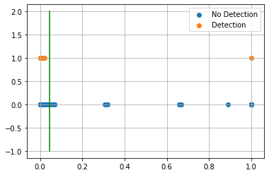

AUC 0.9844924812030075  
Predicted TPR 0.9821428571428571  
Predicted FPR 0.013157894736842105  
Threshold 0.045871377  
-----------------------End of training---------------------------

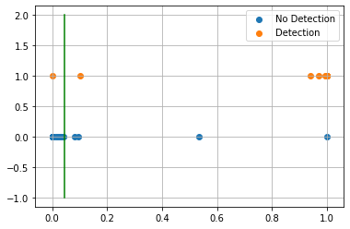

Test on detected 12 non-detected 117  
F0.5 76.39%  
  
Confusion Matrix:  
True Negative 96.58%  
False Positive 3.42%  
False Negative 8.33%  
True Positive 91.67%  
  
Classification Report  
 precision recall f1-score support  
  
 blank 0.991 0.966 0.978 117  
 detected 0.733 0.917 0.815 12  
  
 accuracy 0.961 129  
 macro avg 0.862 0.941 0.897 129  
weighted avg 0.967 0.961 0.963 129  
  
---------------------------end of testing--------------------------------  
 Compounds Tr-TPR Tr-FPR Threshold ROC AUC Score Test-TPR Test-FPR  
 8 48.94% 1.94% 50.07% 73.50% 27.27% 2.54%   
 13 83.93% 1.97% 64.48% 90.98% 83.33% 3.42%   
 15 98.21% 1.32% 4.59% 98.45% 91.67% 3.42%

Compound 8 was the only one that got better. I wonder if I remove mass pairs that are adding noise to our graphs if that will help stabilize our results. Also I will try adding mass pairs that are shared across compounds to see if that can help differentiate compounds. For example compound 8 and 15 share mass pairs. After adjusting mass pairs it may be worth revisiting mass pair filtering.

Compound ID 0  
[22, 23]

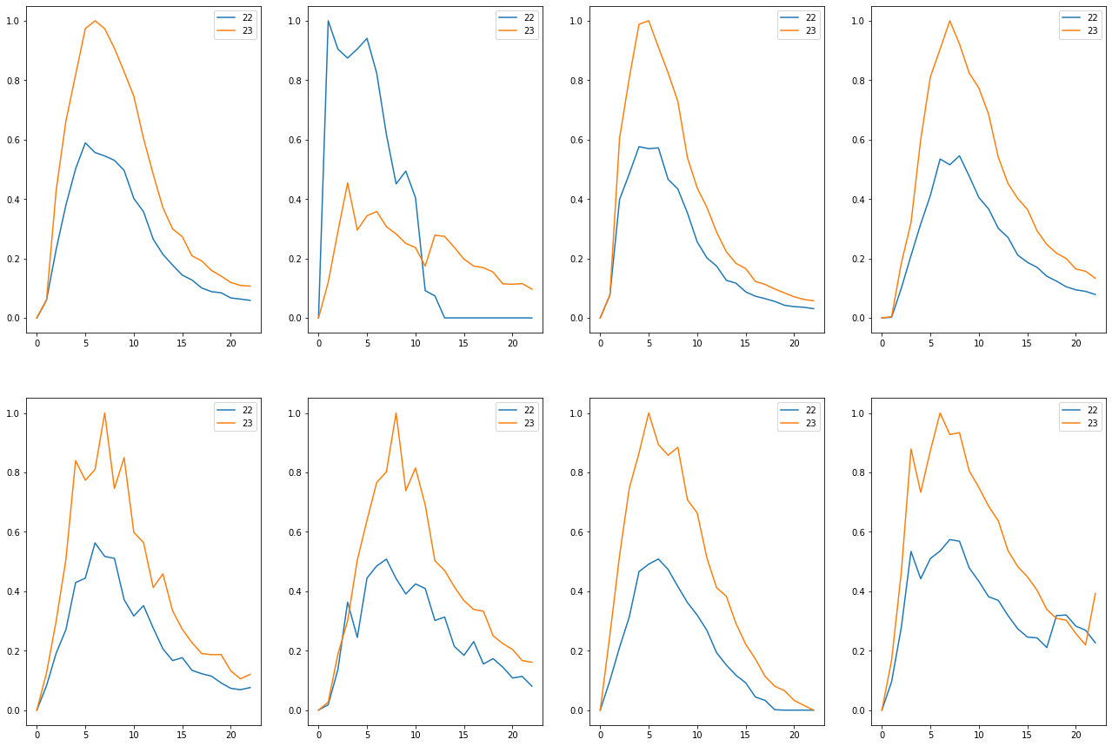

Train on detected 61 non-detected 451  
Train time in seconds: 6.47504734992981

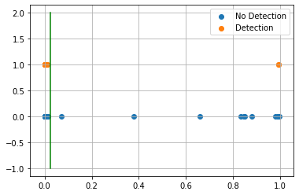

AUC 0.9594525826033222  
Predicted TPR 0.9344262295081968  
Predicted FPR 0.015521064301552107  
Threshold 0.02440100908279419  
-----------------------End of training---------------------------

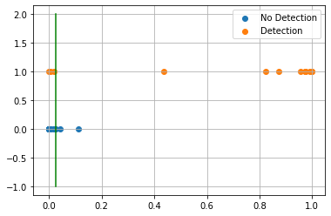

Test on detected 14 non-detected 115  
F0.5 78.57%  
  
Confusion Matrix:  
True Negative 97.39%  
False Positive 2.61%  
False Negative 21.43%  
True Positive 78.57%  
  
Classification Report  
 precision recall f1-score support  
  
 blank 0.974 0.974 0.974 115  
 detected 0.786 0.786 0.786 14  
  
 accuracy 0.953 129  
 macro avg 0.880 0.880 0.880 129  
weighted avg 0.953 0.953 0.953 129  
  
---------------------------end of testing--------------------------------  
  
Compound ID 3  
[47, 49, 50]

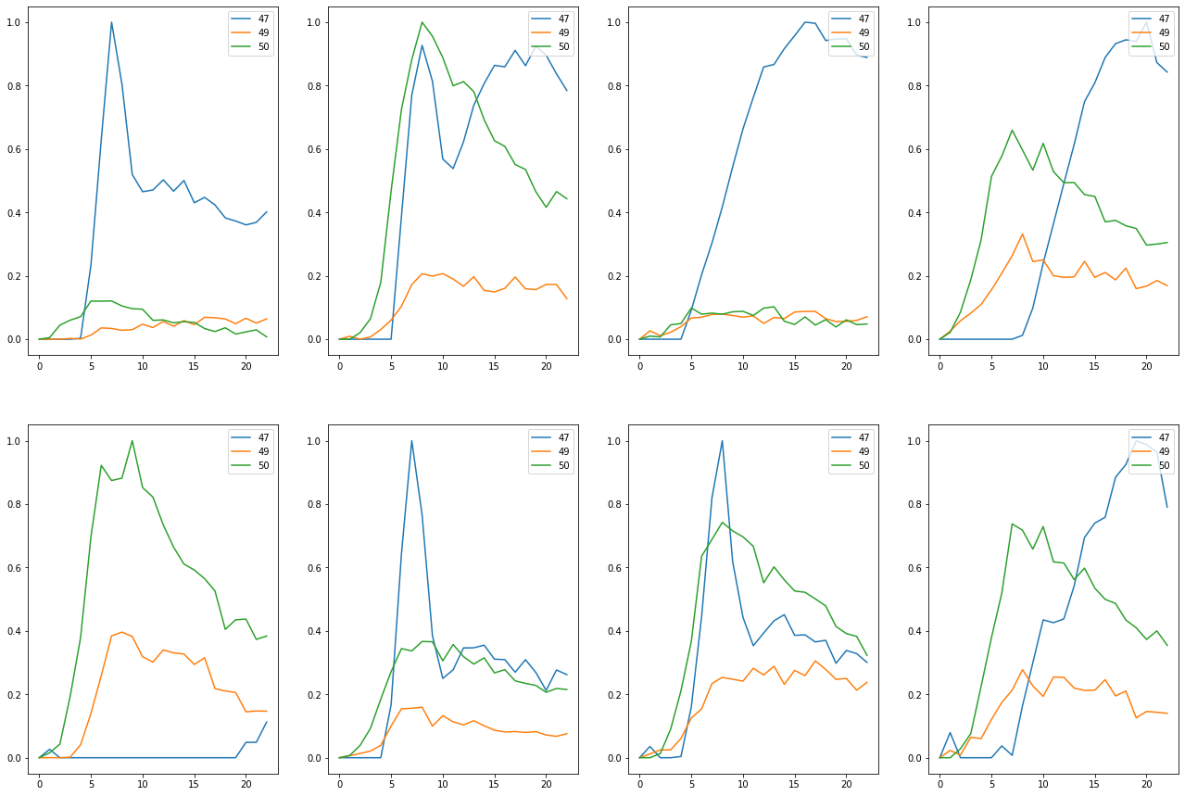

Train on detected 16 non-detected 496  
Train time in seconds: 4.857040166854858

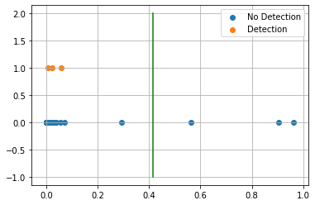

AUC 0.9667338709677419  
Predicted TPR 0.9375  
Predicted FPR 0.004032258064516129  
Threshold 0.41393086314201355  
-----------------------End of training---------------------------

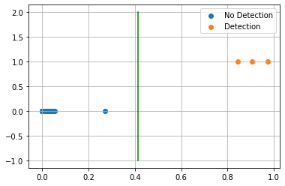

Test on detected 3 non-detected 126  
F0.5 100.00%  
  
Confusion Matrix:  
True Negative 100.00%  
False Positive 0.00%  
False Negative 0.00%  
True Positive 100.00%  
  
Classification Report  
 precision recall f1-score support  
  
 blank 1.000 1.000 1.000 126  
 detected 1.000 1.000 1.000 3  
  
 accuracy 1.000 129  
 macro avg 1.000 1.000 1.000 129  
weighted avg 1.000 1.000 1.000 129  
  
---------------------------end of testing--------------------------------  
  
Compound ID 4  
[2, 11]



Train on detected 61 non-detected 451  
Train time in seconds: 6.610058307647705

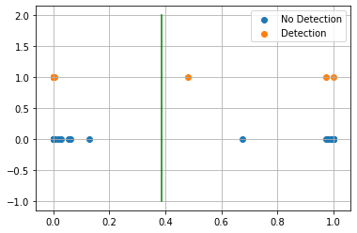

AUC 0.9977827050997783  
Predicted TPR 1.0  
Predicted FPR 0.004434589800443459  
Threshold 0.3851543664932251  
-----------------------End of training---------------------------

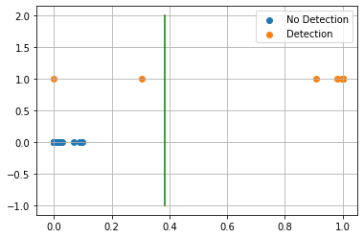

Test on detected 14 non-detected 115  
F0.5 96.77%  
  
Confusion Matrix:  
True Negative 100.00%  
False Positive 0.00%  
False Negative 14.29%  
True Positive 85.71%  
  
Classification Report  
 precision recall f1-score support  
  
 blank 0.983 1.000 0.991 115  
 detected 1.000 0.857 0.923 14  
  
 accuracy 0.984 129  
 macro avg 0.991 0.929 0.957 129  
weighted avg 0.985 0.984 0.984 129  
  
---------------------------end of testing--------------------------------  
  
Compound ID 8  
[36, 39, 46]

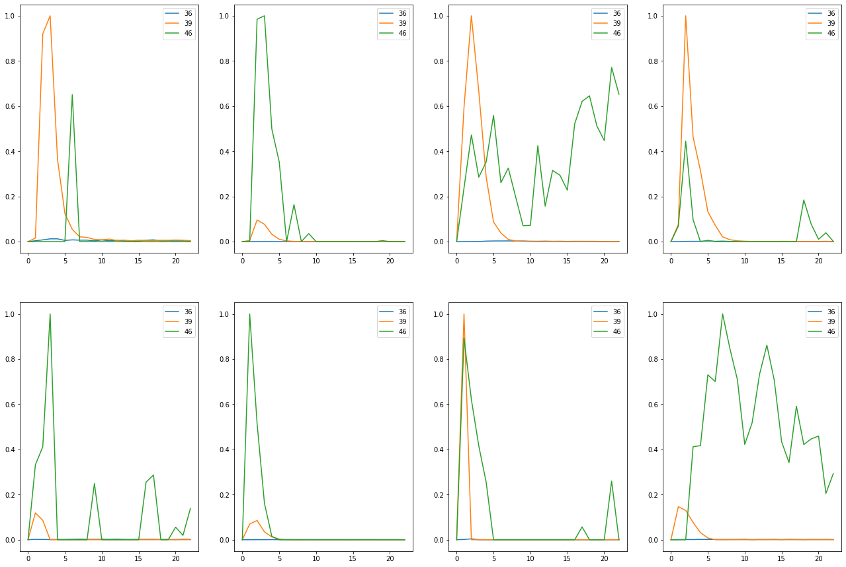

Train on detected 47 non-detected 465  
Train time in seconds: 4.803091764450073

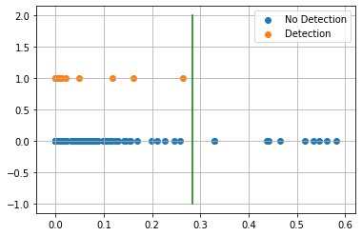

AUC 0.809471516815374  
Predicted TPR 0.6382978723404256  
Predicted FPR 0.01935483870967742  
Threshold 0.2836679220199585  
-----------------------End of training---------------------------

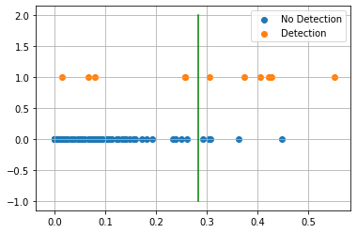

Test on detected 11 non-detected 118  
F0.5 54.55%  
  
Confusion Matrix:  
True Negative 95.76%  
False Positive 4.24%  
False Negative 45.45%  
True Positive 54.55%  
  
Classification Report  
 precision recall f1-score support  
  
 blank 0.958 0.958 0.958 118  
 detected 0.545 0.545 0.545 11  
  
 accuracy 0.922 129  
 macro avg 0.752 0.752 0.752 129  
weighted avg 0.922 0.922 0.922 129  
  
---------------------------end of testing--------------------------------  
  
Compound ID 10  
[0, 3, 4]

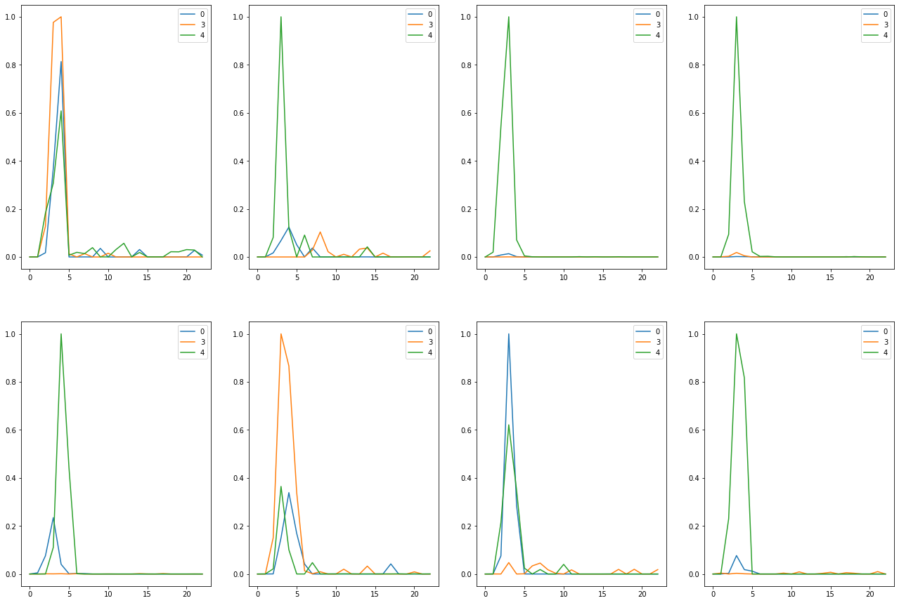

Train on detected 47 non-detected 465  
Train time in seconds: 5.1930201053619385

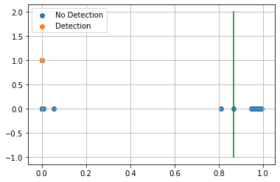

AUC 1.0  
Predicted TPR 1.0  
Predicted FPR 0.0  
Threshold 0.8656920790672302  
-----------------------End of training---------------------------

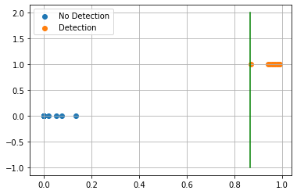

Test on detected 11 non-detected 118  
F0.5 100.00%  
  
Confusion Matrix:  
True Negative 100.00%  
False Positive 0.00%  
False Negative 0.00%  
True Positive 100.00%  
  
Classification Report  
 precision recall f1-score support  
  
 blank 1.000 1.000 1.000 118  
 detected 1.000 1.000 1.000 11  
  
 accuracy 1.000 129  
 macro avg 1.000 1.000 1.000 129  
weighted avg 1.000 1.000 1.000 129  
  
---------------------------end of testing--------------------------------  
  
Compound ID 13  
[41, 42]

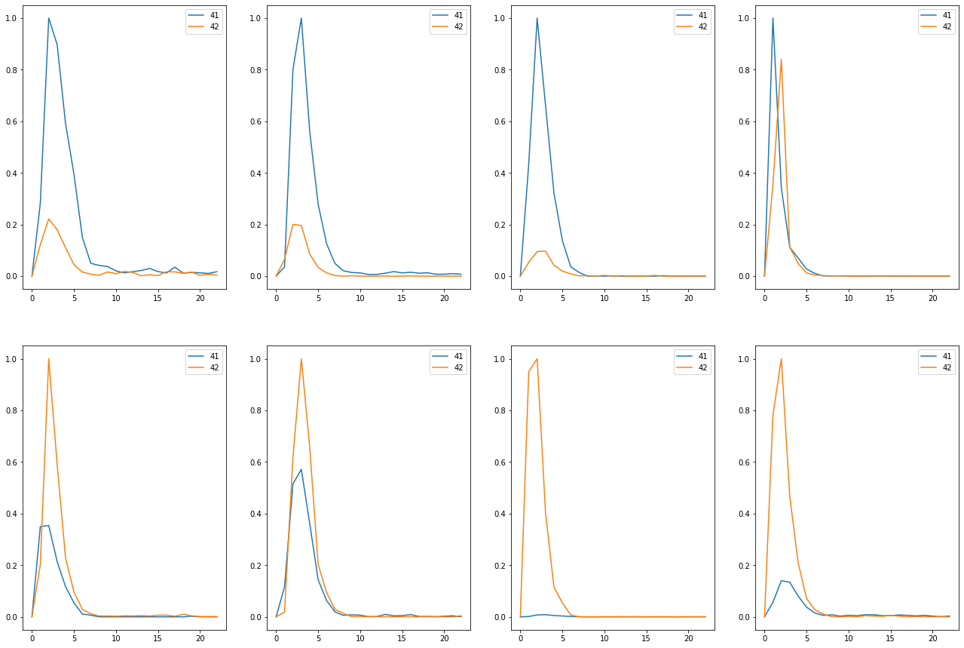

Train on detected 56 non-detected 456  
Train time in seconds: 5.309044599533081

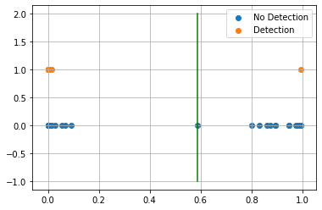

AUC 0.9866854636591479  
Predicted TPR 0.9821428571428571  
Predicted FPR 0.008771929824561403  
Threshold 0.5865732431411743  
-----------------------End of training---------------------------

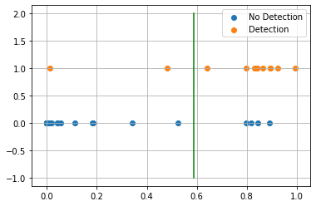

Test on detected 12 non-detected 117  
F0.5 73.53%  
  
Confusion Matrix:  
True Negative 96.58%  
False Positive 3.42%  
False Negative 16.67%  
True Positive 83.33%  
  
Classification Report  
 precision recall f1-score support  
  
 blank 0.983 0.966 0.974 117  
 detected 0.714 0.833 0.769 12  
  
 accuracy 0.953 129  
 macro avg 0.848 0.900 0.872 129  
weighted avg 0.958 0.953 0.955 129  
  
---------------------------end of testing--------------------------------  
  
Compound ID 14  
[16, 18]

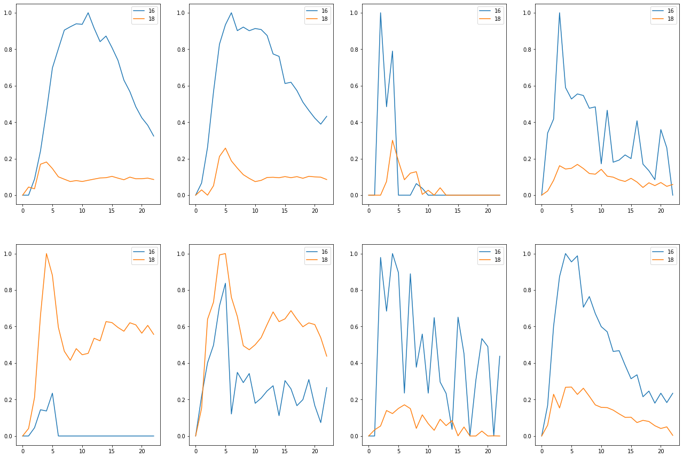

Train on detected 31 non-detected 481  
Train time in seconds: 5.3680455684661865

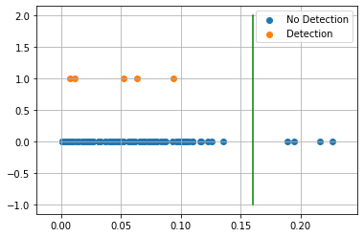

AUC 0.6035477164509423  
Predicted TPR 0.22580645161290322  
Predicted FPR 0.018711018711018712  
Threshold 0.1600111424922943  
-----------------------End of training---------------------------

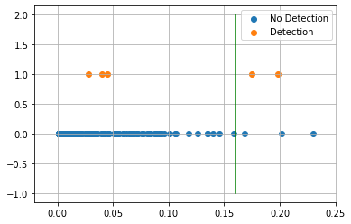

Test on detected 5 non-detected 124  
F0.5 40.00%  
  
Confusion Matrix:  
True Negative 97.58%  
False Positive 2.42%  
False Negative 60.00%  
True Positive 40.00%  
  
Classification Report  
 precision recall f1-score support  
  
 blank 0.976 0.976 0.976 124  
 detected 0.400 0.400 0.400 5  
  
 accuracy 0.953 129  
 macro avg 0.688 0.688 0.688 129  
weighted avg 0.953 0.953 0.953 129  
  
---------------------------end of testing--------------------------------  
  
Compound ID 15  
[36, 39]

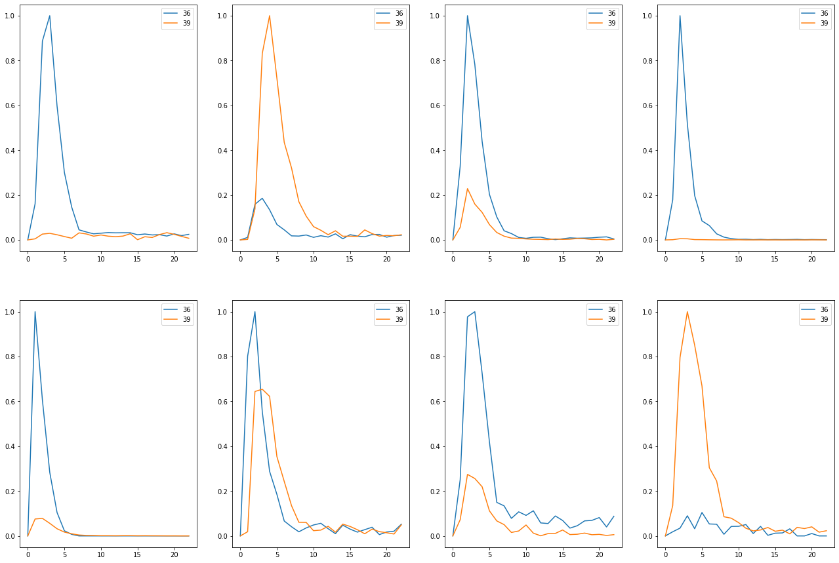

Train on detected 56 non-detected 456  
Train time in seconds: 6.169007778167725

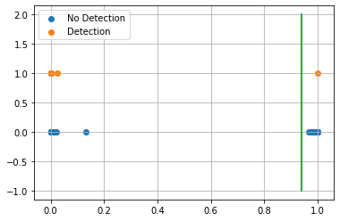

AUC 0.9978070175438596  
Predicted TPR 1.0  
Predicted FPR 0.0043859649122807015  
Threshold 0.9378237128257751  
-----------------------End of training---------------------------

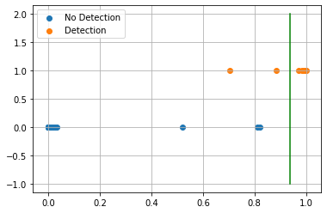

Test on detected 12 non-detected 117  
F0.5 96.15%  
  
Confusion Matrix:  
True Negative 100.00%  
False Positive 0.00%  
False Negative 16.67%  
True Positive 83.33%  
  
Classification Report  
 precision recall f1-score support  
  
 blank 0.983 1.000 0.992 117  
 detected 1.000 0.833 0.909 12  
  
 accuracy 0.984 129  
 macro avg 0.992 0.917 0.950 129  
weighted avg 0.985 0.984 0.984 129  
  
---------------------------end of testing--------------------------------  
  
Compound ID 18  
[21, 40]

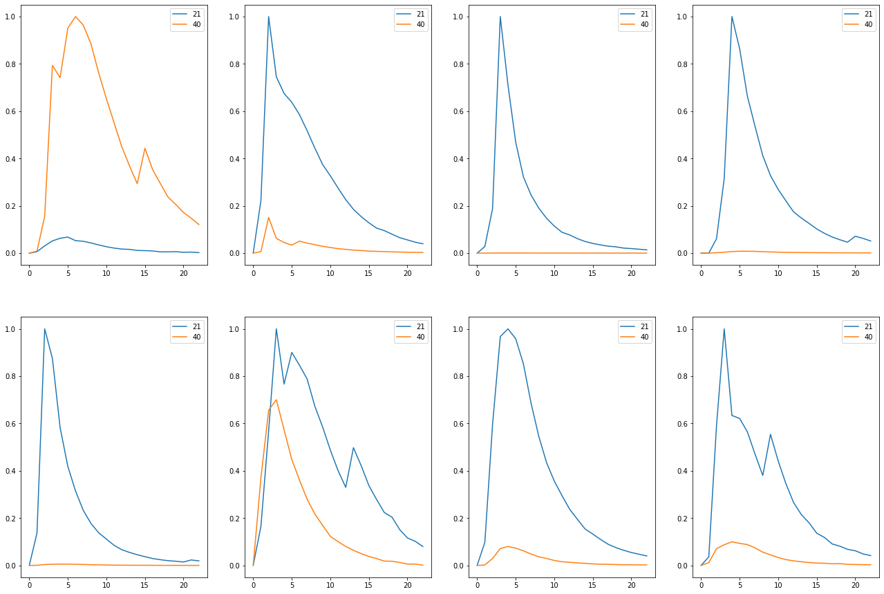

Train on detected 63 non-detected 449  
Train time in seconds: 7.470055818557739

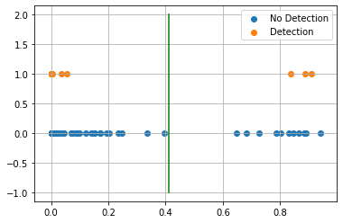

AUC 0.911726234666101  
Predicted TPR 0.8412698412698413  
Predicted FPR 0.017817371937639197  
Threshold 0.4120602011680603  
-----------------------End of training---------------------------

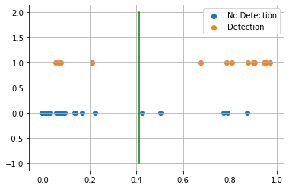

Test on detected 14 non-detected 115  
F0.5 64.29%  
  
Confusion Matrix:  
True Negative 95.65%  
False Positive 4.35%  
False Negative 35.71%  
True Positive 64.29%  
  
Classification Report  
 precision recall f1-score support  
  
 blank 0.957 0.957 0.957 115  
 detected 0.643 0.643 0.643 14  
  
 accuracy 0.922 129  
 macro avg 0.800 0.800 0.800 129  
weighted avg 0.922 0.922 0.922 129  
  
---------------------------end of testing--------------------------------  
  
Compound ID 21  
[33, 34]

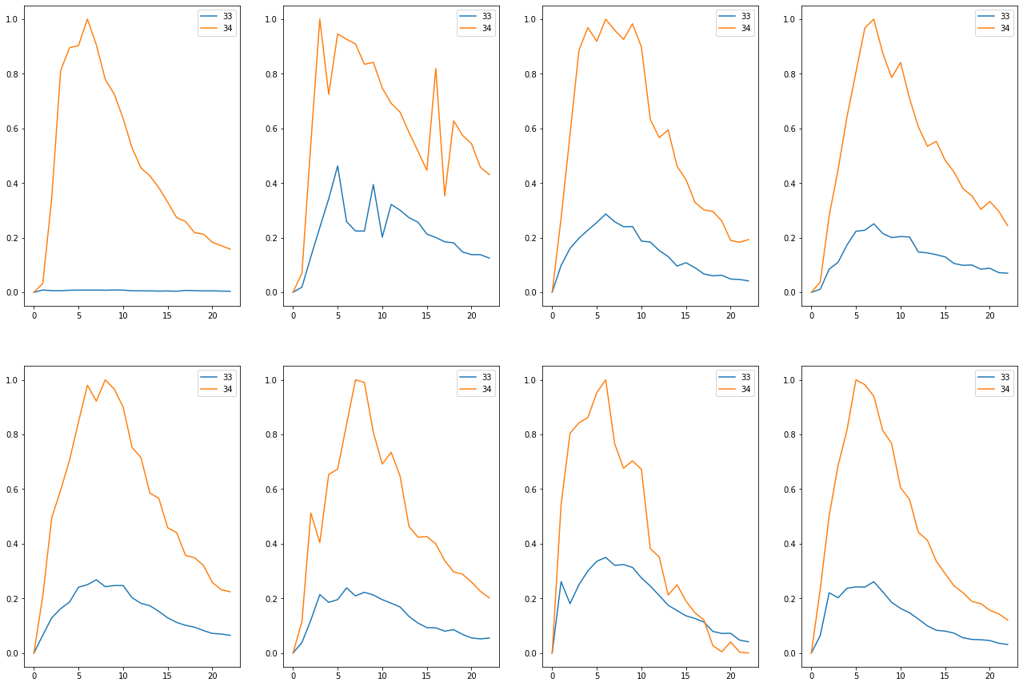

Train on detected 61 non-detected 451  
Train time in seconds: 7.839064598083496

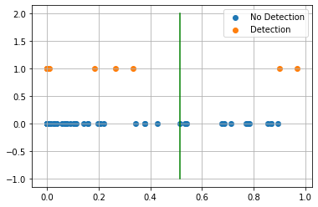

AUC 0.8916615172112974  
Predicted TPR 0.8032786885245902  
Predicted FPR 0.019955654101995565  
Threshold 0.5131327509880066  
-----------------------End of training---------------------------

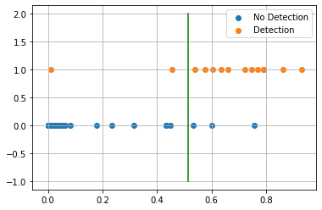

Test on detected 14 non-detected 115  
F0.5 81.08%  
  
Confusion Matrix:  
True Negative 97.39%  
False Positive 2.61%  
False Negative 14.29%  
True Positive 85.71%  
  
Classification Report  
 precision recall f1-score support  
  
 blank 0.982 0.974 0.978 115  
 detected 0.800 0.857 0.828 14  
  
 accuracy 0.961 129  
 macro avg 0.891 0.916 0.903 129  
weighted avg 0.963 0.961 0.962 129  
  
---------------------------end of testing--------------------------------  
  
Compound ID 22  
[35, 37, 38]



Train on detected 65 non-detected 447  
Train time in seconds: 6.064051151275635

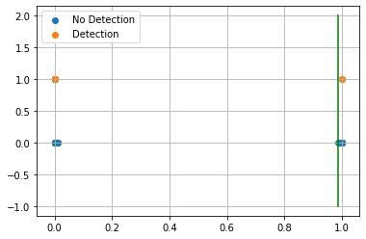

AUC 1.0  
Predicted TPR 1.0  
Predicted FPR 0.0  
Threshold 0.9878960847854614  
-----------------------End of training---------------------------

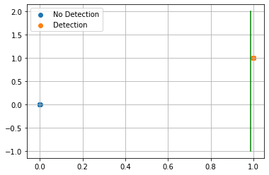

Test on detected 14 non-detected 115  
F0.5 100.00%  
  
Confusion Matrix:  
True Negative 100.00%  
False Positive 0.00%  
False Negative 0.00%  
True Positive 100.00%  
  
Classification Report  
 precision recall f1-score support  
  
 blank 1.000 1.000 1.000 115  
 detected 1.000 1.000 1.000 14  
  
 accuracy 1.000 129  
 macro avg 1.000 1.000 1.000 129  
weighted avg 1.000 1.000 1.000 129  
  
---------------------------end of testing--------------------------------  
 Compounds Tr-TPR Tr-FPR Threshold ROC AUC Score Test-TPR Test-FPR  
 0 93.44% 1.55% 2.44% 95.95% 78.57% 2.61%   
 3 93.75% 0.40% 41.39% 96.67% 100.00% 0.00%   
 4 100.00% 0.44% 38.52% 99.78% 85.71% 0.00%   
 8 63.83% 1.94% 28.37% 80.95% 54.55% 4.24%   
 10 100.00% 0.00% 86.57% 100.00% 100.00% 0.00%   
 13 98.21% 0.88% 58.66% 98.67% 83.33% 3.42%   
 14 22.58% 1.87% 16.00% 60.35% 40.00% 2.42%   
 15 100.00% 0.44% 93.78% 99.78% 83.33% 0.00%   
 18 84.13% 1.78% 41.21% 91.17% 64.29% 4.35%   
 21 80.33% 2.00% 51.31% 89.17% 85.71% 2.61%   
 22 100.00% 0.00% 98.79% 100.00% 100.00% 0.00%

## Filtering

Compound ID 0  
[22, 23]

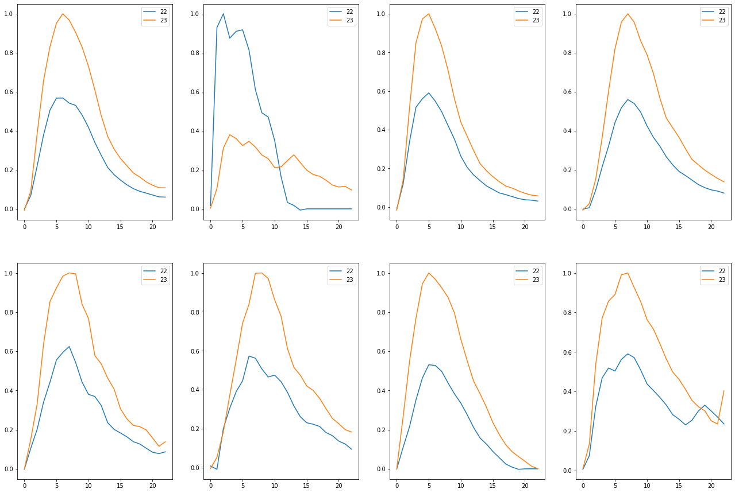

Train on detected 61 non-detected 451  
Train time in seconds: 8.331034183502197

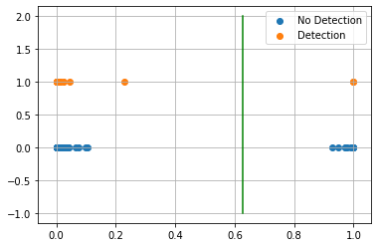

AUC 0.9452764348805932  
Predicted TPR 0.9016393442622951  
Predicted FPR 0.011086474501108648  
Threshold 0.6285853  
-----------------------End of training---------------------------

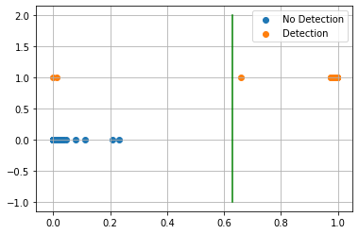

Test on detected 14 non-detected 115  
F0.5 96.77%  
  
Confusion Matrix:  
True Negative 100.00%  
False Positive 0.00%  
False Negative 14.29%  
True Positive 85.71%  
  
Classification Report  
 precision recall f1-score support  
  
 blank 0.983 1.000 0.991 115  
 detected 1.000 0.857 0.923 14  
  
 accuracy 0.984 129  
 macro avg 0.991 0.929 0.957 129  
weighted avg 0.985 0.984 0.984 129  
  
---------------------------end of testing--------------------------------  
  
Compound ID 3  
[47, 49, 50]

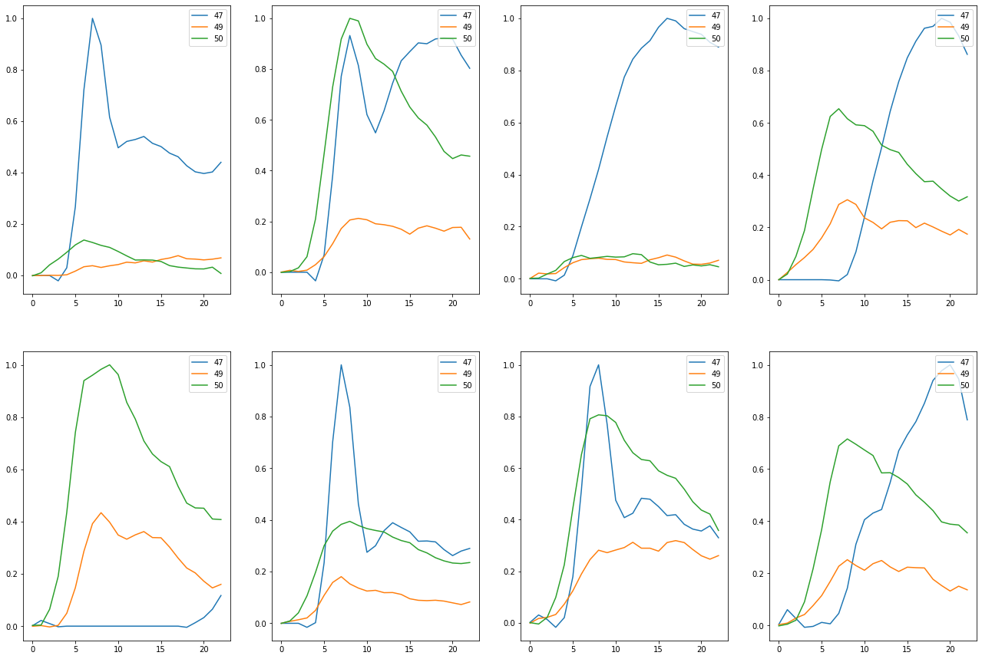

Train on detected 16 non-detected 496  
Train time in seconds: 6.408054351806641

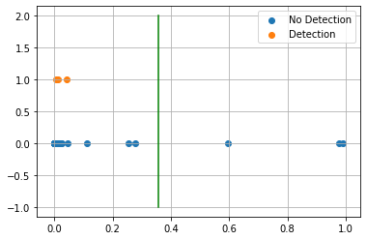

AUC 0.9647177419354839  
Predicted TPR 0.9375  
Predicted FPR 0.008064516129032258  
Threshold 0.35640937  
-----------------------End of training---------------------------

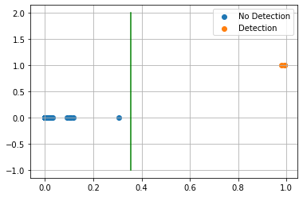

Test on detected 3 non-detected 126  
F0.5 100.00%  
  
Confusion Matrix:  
True Negative 100.00%  
False Positive 0.00%  
False Negative 0.00%  
True Positive 100.00%  
  
Classification Report  
 precision recall f1-score support  
  
 blank 1.000 1.000 1.000 126  
 detected 1.000 1.000 1.000 3  
  
 accuracy 1.000 129  
 macro avg 1.000 1.000 1.000 129  
weighted avg 1.000 1.000 1.000 129  
  
---------------------------end of testing--------------------------------  
  
Compound ID 4  
[2, 11]



Train on detected 61 non-detected 451  
Train time in seconds: 8.136054992675781

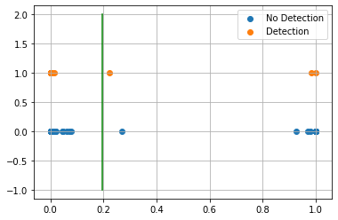

AUC 0.9851513939878593  
Predicted TPR 0.9836065573770492  
Predicted FPR 0.013303769401330377  
Threshold 0.19520617  
-----------------------End of training---------------------------

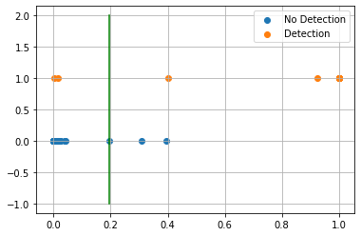

Test on detected 14 non-detected 115  
F0.5 85.71%  
  
Confusion Matrix:  
True Negative 98.26%  
False Positive 1.74%  
False Negative 14.29%  
True Positive 85.71%  
  
Classification Report  
 precision recall f1-score support  
  
 blank 0.983 0.983 0.983 115  
 detected 0.857 0.857 0.857 14  
  
 accuracy 0.969 129  
 macro avg 0.920 0.920 0.920 129  
weighted avg 0.969 0.969 0.969 129  
  
---------------------------end of testing--------------------------------  
  
Compound ID 8  
[36, 39, 46]

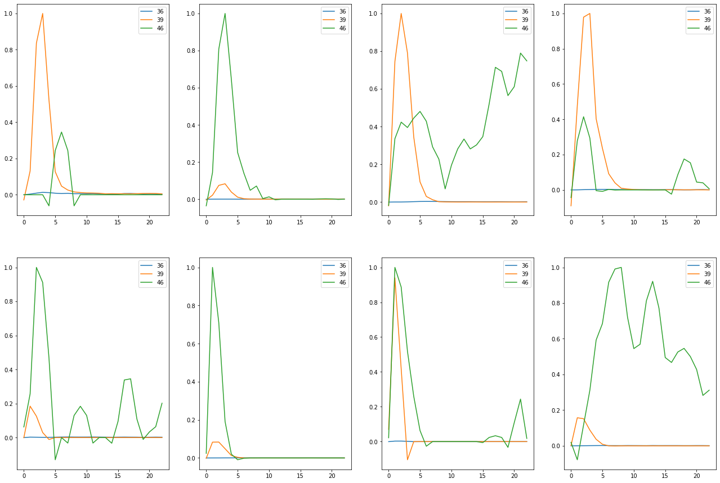

Train on detected 47 non-detected 465  
Train time in seconds: 8.28004240989685

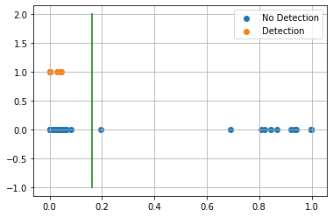

AUC 0.9637840311141617  
Predicted TPR 0.9361702127659575  
Predicted FPR 0.008602150537634409  
Threshold 0.16074687  
-----------------------End of training---------------------------

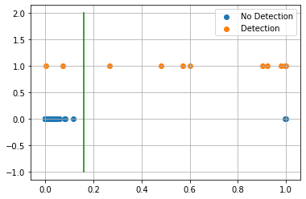

Test on detected 11 non-detected 118  
F0.5 81.82%  
  
Confusion Matrix:  
True Negative 98.31%  
False Positive 1.69%  
False Negative 18.18%  
True Positive 81.82%  
  
Classification Report  
 precision recall f1-score support  
  
 blank 0.983 0.983 0.983 118  
 detected 0.818 0.818 0.818 11  
  
 accuracy 0.969 129  
 macro avg 0.901 0.901 0.901 129  
weighted avg 0.969 0.969 0.969 129  
  
---------------------------end of testing--------------------------------  
  
Compound ID 10  
[0, 3, 4]

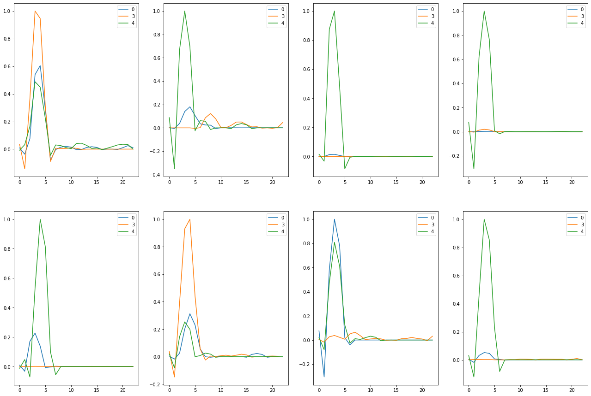

Train on detected 47 non-detected 465  
Train time in seconds: 7.085023641586304

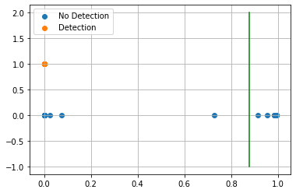

AUC 1.0  
Predicted TPR 1.0  
Predicted FPR 0.0  
Threshold 0.87702346  
-----------------------End of training---------------------------

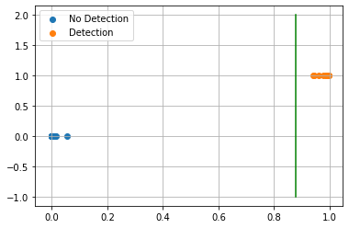

Test on detected 11 non-detected 118  
F0.5 100.00%  
  
Confusion Matrix:  
True Negative 100.00%  
False Positive 0.00%  
False Negative 0.00%  
True Positive 100.00%  
  
Classification Report  
 precision recall f1-score support  
  
 blank 1.000 1.000 1.000 118  
 detected 1.000 1.000 1.000 11  
  
 accuracy 1.000 129  
 macro avg 1.000 1.000 1.000 129  
weighted avg 1.000 1.000 1.000 129  
  
---------------------------end of testing--------------------------------  
  
Compound ID 13  
[41, 42]

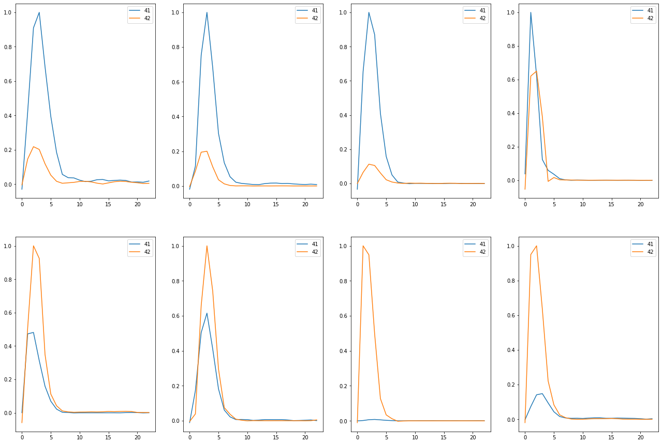

Train on detected 56 non-detected 456  
Train time in seconds: 6.6720616817474365

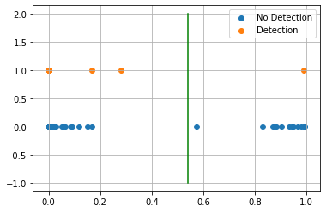

AUC 0.9855889724310778  
Predicted TPR 0.9821428571428571  
Predicted FPR 0.010964912280701754  
Threshold 0.5399887  
-----------------------End of training---------------------------

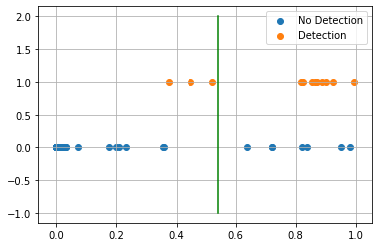

Test on detected 12 non-detected 117  
F0.5 59.21%  
  
Confusion Matrix:  
True Negative 94.02%  
False Positive 5.98%  
False Negative 25.00%  
True Positive 75.00%  
  
Classification Report  
 precision recall f1-score support  
  
 blank 0.973 0.940 0.957 117  
 detected 0.562 0.750 0.643 12  
  
 accuracy 0.922 129  
 macro avg 0.768 0.845 0.800 129  
weighted avg 0.935 0.922 0.927 129  
  
---------------------------end of testing--------------------------------  
  
Compound ID 14  
[16, 18]

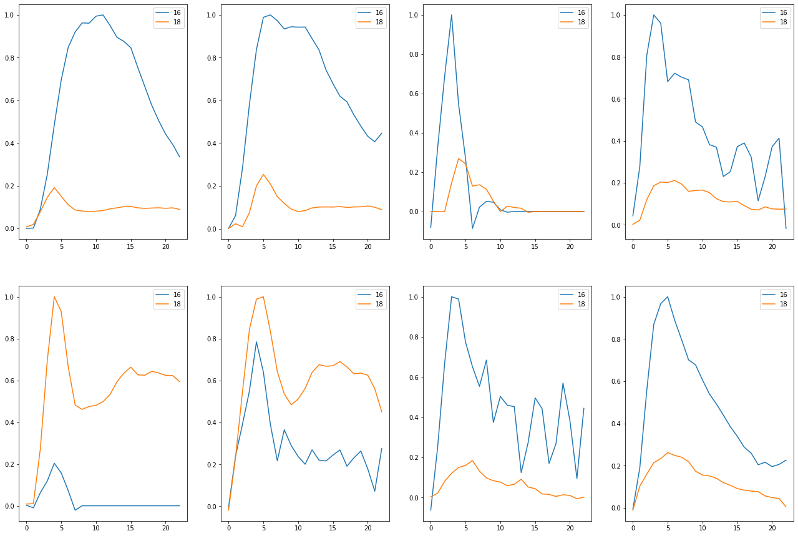

Train on detected 31 non-detected 481  
Train time in seconds: 6.687057018280029

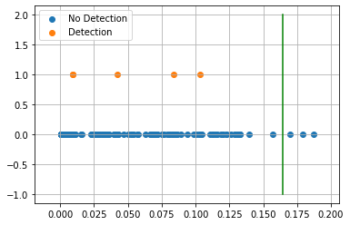

AUC 0.5562001207162497  
Predicted TPR 0.12903225806451613  
Predicted FPR 0.016632016632016633  
Threshold 0.16428208  
-----------------------End of training---------------------------

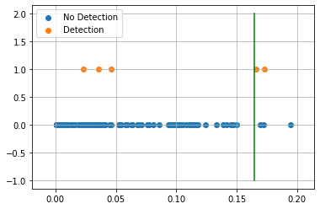

Test on detected 5 non-detected 124  
F0.5 40.00%  
  
Confusion Matrix:  
True Negative 97.58%  
False Positive 2.42%  
False Negative 60.00%  
True Positive 40.00%  
  
Classification Report  
 precision recall f1-score support  
  
 blank 0.976 0.976 0.976 124  
 detected 0.400 0.400 0.400 5  
  
 accuracy 0.953 129  
 macro avg 0.688 0.688 0.688 129  
weighted avg 0.953 0.953 0.953 129  
  
---------------------------end of testing--------------------------------  
  
Compound ID 15  
[36, 39]

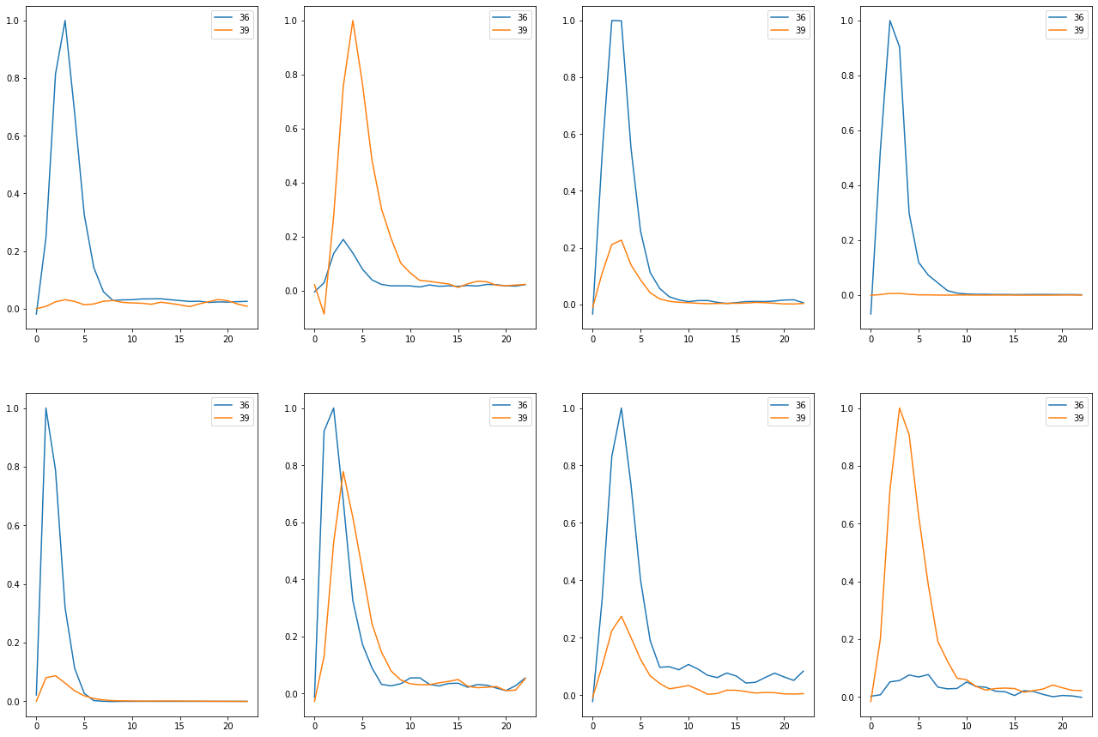

Train on detected 56 non-detected 456  
Train time in seconds: 7.711068630218506

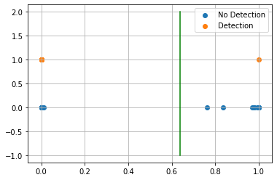

AUC 0.9989035087719299  
Predicted TPR 1.0  
Predicted FPR 0.0021929824561403508  
Threshold 0.63914704  
-----------------------End of training---------------------------

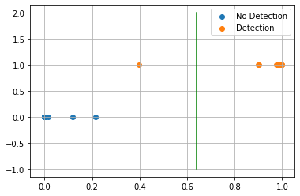

Test on detected 12 non-detected 117  
F0.5 98.21%  
  
Confusion Matrix:  
True Negative 100.00%  
False Positive 0.00%  
False Negative 8.33%  
True Positive 91.67%  
  
Classification Report  
 precision recall f1-score support  
  
 blank 0.992 1.000 0.996 117  
 detected 1.000 0.917 0.957 12  
  
 accuracy 0.992 129  
 macro avg 0.996 0.958 0.976 129  
weighted avg 0.992 0.992 0.992 129  
  
---------------------------end of testing--------------------------------  
  
Compound ID 18  
[21, 40]

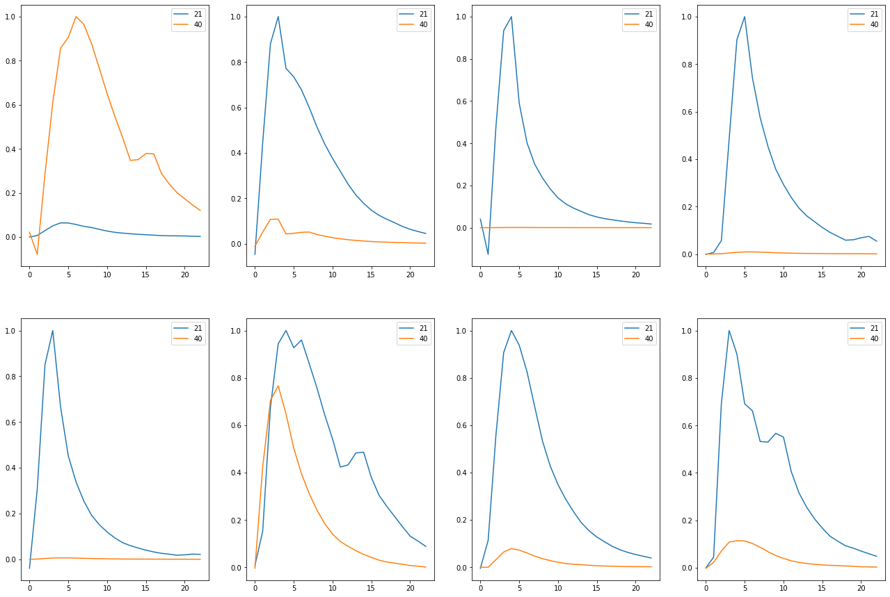

Train on detected 63 non-detected 449  
Train time in seconds: 9.194055318832397

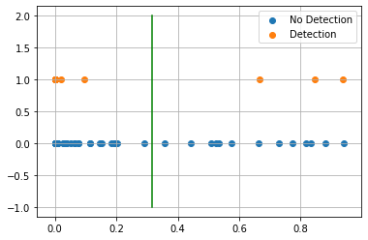

AUC 0.8720436949835613  
Predicted TPR 0.7619047619047619  
Predicted FPR 0.017817371937639197  
Threshold 0.3167883  
-----------------------End of training---------------------------

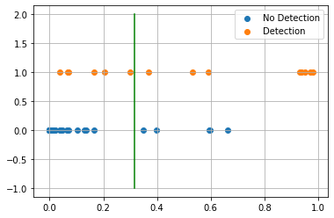

Test on detected 14 non-detected 115  
F0.5 60.61%  
  
Confusion Matrix:  
True Negative 95.65%  
False Positive 4.35%  
False Negative 42.86%  
True Positive 57.14%  
  
Classification Report  
 precision recall f1-score support  
  
 blank 0.948 0.957 0.952 115  
 detected 0.615 0.571 0.593 14  
  
 accuracy 0.915 129  
 macro avg 0.782 0.764 0.772 129  
weighted avg 0.912 0.915 0.913 129  
  
---------------------------end of testing--------------------------------  
  
Compound ID 21  
[33, 34]

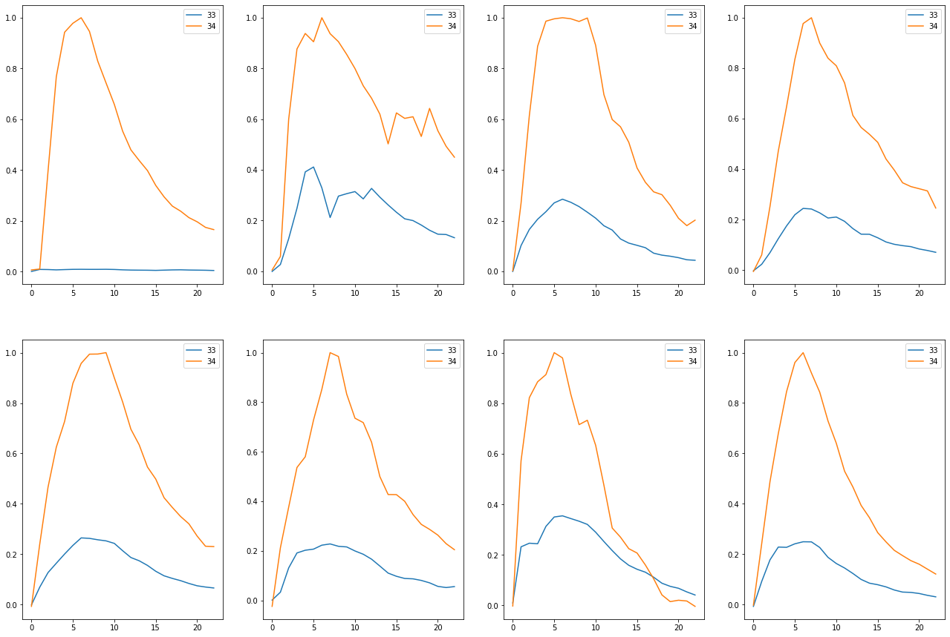

Train on detected 61 non-detected 451  
Train time in seconds: 9.041089057922363

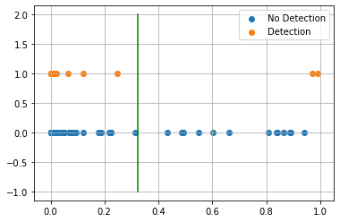

AUC 0.9102722547344699  
Predicted TPR 0.8360655737704918  
Predicted FPR 0.015521064301552107  
Threshold 0.32263407  
-----------------------End of training---------------------------

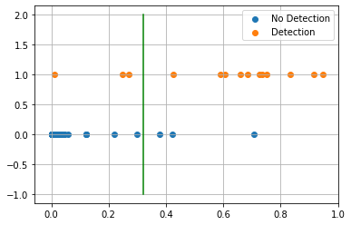

Test on detected 14 non-detected 115  
F0.5 78.57%  
  
Confusion Matrix:  
True Negative 97.39%  
False Positive 2.61%  
False Negative 21.43%  
True Positive 78.57%  
  
Classification Report  
 precision recall f1-score support  
  
 blank 0.974 0.974 0.974 115  
 detected 0.786 0.786 0.786 14  
  
 accuracy 0.953 129  
 macro avg 0.880 0.880 0.880 129  
weighted avg 0.953 0.953 0.953 129  
  
---------------------------end of testing--------------------------------  
  
Compound ID 22  
[35, 37, 38]



Train on detected 65 non-detected 447  
Train time in seconds: 7.279049634933472

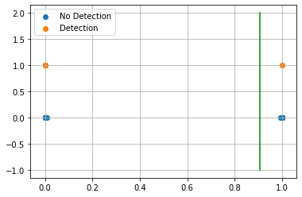

AUC 1.0  
Predicted TPR 1.0  
Predicted FPR 0.0  
Threshold 0.9065092  
-----------------------End of training---------------------------

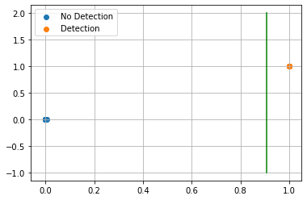

Test on detected 14 non-detected 115  
F0.5 100.00%  
  
Confusion Matrix:  
True Negative 100.00%  
False Positive 0.00%  
False Negative 0.00%  
True Positive 100.00%  
  
Classification Report  
 precision recall f1-score support  
  
 blank 1.000 1.000 1.000 115  
 detected 1.000 1.000 1.000 14  
  
 accuracy 1.000 129  
 macro avg 1.000 1.000 1.000 129  
weighted avg 1.000 1.000 1.000 129  
  
---------------------------end of testing--------------------------------

## Results

Compounds Tr-TPR Tr-FPR Threshold ROC AUC Score Test-TPR Test-FPR  
 0 90.16% 1.11% 62.86% 94.53% 85.71% 0.00%   
 3 93.75% 0.81% 35.64% 96.47% 100.00% 0.00%   
 4 98.36% 1.33% 19.52% 98.52% 85.71% 1.74%   
 8 93.62% 0.86% 16.07% 96.38% 81.82% 1.69%   
 10 100.00% 0.00% 87.70% 100.00% 100.00% 0.00%   
 13 98.21% 1.10% 54.00% 98.56% 75.00% 5.98%   
 14 12.90% 1.66% 16.43% 55.62% 40.00% 2.42%   
 15 100.00% 0.22% 63.91% 99.89% 91.67% 0.00%   
 18 76.19% 1.78% 31.68% 87.20% 57.14% 4.35%   
 21 83.61% 1.55% 32.26% 91.03% 78.57% 2.61%   
 22 100.00% 0.00% 90.65% 100.00% 100.00% 0.00%

Original  
 Compounds Tr-TPR Tr-FPR Threshold ROC AUC Score Test-TPR Test-FPR  
 0 95.08% 0.22% 23.65% 97.43% 92.86% 0.87%   
 3 93.75% 0.81% 5.35% 96.47% 100.00% 3.97%   
 4 100.00% 0.44% 55.87% 99.78% 85.71% 0.00%   
 7 100.00% 1.19% 8.86% 99.40% 0.00% 1.56%   
 8 38.30% 1.51% 28.88% 68.40% 27.27% 1.69%   
 10 72.34% 1.94% 7.07% 85.20% 54.55% 3.39%   
 13 60.71% 1.54% 62.28% 79.59% 25.00% 1.71%   
 14 38.71% 1.66% 27.67% 68.52% 40.00% 4.03%   
 15 98.21% 1.75% 4.16% 98.23% 91.67% 4.27%   
 18 92.06% 1.78% 63.36% 95.14% 57.14% 6.09%   
 19 0.00% 0.00% 100.00% 50.00% 0.00% 0.00%   
 21 96.72% 2.00% 13.49% 97.36% 92.86% 0.87%   
 22 100.00% 0.67% 0.04% 99.66% 100.00% 0.00%   
  
 Filtered  
 Compounds Tr-TPR Tr-FPR Threshold ROC AUC Score Test-TPR Test-FPR  
 0 95.08% 1.77% 15.14% 96.65% 92.86% 0.87%   
 3 93.75% 0.40% 4.26% 96.67% 100.00% 0.79%   
 4 96.72% 1.11% 1.47% 97.81% 78.57% 2.61%   
 7 100.00% 1.79% 15.97% 99.11% 0.00% 1.56%   
 8 61.70% 1.51% 37.70% 80.10% 27.27% 3.39%   
 10 95.74% 0.65% 13.21% 97.55% 72.73% 2.54%   
 13 100.00% 0.88% 36.57% 99.56% 83.33% 0.00%   
 14 35.48% 1.46% 16.94% 67.01% 20.00% 5.65%   
 15 94.64% 0.00% 2.84% 97.32% 91.67% 0.85%   
 18 76.19% 1.78% 27.57% 87.20% 57.14% 3.48%   
 19 0.00% 0.00% 100.00% 50.00% 0.00% 0.00%   
 21 95.08% 0.67% 50.97% 97.21% 92.86% 0.87%   
 22 100.00% 0.00% 87.79% 100.00% 100.00% 0.00%   
  
 No Filtering Adjusted  
 Compounds Tr-TPR Tr-FPR Threshold ROC AUC Score Test-TPR Test-FPR  
 0 93.44% 1.55% 2.44% 95.95% 78.57% 2.61%   
 3 93.75% 0.40% 41.39% 96.67% 100.00% 0.00%   
 4 100.00% 0.44% 38.52% 99.78% 85.71% 0.00%   
 8 63.83% 1.94% 28.37% 80.95% 54.55% 4.24%   
 10 100.00% 0.00% 86.57% 100.00% 100.00% 0.00%   
 13 98.21% 0.88% 58.66% 98.67% 83.33% 3.42%   
 14 22.58% 1.87% 16.00% 60.35% 40.00% 2.42%   
 15 100.00% 0.44% 93.78% 99.78% 83.33% 0.00%   
 18 84.13% 1.78% 41.21% 91.17% 64.29% 4.35%   
 21 80.33% 2.00% 51.31% 89.17% 85.71% 2.61%   
 22 100.00% 0.00% 98.79% 100.00% 100.00% 0.00%   
  
 Filtered Adjusted  
 Compounds Tr-TPR Tr-FPR Threshold ROC AUC Score Test-TPR Test-FPR  
 0 90.16% 1.11% 62.86% 94.53% 85.71% 0.00%   
 3 93.75% 0.81% 35.64% 96.47% 100.00% 0.00%   
 4 98.36% 1.33% 19.52% 98.52% 85.71% 1.74%   
 8 93.62% 0.86% 16.07% 96.38% 81.82% 1.69%   
 10 100.00% 0.00% 87.70% 100.00% 100.00% 0.00%   
 13 98.21% 1.10% 54.00% 98.56% 75.00% 5.98%   
 14 12.90% 1.66% 16.43% 55.62% 40.00% 2.42%   
 15 100.00% 0.22% 63.91% 99.89% 91.67% 0.00%   
 18 76.19% 1.78% 31.68% 87.20% 57.14% 4.35%   
 21 83.61% 1.55% 32.26% 91.03% 78.57% 2.61%   
 22 100.00% 0.00% 90.65% 100.00% 100.00% 0.00%

## Final Model Finding

Compound ID 0  
Original  
[22, 23, 25, 26, 33, 34]



Train on detected 61 non-detected 451  
Train time in seconds: 6.836056470870972

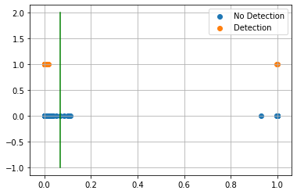

AUC 0.9736287303260515  
Predicted TPR 0.9672131147540983  
Predicted FPR 0.019955654101995565  
Threshold 0.06851929426193237  
-----------------------End of training---------------------------

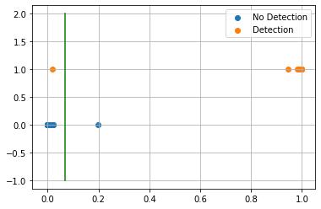

Test on detected 14 non-detected 115  
F0.5 92.86%  
  
Confusion Matrix:  
True Negative 99.13%  
False Positive 0.87%  
False Negative 7.14%  
True Positive 92.86%  
  
Classification Report  
 precision recall f1-score support  
  
 blank 0.991 0.991 0.991 115  
 detected 0.929 0.929 0.929 14  
  
 accuracy 0.984 129  
 macro avg 0.960 0.960 0.960 129  
weighted avg 0.984 0.984 0.984 129  
  
---------------------------end of testing--------------------------------  
  
Compound ID 3  
Non-filtered Adjusted  
[47, 49, 50]



Train on detected 16 non-detected 496  
Train time in seconds: 7.77804708480835

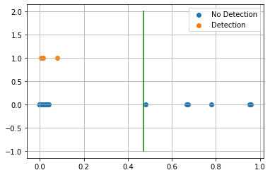

AUC 0.9627016129032258  
Predicted TPR 0.9375  
Predicted FPR 0.012096774193548387  
Threshold 0.46942374110221863  
-----------------------End of training---------------------------

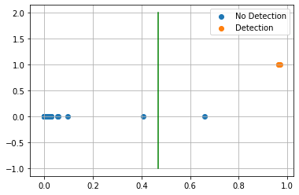

Test on detected 3 non-detected 126  
F0.5 78.95%  
  
Confusion Matrix:  
True Negative 99.21%  
False Positive 0.79%  
False Negative 0.00%  
True Positive 100.00%  
  
Classification Report  
 precision recall f1-score support  
  
 blank 1.000 0.992 0.996 126  
 detected 0.750 1.000 0.857 3  
  
 accuracy 0.992 129  
 macro avg 0.875 0.996 0.927 129  
weighted avg 0.994 0.992 0.993 129  
  
---------------------------end of testing--------------------------------  
  
Compound ID 4  
Non-filtered Adjusted  
[2, 11]



Train on detected 61 non-detected 451  
Train time in seconds: 7.670090198516846

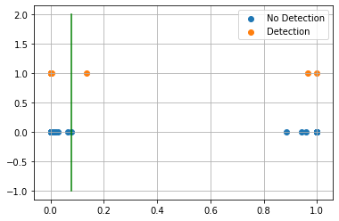

AUC 0.9944567627494456  
Predicted TPR 1.0  
Predicted FPR 0.011086474501108648  
Threshold 0.07728809118270874  
-----------------------End of training---------------------------

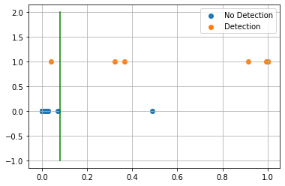

Test on detected 14 non-detected 115  
F0.5 92.86%  
  
Confusion Matrix:  
True Negative 99.13%  
False Positive 0.87%  
False Negative 7.14%  
True Positive 92.86%  
  
Classification Report  
 precision recall f1-score support  
  
 blank 0.991 0.991 0.991 115  
 detected 0.929 0.929 0.929 14  
  
 accuracy 0.984 129  
 macro avg 0.960 0.960 0.960 129  
weighted avg 0.984 0.984 0.984 129  
  
---------------------------end of testing--------------------------------  
  
Compound ID 7  
Original  
[16, 18, 27, 30, 46]



Train on detected 8 non-detected 504  
Train time in seconds: 7.605040073394775

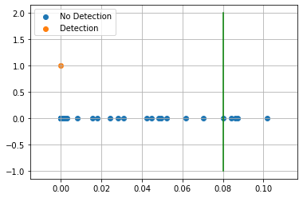

AUC 0.9930555555555556  
Predicted TPR 1.0  
Predicted FPR 0.013888888888888888  
Threshold 0.07999655604362488  
-----------------------End of training---------------------------

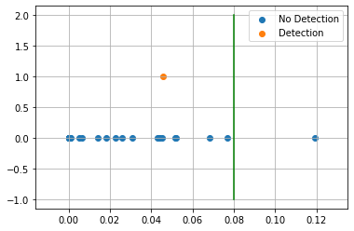

Test on detected 1 non-detected 128  
F0.5 0.00%  
  
Confusion Matrix:  
True Negative 99.22%  
False Positive 0.78%  
False Negative 100.00%  
True Positive 0.00%  
  
Classification Report  
 precision recall f1-score support  
  
 blank 0.992 0.992 0.992 128  
 detected 0.000 0.000 0.000 1  
  
 accuracy 0.984 129  
 macro avg 0.496 0.496 0.496 129  
weighted avg 0.984 0.984 0.984 129  
  
---------------------------end of testing--------------------------------  
  
Compound ID 8  
Filtered Adjusted  
[36, 39, 46]



Train on detected 47 non-detected 465  
Train time in seconds: 6.968081951141357

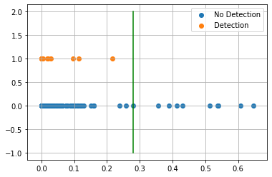

AUC 0.812697323266987  
Predicted TPR 0.6382978723404256  
Predicted FPR 0.012903225806451613  
Threshold 0.28015256  
-----------------------End of training---------------------------

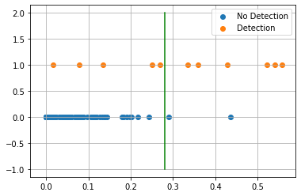

Test on detected 11 non-detected 118  
F0.5 69.77%  
  
Confusion Matrix:  
True Negative 98.31%  
False Positive 1.69%  
False Negative 45.45%  
True Positive 54.55%  
  
Classification Report  
 precision recall f1-score support  
  
 blank 0.959 0.983 0.971 118  
 detected 0.750 0.545 0.632 11  
  
 accuracy 0.946 129  
 macro avg 0.854 0.764 0.801 129  
weighted avg 0.941 0.946 0.942 129  
  
---------------------------end of testing--------------------------------  
  
Compound ID 10  
Filtered Adjusted  
[0, 3, 4]



Train on detected 47 non-detected 465  
Train time in seconds: 7.583083629608154

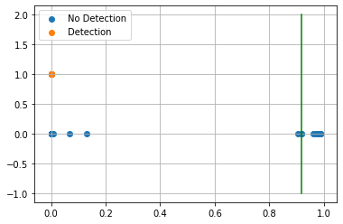

AUC 1.0  
Predicted TPR 1.0  
Predicted FPR 0.0  
Threshold 0.91865396  
-----------------------End of training---------------------------

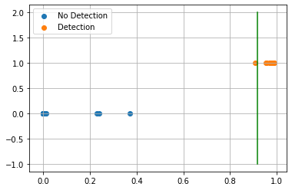

Test on detected 11 non-detected 118  
F0.5 98.04%  
  
Confusion Matrix:  
True Negative 100.00%  
False Positive 0.00%  
False Negative 9.09%  
True Positive 90.91%  
  
Classification Report  
 precision recall f1-score support  
  
 blank 0.992 1.000 0.996 118  
 detected 1.000 0.909 0.952 11  
  
 accuracy 0.992 129  
 macro avg 0.996 0.955 0.974 129  
weighted avg 0.992 0.992 0.992 129  
  
---------------------------end of testing--------------------------------  
  
Compound ID 13  
Filtered  
[41, 42, 46]



Train on detected 56 non-detected 456  
Train time in seconds: 11.802071809768677

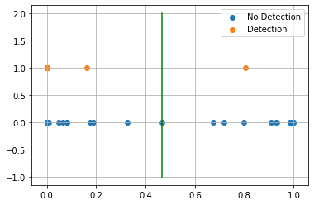

AUC 0.9956140350877193  
Predicted TPR 1.0  
Predicted FPR 0.008771929824561403  
Threshold 0.46767944  
-----------------------End of training---------------------------

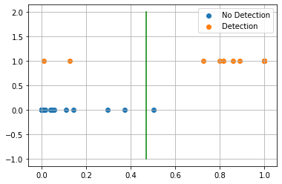

Test on detected 12 non-detected 117  
F0.5 89.29%  
  
Confusion Matrix:  
True Negative 99.15%  
False Positive 0.85%  
False Negative 16.67%  
True Positive 83.33%  
  
Classification Report  
 precision recall f1-score support  
  
 blank 0.983 0.991 0.987 117  
 detected 0.909 0.833 0.870 12  
  
 accuracy 0.977 129  
 macro avg 0.946 0.912 0.928 129  
weighted avg 0.976 0.977 0.976 129  
  
---------------------------end of testing--------------------------------  
  
Compound ID 14  
Original  
[16, 18, 46]



Train on detected 31 non-detected 481  
Train time in seconds: 7.520036458969116

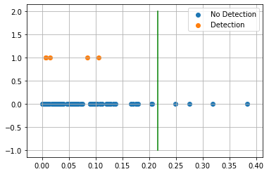

AUC 0.7003219099993294  
Predicted TPR 0.41935483870967744  
Predicted FPR 0.018711018711018712  
Threshold 0.21624070405960083  
-----------------------End of training---------------------------

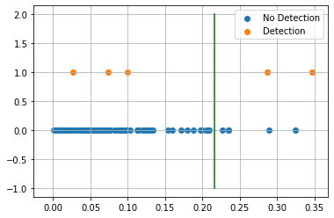

Test on detected 5 non-detected 124  
F0.5 30.30%  
  
Confusion Matrix:  
True Negative 95.97%  
False Positive 4.03%  
False Negative 60.00%  
True Positive 40.00%  
  
Classification Report  
 precision recall f1-score support  
  
 blank 0.975 0.960 0.967 124  
 detected 0.286 0.400 0.333 5  
  
 accuracy 0.938 129  
 macro avg 0.631 0.680 0.650 129  
weighted avg 0.949 0.938 0.943 129  
  
---------------------------end of testing--------------------------------  
  
Compound ID 15  
Filtered Adjusted  
[36, 39]



Train on detected 56 non-detected 456  
Train time in seconds: 9.054047584533691

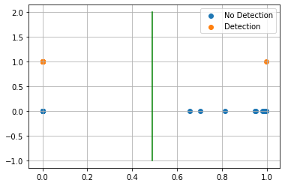

AUC 1.0  
Predicted TPR 1.0  
Predicted FPR 0.0  
Threshold 0.48917475  
-----------------------End of training---------------------------

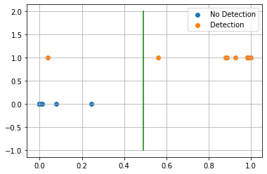

Test on detected 12 non-detected 117  
F0.5 98.21%  
  
Confusion Matrix:  
True Negative 100.00%  
False Positive 0.00%  
False Negative 8.33%  
True Positive 91.67%  
  
Classification Report  
 precision recall f1-score support  
  
 blank 0.992 1.000 0.996 117  
 detected 1.000 0.917 0.957 12  
  
 accuracy 0.992 129  
 macro avg 0.996 0.958 0.976 129  
weighted avg 0.992 0.992 0.992 129  
  
---------------------------end of testing--------------------------------  
  
Compound ID 18  
Original  
[19, 20, 21, 40]



Train on detected 63 non-detected 449  
Train time in seconds: 8.938030481338501

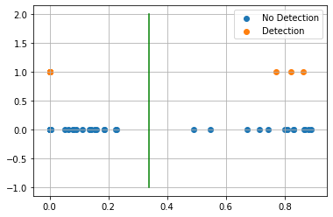

AUC 0.9128398204122036  
Predicted TPR 0.8412698412698413  
Predicted FPR 0.015590200445434299  
Threshold 0.33725079894065857  
-----------------------End of training---------------------------

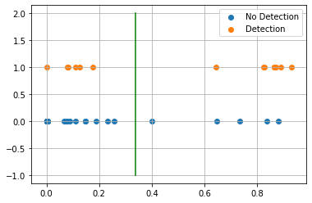

Test on detected 14 non-detected 115  
F0.5 60.61%  
  
Confusion Matrix:  
True Negative 95.65%  
False Positive 4.35%  
False Negative 42.86%  
True Positive 57.14%  
  
Classification Report  
 precision recall f1-score support  
  
 blank 0.948 0.957 0.952 115  
 detected 0.615 0.571 0.593 14  
  
 accuracy 0.915 129  
 macro avg 0.782 0.764 0.772 129  
weighted avg 0.912 0.915 0.913 129  
  
---------------------------end of testing--------------------------------  
  
Compound ID 19  
Filtered  
[7, 8]



Train on detected 3 non-detected 509  
Train time in seconds: 7.6830761432647705

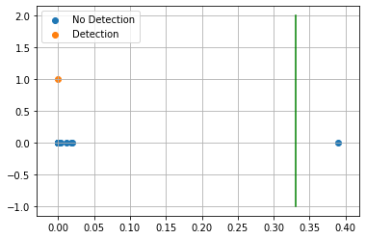

AUC 1.0  
Predicted TPR 1.0  
Predicted FPR 0.0  
Threshold 0.3305719  
-----------------------End of training---------------------------

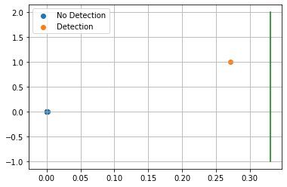

Test on detected 1 non-detected 128  
F0.5 0.00%  
  
Confusion Matrix:  
True Negative 100.00%  
False Positive 0.00%  
False Negative 100.00%  
True Positive 0.00%  
  
Classification Report  
 precision recall f1-score support  
  
 blank 0.992 1.000 0.996 128  
 detected 0.000 0.000 0.000 1  
  
 accuracy 0.992 129  
 macro avg 0.496 0.500 0.498 129  
weighted avg 0.985 0.992 0.988 129  
  
---------------------------end of testing--------------------------------  
  
Compound ID 21  
Original  
[22, 23, 25, 26, 33, 34]

C:\Users\Brian.Mello\AppData\Local\Continuum\anaconda3\lib\site-packages\sklearn\metrics\classification.py:1437: UndefinedMetricWarning: F-score is ill-defined and being set to 0.0 due to no predicted samples.  
 'precision', 'predicted', average, warn_for)  
C:\Users\Brian.Mello\AppData\Local\Continuum\anaconda3\lib\site-packages\sklearn\metrics\classification.py:1437: UndefinedMetricWarning: Precision and F-score are ill-defined and being set to 0.0 in labels with no predicted samples.  
 'precision', 'predicted', average, warn_for)  
C:\Users\Brian.Mello\AppData\Local\Continuum\anaconda3\lib\site-packages\sklearn\metrics\classification.py:1437: UndefinedMetricWarning: Precision and F-score are ill-defined and being set to 0.0 in labels with no predicted samples.  
 'precision', 'predicted', average, warn_for)  
C:\Users\Brian.Mello\AppData\Local\Continuum\anaconda3\lib\site-packages\sklearn\metrics\classification.py:1437: UndefinedMetricWarning: Precision and F-score are ill-defined and being set to 0.0 in labels with no predicted samples.  
 'precision', 'predicted', average, warn_for)



Train on detected 61 non-detected 451  
Train time in seconds: 8.773017644882202

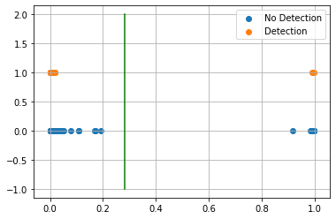

AUC 0.9743011886154629  
Predicted TPR 0.9508196721311475  
Predicted FPR 0.0022172949002217295  
Threshold 0.28069868683815  
-----------------------End of training---------------------------

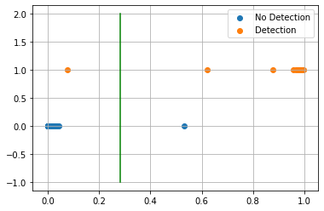

Test on detected 14 non-detected 115  
F0.5 92.86%  
  
Confusion Matrix:  
True Negative 99.13%  
False Positive 0.87%  
False Negative 7.14%  
True Positive 92.86%  
  
Classification Report  
 precision recall f1-score support  
  
 blank 0.991 0.991 0.991 115  
 detected 0.929 0.929 0.929 14  
  
 accuracy 0.984 129  
 macro avg 0.960 0.960 0.960 129  
weighted avg 0.984 0.984 0.984 129  
  
---------------------------end of testing--------------------------------  
  
Compound ID 22  
Filtered Adjusted  
[35, 37, 38]



Train on detected 65 non-detected 447  
Train time in seconds: 8.329045057296753

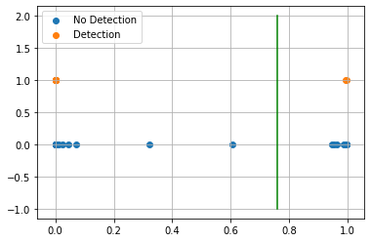

AUC 1.0  
Predicted TPR 1.0  
Predicted FPR 0.0  
Threshold 0.75910807  
-----------------------End of training---------------------------

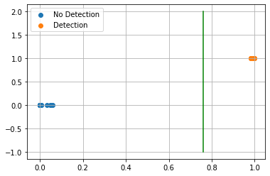

Test on detected 14 non-detected 115  
F0.5 100.00%  
  
Confusion Matrix:  
True Negative 100.00%  
False Positive 0.00%  
False Negative 0.00%  
True Positive 100.00%  
  
Classification Report  
 precision recall f1-score support  
  
 blank 1.000 1.000 1.000 115  
 detected 1.000 1.000 1.000 14  
  
 accuracy 1.000 129  
 macro avg 1.000 1.000 1.000 129  
weighted avg 1.000 1.000 1.000 129  
  
---------------------------end of testing--------------------------------

## Final Model Results

Comp. TPR FPR Thresh. ROC Score Test-TPR Test-FPR Type   
 0 96.72% 2.00% 6.85% 97.36% 92.86% 0.87% Orig.  
 3 93.75% 1.21% 46.94% 96.27% 100.00% 0.79% Non-fil. Adj.  
 4 100.00% 1.11% 7.73% 99.45% 92.86% 0.87% Non-fil. Adj.  
 7 100.00% 1.39% 8.00% 99.31% 0.00% 0.78% Orig.  
 8 63.83% 1.29% 28.02% 81.27% 54.55% 1.69% Filt. Adj.  
 10 100.00% 0.00% 91.87% 100.00% 90.91% 0.00% Filt. Adj.  
 13 100.00% 0.88% 46.77% 99.56% 83.33% 0.85% Fil.  
 14 41.94% 1.87% 21.62% 70.03% 40.00% 4.03% Orig.  
 15 100.00% 0.00% 48.92% 100.00% 91.67% 0.00% Filt. Adj.  
 18 84.13% 1.56% 33.73% 91.28% 57.14% 4.35% Orig.  
 19 100.00% 0.00% 33.06% 100.00% 0.00% 0.00% Fil.  
 21 95.08% 0.22% 28.07% 97.43% 92.86% 0.87% Orig.  
 22 100.00% 0.00% 75.91% 100.00% 100.00% 0.00% Filt. Adj.

# Results¶

Model Evaluation and Validation¶

Compound ID 0  
[22, 23, 25, 26, 33, 34]

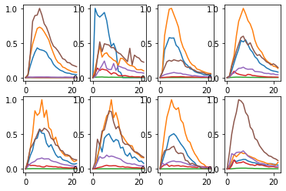

Train on detected 61 non-detected 451  
Train time in seconds: 9.401053428649902

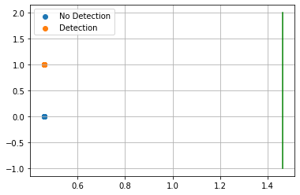

AUC 0.5  
Predicted TPR 0.0  
Predicted FPR 0.0  
Threshold 1.4624586  
-----------------------End of training---------------------------



Test on detected 14 non-detected 115  
F0.5 0.00%  
  
Confusion Matrix:  
True Negative 100.00%  
False Positive 0.00%  
False Negative 100.00%  
True Positive 0.00%  
  
Classification Report  
 precision recall f1-score support  
  
 blank 0.891 1.000 0.943 115  
 detected 0.000 0.000 0.000 14  
  
 accuracy 0.891 129  
 macro avg 0.446 0.500 0.471 129  
weighted avg 0.795 0.891 0.840 129  
  
---------------------------end of testing--------------------------------  
  
Compound ID 3

C:\Users\Brian.Mello\AppData\Local\Continuum\anaconda3\lib\site-packages\sklearn\metrics\classification.py:1437: UndefinedMetricWarning: F-score is ill-defined and being set to 0.0 due to no predicted samples.  
 'precision', 'predicted', average, warn_for)  
C:\Users\Brian.Mello\AppData\Local\Continuum\anaconda3\lib\site-packages\sklearn\metrics\classification.py:1437: UndefinedMetricWarning: Precision and F-score are ill-defined and being set to 0.0 in labels with no predicted samples.  
 'precision', 'predicted', average, warn_for)  
C:\Users\Brian.Mello\AppData\Local\Continuum\anaconda3\lib\site-packages\sklearn\metrics\classification.py:1437: UndefinedMetricWarning: Precision and F-score are ill-defined and being set to 0.0 in labels with no predicted samples.  
 'precision', 'predicted', average, warn_for)  
C:\Users\Brian.Mello\AppData\Local\Continuum\anaconda3\lib\site-packages\sklearn\metrics\classification.py:1437: UndefinedMetricWarning: Precision and F-score are ill-defined and being set to 0.0 in labels with no predicted samples.  
 'precision', 'predicted', average, warn_for)

[20, 47, 49, 50]

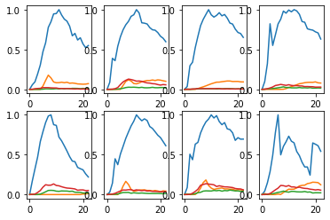

Train on detected 16 non-detected 496  
Train time in seconds: 10.241057395935059

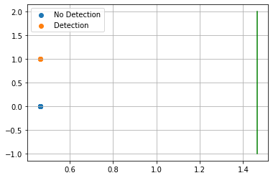

AUC 0.5  
Predicted TPR 0.0  
Predicted FPR 0.0  
Threshold 1.4649795  
-----------------------End of training---------------------------



Test on detected 3 non-detected 126  
F0.5 0.00%  
  
Confusion Matrix:  
True Negative 100.00%  
False Positive 0.00%  
False Negative 100.00%  
True Positive 0.00%  
  
Classification Report  
 precision recall f1-score support  
  
 blank 0.977 1.000 0.988 126  
 detected 0.000 0.000 0.000 3  
  
 accuracy 0.977 129  
 macro avg 0.488 0.500 0.494 129  
weighted avg 0.954 0.977 0.965 129  
  
---------------------------end of testing--------------------------------  
  
Compound ID 4

C:\Users\Brian.Mello\AppData\Local\Continuum\anaconda3\lib\site-packages\sklearn\metrics\classification.py:1437: UndefinedMetricWarning: F-score is ill-defined and being set to 0.0 due to no predicted samples.  
 'precision', 'predicted', average, warn_for)  
C:\Users\Brian.Mello\AppData\Local\Continuum\anaconda3\lib\site-packages\sklearn\metrics\classification.py:1437: UndefinedMetricWarning: Precision and F-score are ill-defined and being set to 0.0 in labels with no predicted samples.  
 'precision', 'predicted', average, warn_for)  
C:\Users\Brian.Mello\AppData\Local\Continuum\anaconda3\lib\site-packages\sklearn\metrics\classification.py:1437: UndefinedMetricWarning: Precision and F-score are ill-defined and being set to 0.0 in labels with no predicted samples.  
 'precision', 'predicted', average, warn_for)  
C:\Users\Brian.Mello\AppData\Local\Continuum\anaconda3\lib\site-packages\sklearn\metrics\classification.py:1437: UndefinedMetricWarning: Precision and F-score are ill-defined and being set to 0.0 in labels with no predicted samples.  
 'precision', 'predicted', average, warn_for)

[2, 11]

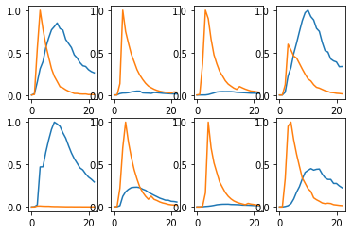

Train on detected 61 non-detected 451  
Train time in seconds: 10.835213899612427

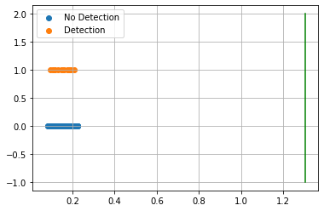

AUC 0.5  
Predicted TPR 0.0  
Predicted FPR 0.0  
Threshold 1.304296  
-----------------------End of training---------------------------

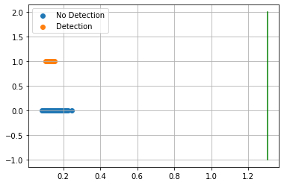

Test on detected 14 non-detected 115  
F0.5 0.00%  
  
Confusion Matrix:  
True Negative 100.00%  
False Positive 0.00%  
False Negative 100.00%  
True Positive 0.00%  
  
Classification Report  
 precision recall f1-score support  
  
 blank 0.891 1.000 0.943 115  
 detected 0.000 0.000 0.000 14  
  
 accuracy 0.891 129  
 macro avg 0.446 0.500 0.471 129  
weighted avg 0.795 0.891 0.840 129  
  
---------------------------end of testing--------------------------------  
  
Compound ID 7

C:\Users\Brian.Mello\AppData\Local\Continuum\anaconda3\lib\site-packages\sklearn\metrics\classification.py:1437: UndefinedMetricWarning: F-score is ill-defined and being set to 0.0 due to no predicted samples.  
 'precision', 'predicted', average, warn_for)  
C:\Users\Brian.Mello\AppData\Local\Continuum\anaconda3\lib\site-packages\sklearn\metrics\classification.py:1437: UndefinedMetricWarning: Precision and F-score are ill-defined and being set to 0.0 in labels with no predicted samples.  
 'precision', 'predicted', average, warn_for)  
C:\Users\Brian.Mello\AppData\Local\Continuum\anaconda3\lib\site-packages\sklearn\metrics\classification.py:1437: UndefinedMetricWarning: Precision and F-score are ill-defined and being set to 0.0 in labels with no predicted samples.  
 'precision', 'predicted', average, warn_for)  
C:\Users\Brian.Mello\AppData\Local\Continuum\anaconda3\lib\site-packages\sklearn\metrics\classification.py:1437: UndefinedMetricWarning: Precision and F-score are ill-defined and being set to 0.0 in labels with no predicted samples.  
 'precision', 'predicted', average, warn_for)

[16, 18, 27, 30, 46]

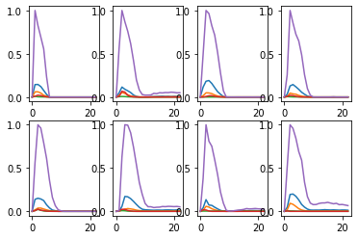

Train on detected 8 non-detected 504  
Train time in seconds: 11.032029151916504

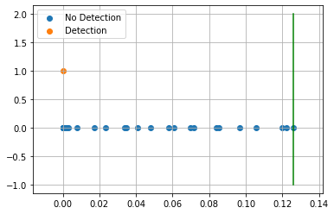

AUC 0.9970238095238095  
Predicted TPR 1.0  
Predicted FPR 0.005952380952380952  
Threshold 0.12606335  
-----------------------End of training---------------------------

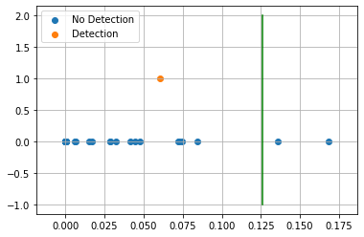

Test on detected 1 non-detected 128  
F0.5 0.00%  
  
Confusion Matrix:  
True Negative 98.44%  
False Positive 1.56%  
False Negative 100.00%  
True Positive 0.00%  
  
Classification Report  
 precision recall f1-score support  
  
 blank 0.992 0.984 0.988 128  
 detected 0.000 0.000 0.000 1  
  
 accuracy 0.977 129  
 macro avg 0.496 0.492 0.494 129  
weighted avg 0.984 0.977 0.981 129  
  
---------------------------end of testing--------------------------------  
  
Compound ID 8  
[16, 18, 39, 46]

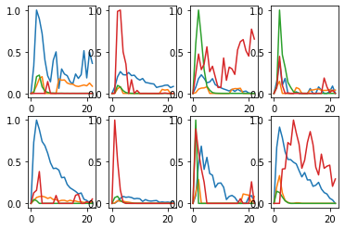

Train on detected 47 non-detected 465  
Train time in seconds: 9.94102430343628

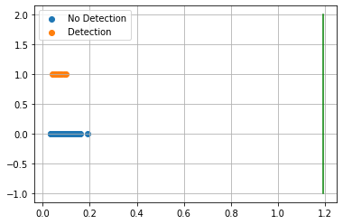

AUC 0.5  
Predicted TPR 0.0  
Predicted FPR 0.0  
Threshold 1.1920657  
-----------------------End of training---------------------------

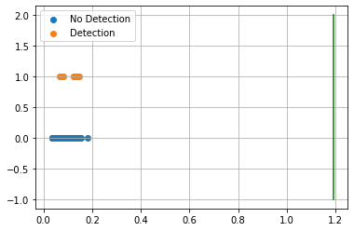

Test on detected 11 non-detected 118  
F0.5 0.00%  
  
Confusion Matrix:  
True Negative 100.00%  
False Positive 0.00%  
False Negative 100.00%  
True Positive 0.00%  
  
Classification Report  
 precision recall f1-score support  
  
 blank 0.915 1.000 0.955 118  
 detected 0.000 0.000 0.000 11  
  
 accuracy 0.915 129  
 macro avg 0.457 0.500 0.478 129  
weighted avg 0.837 0.915 0.874 129  
  
---------------------------end of testing--------------------------------  
  
Compound ID 10

C:\Users\Brian.Mello\AppData\Local\Continuum\anaconda3\lib\site-packages\sklearn\metrics\classification.py:1437: UndefinedMetricWarning: F-score is ill-defined and being set to 0.0 due to no predicted samples.  
 'precision', 'predicted', average, warn_for)  
C:\Users\Brian.Mello\AppData\Local\Continuum\anaconda3\lib\site-packages\sklearn\metrics\classification.py:1437: UndefinedMetricWarning: Precision and F-score are ill-defined and being set to 0.0 in labels with no predicted samples.  
 'precision', 'predicted', average, warn_for)  
C:\Users\Brian.Mello\AppData\Local\Continuum\anaconda3\lib\site-packages\sklearn\metrics\classification.py:1437: UndefinedMetricWarning: Precision and F-score are ill-defined and being set to 0.0 in labels with no predicted samples.  
 'precision', 'predicted', average, warn_for)  
C:\Users\Brian.Mello\AppData\Local\Continuum\anaconda3\lib\site-packages\sklearn\metrics\classification.py:1437: UndefinedMetricWarning: Precision and F-score are ill-defined and being set to 0.0 in labels with no predicted samples.  
 'precision', 'predicted', average, warn_for)

[0, 3, 4, 19, 20, 22, 23]

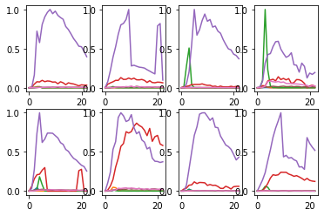

Train on detected 47 non-detected 465  
Train time in seconds: 10.10304856300354

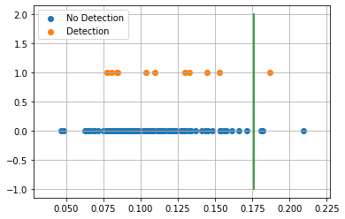

AUC 0.5031114161519102  
Predicted TPR 0.02127659574468085  
Predicted FPR 0.015053763440860216  
Threshold 0.17622095  
-----------------------End of training---------------------------

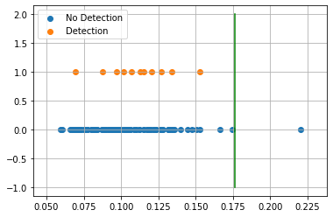

Test on detected 11 non-detected 118  
F0.5 0.00%  
  
Confusion Matrix:  
True Negative 99.15%  
False Positive 0.85%  
False Negative 100.00%  
True Positive 0.00%  
  
Classification Report  
 precision recall f1-score support  
  
 blank 0.914 0.992 0.951 118  
 detected 0.000 0.000 0.000 11  
  
 accuracy 0.907 129  
 macro avg 0.457 0.496 0.476 129  
weighted avg 0.836 0.907 0.870 129  
  
---------------------------end of testing--------------------------------  
  
Compound ID 13  
[41, 42, 46]

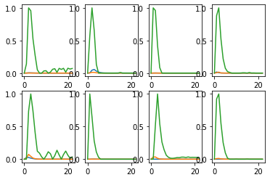

Train on detected 56 non-detected 456  
Train time in seconds: 11.8350989818573

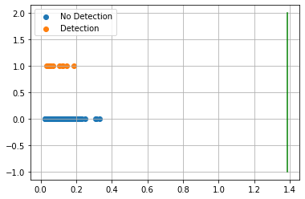

AUC 0.5  
Predicted TPR 0.0  
Predicted FPR 0.0  
Threshold 1.3859324  
-----------------------End of training---------------------------

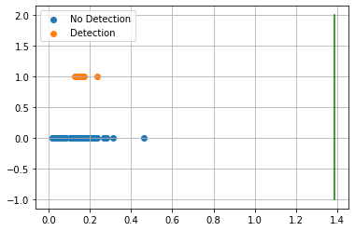

Test on detected 12 non-detected 117  
F0.5 0.00%  
  
Confusion Matrix:  
True Negative 100.00%  
False Positive 0.00%  
False Negative 100.00%  
True Positive 0.00%  
  
Classification Report  
 precision recall f1-score support  
  
 blank 0.907 1.000 0.951 117  
 detected 0.000 0.000 0.000 12  
  
 accuracy 0.907 129  
 macro avg 0.453 0.500 0.476 129  
weighted avg 0.823 0.907 0.863 129  
  
---------------------------end of testing--------------------------------  
  
Compound ID 14

C:\Users\Brian.Mello\AppData\Local\Continuum\anaconda3\lib\site-packages\sklearn\metrics\classification.py:1437: UndefinedMetricWarning: F-score is ill-defined and being set to 0.0 due to no predicted samples.  
 'precision', 'predicted', average, warn_for)  
C:\Users\Brian.Mello\AppData\Local\Continuum\anaconda3\lib\site-packages\sklearn\metrics\classification.py:1437: UndefinedMetricWarning: Precision and F-score are ill-defined and being set to 0.0 in labels with no predicted samples.  
 'precision', 'predicted', average, warn_for)  
C:\Users\Brian.Mello\AppData\Local\Continuum\anaconda3\lib\site-packages\sklearn\metrics\classification.py:1437: UndefinedMetricWarning: Precision and F-score are ill-defined and being set to 0.0 in labels with no predicted samples.  
 'precision', 'predicted', average, warn_for)  
C:\Users\Brian.Mello\AppData\Local\Continuum\anaconda3\lib\site-packages\sklearn\metrics\classification.py:1437: UndefinedMetricWarning: Precision and F-score are ill-defined and being set to 0.0 in labels with no predicted samples.  
 'precision', 'predicted', average, warn_for)

[16, 18, 46]

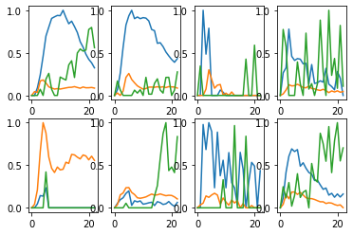

Train on detected 31 non-detected 481  
Train time in seconds: 11.064030408859253

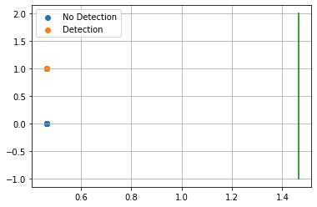

AUC 0.5  
Predicted TPR 0.0  
Predicted FPR 0.0  
Threshold 1.4649612  
-----------------------End of training---------------------------



Test on detected 5 non-detected 124  
F0.5 0.00%  
  
Confusion Matrix:  
True Negative 100.00%  
False Positive 0.00%  
False Negative 100.00%  
True Positive 0.00%  
  
Classification Report  
 precision recall f1-score support  
  
 blank 0.961 1.000 0.980 124  
 detected 0.000 0.000 0.000 5  
  
 accuracy 0.961 129  
 macro avg 0.481 0.500 0.490 129  
weighted avg 0.924 0.961 0.942 129  
  
---------------------------end of testing--------------------------------  
  
Compound ID 15

C:\Users\Brian.Mello\AppData\Local\Continuum\anaconda3\lib\site-packages\sklearn\metrics\classification.py:1437: UndefinedMetricWarning: F-score is ill-defined and being set to 0.0 due to no predicted samples.  
 'precision', 'predicted', average, warn_for)  
C:\Users\Brian.Mello\AppData\Local\Continuum\anaconda3\lib\site-packages\sklearn\metrics\classification.py:1437: UndefinedMetricWarning: Precision and F-score are ill-defined and being set to 0.0 in labels with no predicted samples.  
 'precision', 'predicted', average, warn_for)  
C:\Users\Brian.Mello\AppData\Local\Continuum\anaconda3\lib\site-packages\sklearn\metrics\classification.py:1437: UndefinedMetricWarning: Precision and F-score are ill-defined and being set to 0.0 in labels with no predicted samples.  
 'precision', 'predicted', average, warn_for)  
C:\Users\Brian.Mello\AppData\Local\Continuum\anaconda3\lib\site-packages\sklearn\metrics\classification.py:1437: UndefinedMetricWarning: Precision and F-score are ill-defined and being set to 0.0 in labels with no predicted samples.  
 'precision', 'predicted', average, warn_for)

[36, 39, 46]

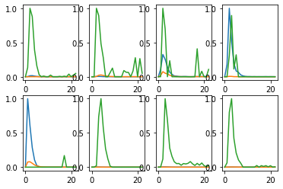

Train on detected 56 non-detected 456  
Train time in seconds: 10.644097566604614

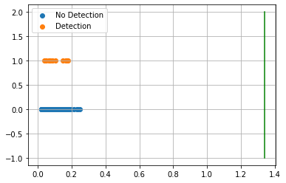

AUC 0.5  
Predicted TPR 0.0  
Predicted FPR 0.0  
Threshold 1.3389517  
-----------------------End of training---------------------------

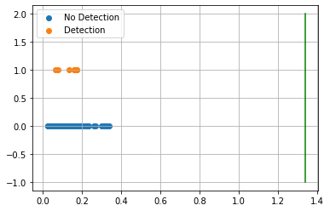

Test on detected 12 non-detected 117  
F0.5 0.00%  
  
Confusion Matrix:  
True Negative 100.00%  
False Positive 0.00%  
False Negative 100.00%  
True Positive 0.00%  
  
Classification Report  
 precision recall f1-score support  
  
 blank 0.907 1.000 0.951 117  
 detected 0.000 0.000 0.000 12  
  
 accuracy 0.907 129  
 macro avg 0.453 0.500 0.476 129  
weighted avg 0.823 0.907 0.863 129  
  
---------------------------end of testing--------------------------------  
  
Compound ID 18

C:\Users\Brian.Mello\AppData\Local\Continuum\anaconda3\lib\site-packages\sklearn\metrics\classification.py:1437: UndefinedMetricWarning: F-score is ill-defined and being set to 0.0 due to no predicted samples.  
 'precision', 'predicted', average, warn_for)  
C:\Users\Brian.Mello\AppData\Local\Continuum\anaconda3\lib\site-packages\sklearn\metrics\classification.py:1437: UndefinedMetricWarning: Precision and F-score are ill-defined and being set to 0.0 in labels with no predicted samples.  
 'precision', 'predicted', average, warn_for)  
C:\Users\Brian.Mello\AppData\Local\Continuum\anaconda3\lib\site-packages\sklearn\metrics\classification.py:1437: UndefinedMetricWarning: Precision and F-score are ill-defined and being set to 0.0 in labels with no predicted samples.  
 'precision', 'predicted', average, warn_for)  
C:\Users\Brian.Mello\AppData\Local\Continuum\anaconda3\lib\site-packages\sklearn\metrics\classification.py:1437: UndefinedMetricWarning: Precision and F-score are ill-defined and being set to 0.0 in labels with no predicted samples.  
 'precision', 'predicted', average, warn_for)

[19, 20, 21, 40]

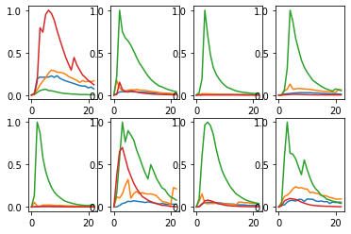

Train on detected 63 non-detected 449  
Train time in seconds: 10.741060495376587

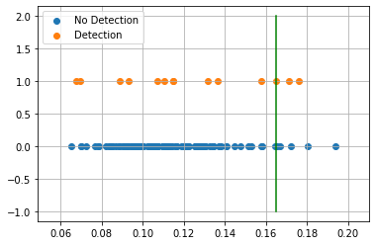

AUC 0.5568105490154488  
Predicted TPR 0.12698412698412698  
Predicted FPR 0.013363028953229399  
Threshold 0.16477808  
-----------------------End of training---------------------------

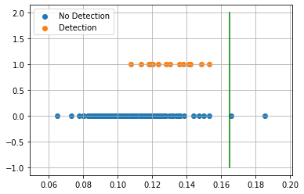

Test on detected 14 non-detected 115  
F0.5 0.00%  
  
Confusion Matrix:  
True Negative 98.26%  
False Positive 1.74%  
False Negative 100.00%  
True Positive 0.00%  
  
Classification Report  
 precision recall f1-score support  
  
 blank 0.890 0.983 0.934 115  
 detected 0.000 0.000 0.000 14  
  
 accuracy 0.876 129  
 macro avg 0.445 0.491 0.467 129  
weighted avg 0.793 0.876 0.833 129  
  
---------------------------end of testing--------------------------------  
  
Compound ID 19  
[7, 8]

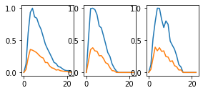

Train on detected 3 non-detected 509  
Train time in seconds: 11.781062602996826

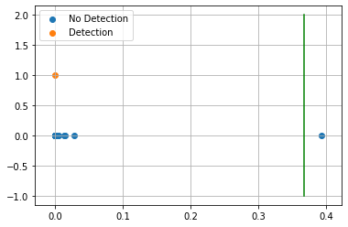

AUC 1.0  
Predicted TPR 1.0  
Predicted FPR 0.0  
Threshold 0.36723447  
-----------------------End of training---------------------------

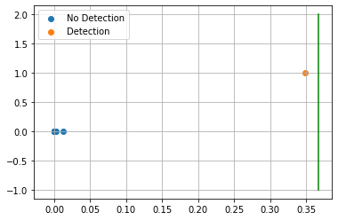

Test on detected 1 non-detected 128  
F0.5 0.00%  
  
Confusion Matrix:  
True Negative 100.00%  
False Positive 0.00%  
False Negative 100.00%  
True Positive 0.00%  
  
Classification Report  
 precision recall f1-score support  
  
 blank 0.992 1.000 0.996 128  
 detected 0.000 0.000 0.000 1  
  
 accuracy 0.992 129  
 macro avg 0.496 0.500 0.498 129  
weighted avg 0.985 0.992 0.988 129  
  
---------------------------end of testing--------------------------------  
  
Compound ID 21

C:\Users\Brian.Mello\AppData\Local\Continuum\anaconda3\lib\site-packages\sklearn\metrics\classification.py:1437: UndefinedMetricWarning: F-score is ill-defined and being set to 0.0 due to no predicted samples.  
 'precision', 'predicted', average, warn_for)  
C:\Users\Brian.Mello\AppData\Local\Continuum\anaconda3\lib\site-packages\sklearn\metrics\classification.py:1437: UndefinedMetricWarning: Precision and F-score are ill-defined and being set to 0.0 in labels with no predicted samples.  
 'precision', 'predicted', average, warn_for)  
C:\Users\Brian.Mello\AppData\Local\Continuum\anaconda3\lib\site-packages\sklearn\metrics\classification.py:1437: UndefinedMetricWarning: Precision and F-score are ill-defined and being set to 0.0 in labels with no predicted samples.  
 'precision', 'predicted', average, warn_for)  
C:\Users\Brian.Mello\AppData\Local\Continuum\anaconda3\lib\site-packages\sklearn\metrics\classification.py:1437: UndefinedMetricWarning: Precision and F-score are ill-defined and being set to 0.0 in labels with no predicted samples.  
 'precision', 'predicted', average, warn_for)

[22, 23, 25, 26, 33, 34]



Train on detected 61 non-detected 451  
Train time in seconds: 12.135090827941895

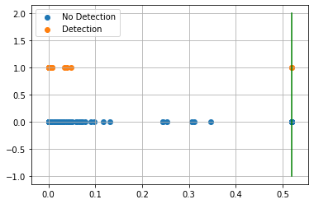

AUC 0.9709752462651303  
Predicted TPR 0.9508196721311475  
Predicted FPR 0.008869179600886918  
Threshold 0.5195075  
-----------------------End of training---------------------------

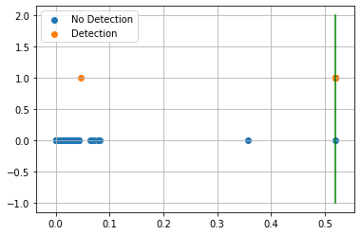

Test on detected 14 non-detected 115  
F0.5 92.86%  
  
Confusion Matrix:  
True Negative 99.13%  
False Positive 0.87%  
False Negative 7.14%  
True Positive 92.86%  
  
Classification Report  
 precision recall f1-score support  
  
 blank 0.991 0.991 0.991 115  
 detected 0.929 0.929 0.929 14  
  
 accuracy 0.984 129  
 macro avg 0.960 0.960 0.960 129  
weighted avg 0.984 0.984 0.984 129  
  
---------------------------end of testing--------------------------------  
  
Compound ID 22  
[35, 37, 38]

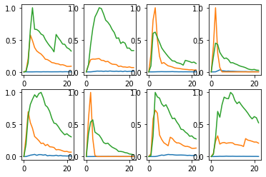

Train on detected 65 non-detected 447  
Train time in seconds: 11.940043687820435

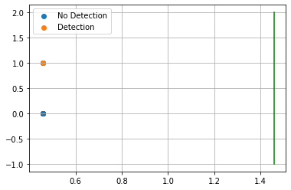

AUC 0.5  
Predicted TPR 0.0  
Predicted FPR 0.0  
Threshold 1.4595582  
-----------------------End of training---------------------------



Test on detected 14 non-detected 115  
F0.5 0.00%  
  
Confusion Matrix:  
True Negative 100.00%  
False Positive 0.00%  
False Negative 100.00%  
True Positive 0.00%  
  
Classification Report  
 precision recall f1-score support  
  
 blank 0.891 1.000 0.943 115  
 detected 0.000 0.000 0.000 14  
  
 accuracy 0.891 129  
 macro avg 0.446 0.500 0.471 129  
weighted avg 0.795 0.891 0.840 129  
  
---------------------------end of testing--------------------------------  
 Compounds Tr-TPR Tr-FPR Threshold ROC AUC Score Test-TPR Test-FPR  
 0 0.00% 0.00% 146.25% 50.00% 0.00% 0.00%   
 3 0.00% 0.00% 146.50% 50.00% 0.00% 0.00%   
 4 0.00% 0.00% 130.43% 50.00% 0.00% 0.00%   
 7 100.00% 0.60% 12.61% 99.70% 0.00% 1.56%   
 8 0.00% 0.00% 119.21% 50.00% 0.00% 0.00%   
 10 2.13% 1.51% 17.62% 50.31% 0.00% 0.85%   
 13 0.00% 0.00% 138.59% 50.00% 0.00% 0.00%   
 14 0.00% 0.00% 146.50% 50.00% 0.00% 0.00%   
 15 0.00% 0.00% 133.90% 50.00% 0.00% 0.00%   
 18 12.70% 1.34% 16.48% 55.68% 0.00% 1.74%   
 19 100.00% 0.00% 36.72% 100.00% 0.00% 0.00%   
 21 95.08% 0.89% 51.95% 97.10% 92.86% 0.87%   
 22 0.00% 0.00% 145.96% 50.00% 0.00% 0.00%

## Justification¶

Comp. TPR FPR Thresh. ROC Score Test-TPR Test-FPR Type   
 0 96.72% 2.00% 6.85% 97.36% 92.86% 0.87% Orig.  
 3 93.75% 1.21% 46.94% 96.27% 100.00% 0.79% Non-fil. Adj.  
 4 100.00% 1.11% 7.73% 99.45% 92.86% 0.87% Non-fil. Adj.  
 7 100.00% 1.39% 8.00% 99.31% 0.00% 0.78% Orig.  
 8 63.83% 1.29% 28.02% 81.27% 54.55% 1.69% Filt. Adj.  
 10 100.00% 0.00% 91.87% 100.00% 90.91% 0.00% Filt. Adj.  
 13 100.00% 0.88% 46.77% 99.56% 83.33% 0.85% Fil.  
 14 41.94% 1.87% 21.62% 70.03% 40.00% 4.03% Orig.  
 15 100.00% 0.00% 48.92% 100.00% 91.67% 0.00% Filt. Adj.  
 18 84.13% 1.56% 33.73% 91.28% 57.14% 4.35% Orig.  
 19 100.00% 0.00% 33.06% 100.00% 0.00% 0.00% Fil.  
 21 95.08% 0.22% 28.07% 97.43% 92.86% 0.87% Orig.  
 22 100.00% 0.00% 75.91% 100.00% 100.00% 0.00% Filt. Adj.

# Conclusion¶

Free form Visualization¶

Compound 0  
Substrate None

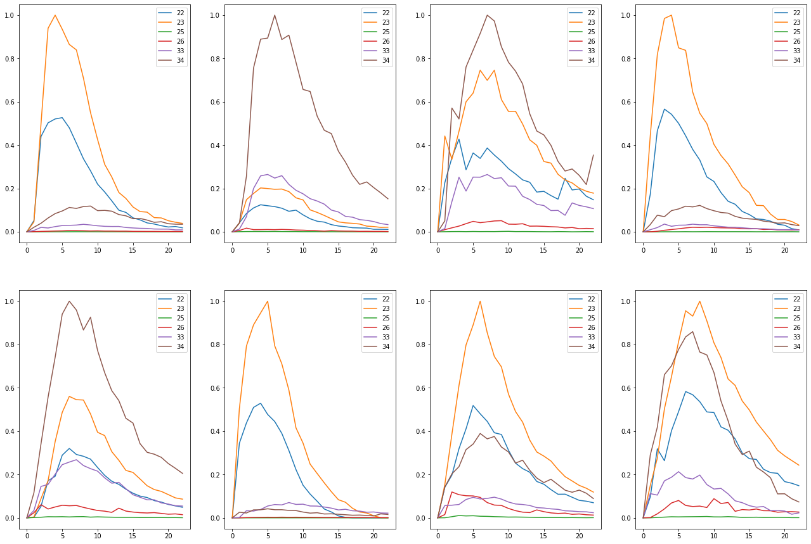

Compound 3  
Substrate None

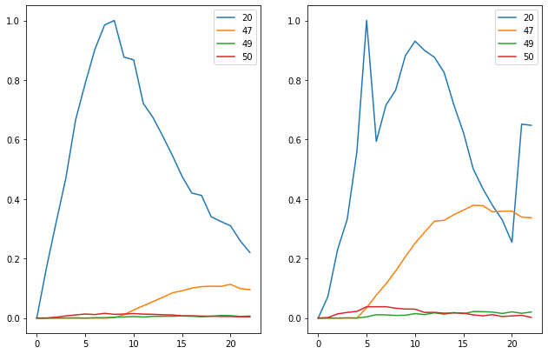

Substrate Per5

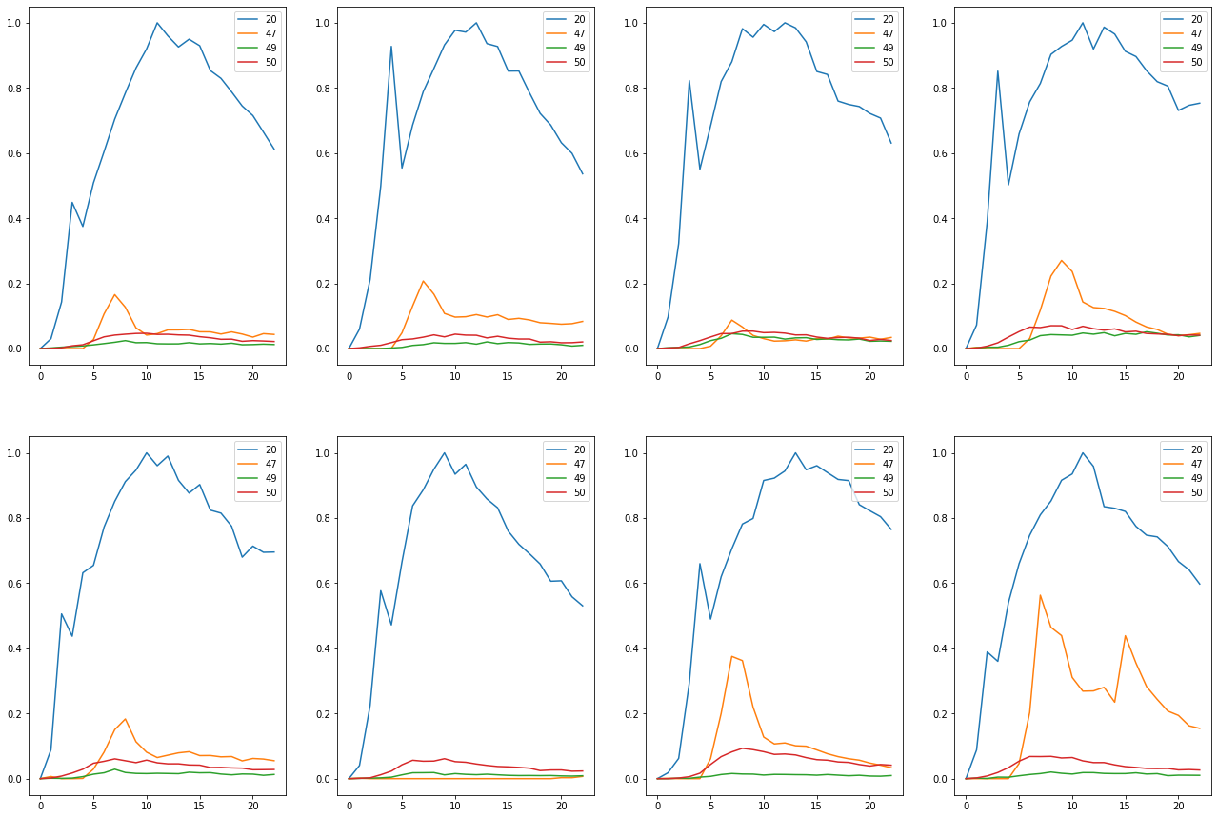

Substrate Teflon

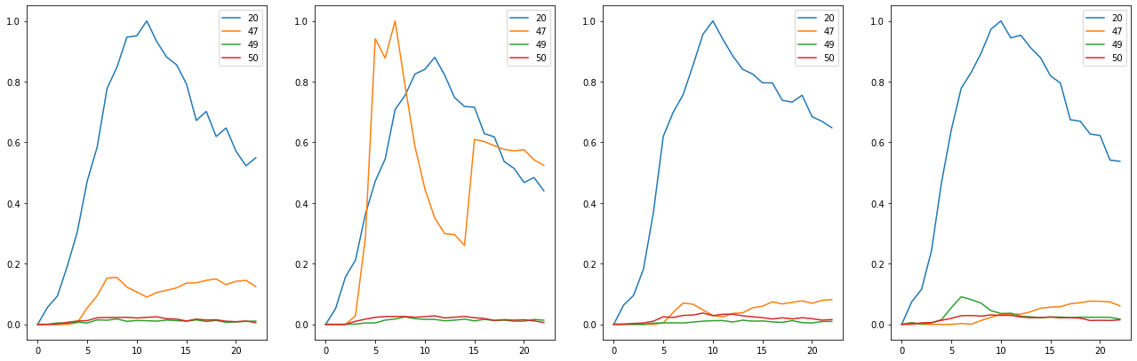

Compound 4  
Substrate None

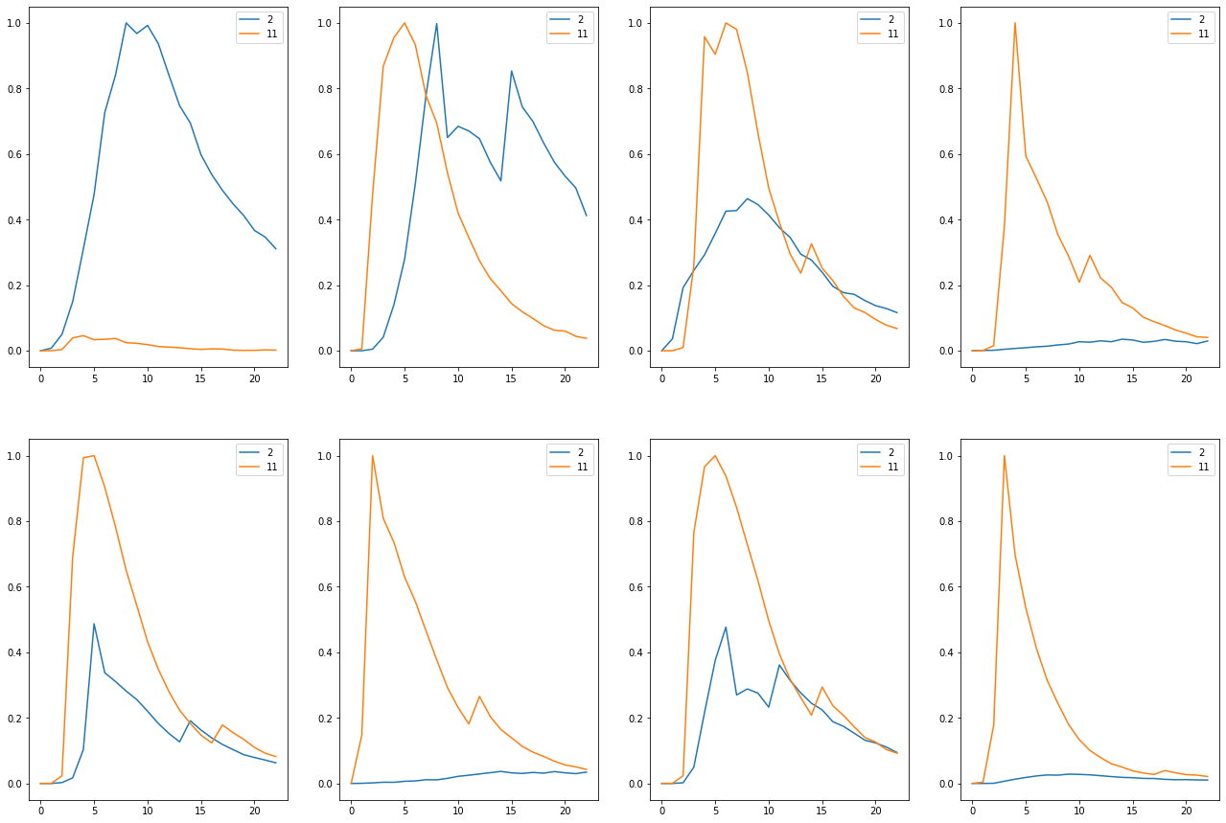

Compound 7  
Substrate None

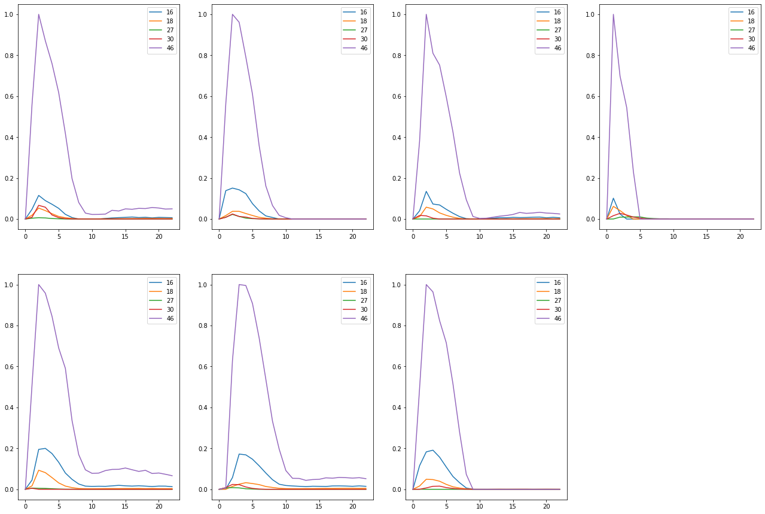

Compound 8  
Substrate BG1

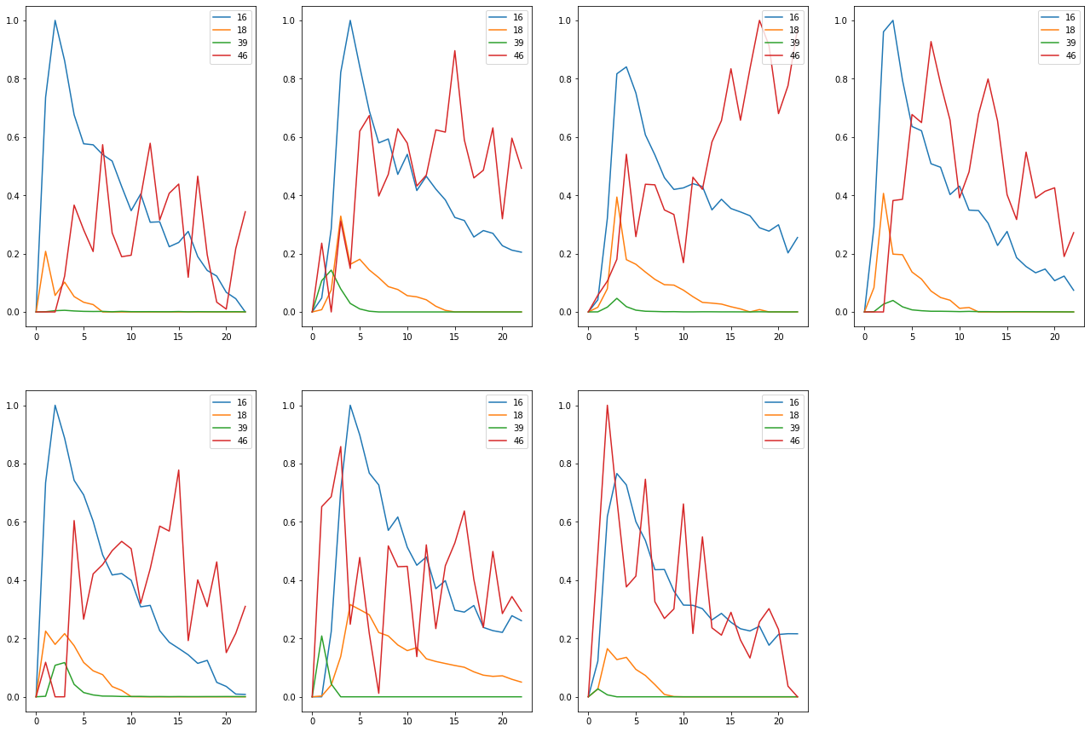

Substrate BG4

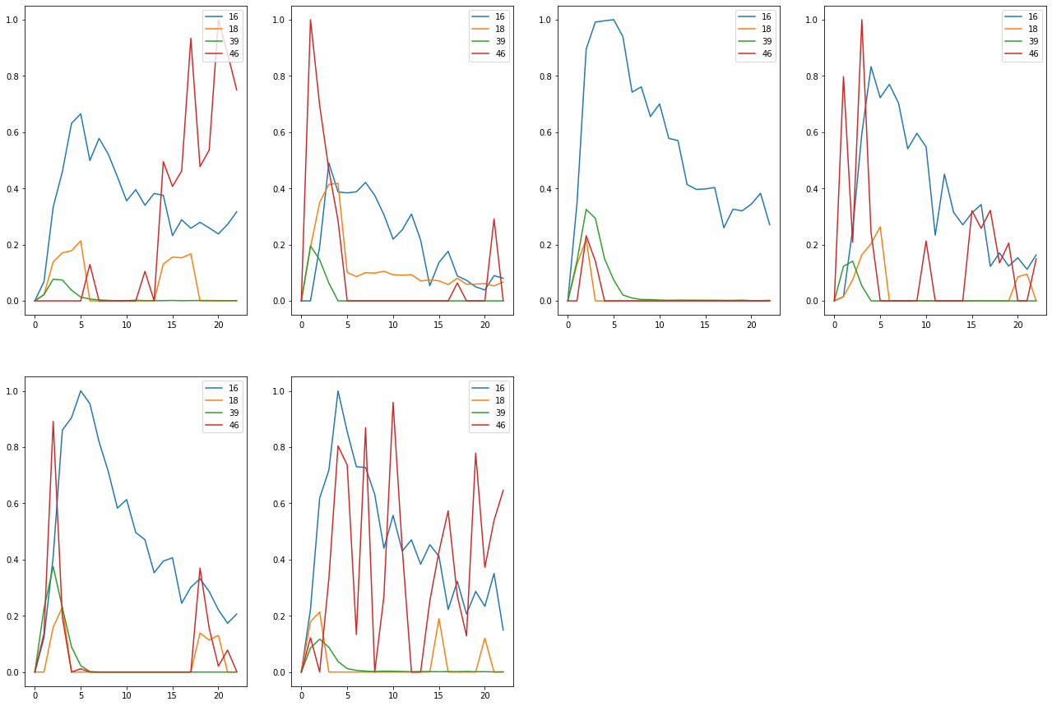

Substrate CB4

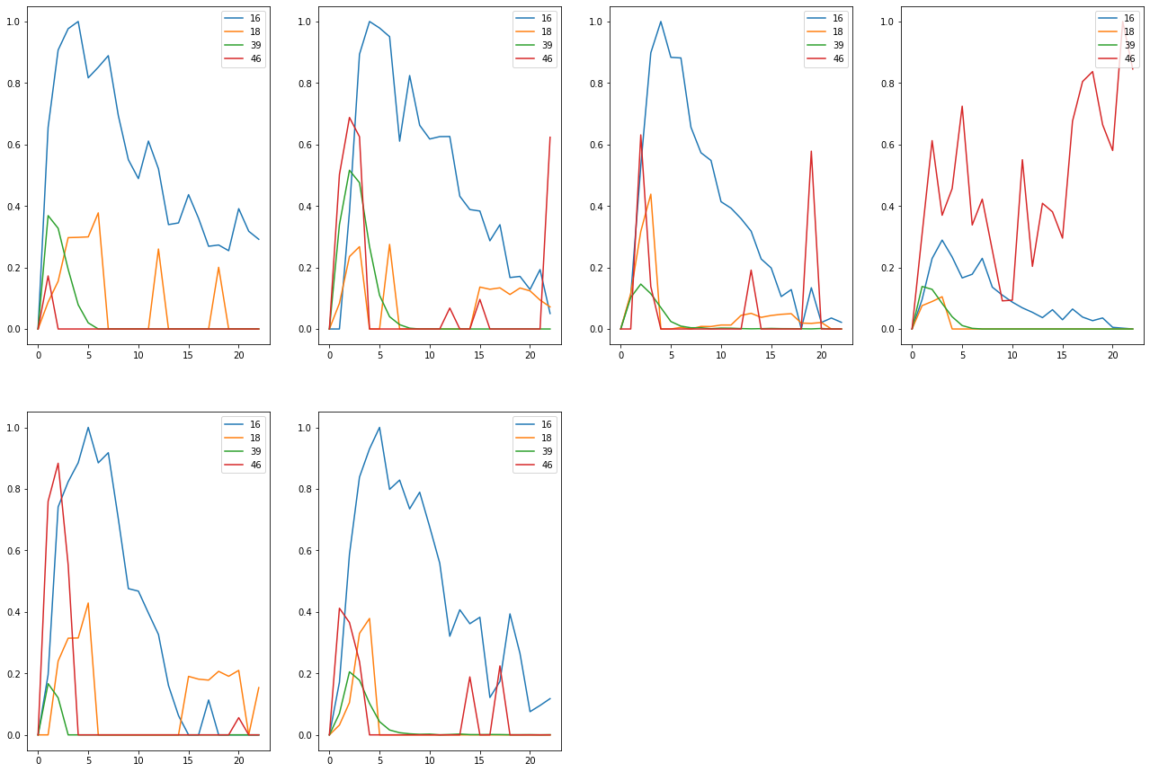

Substrate Med4

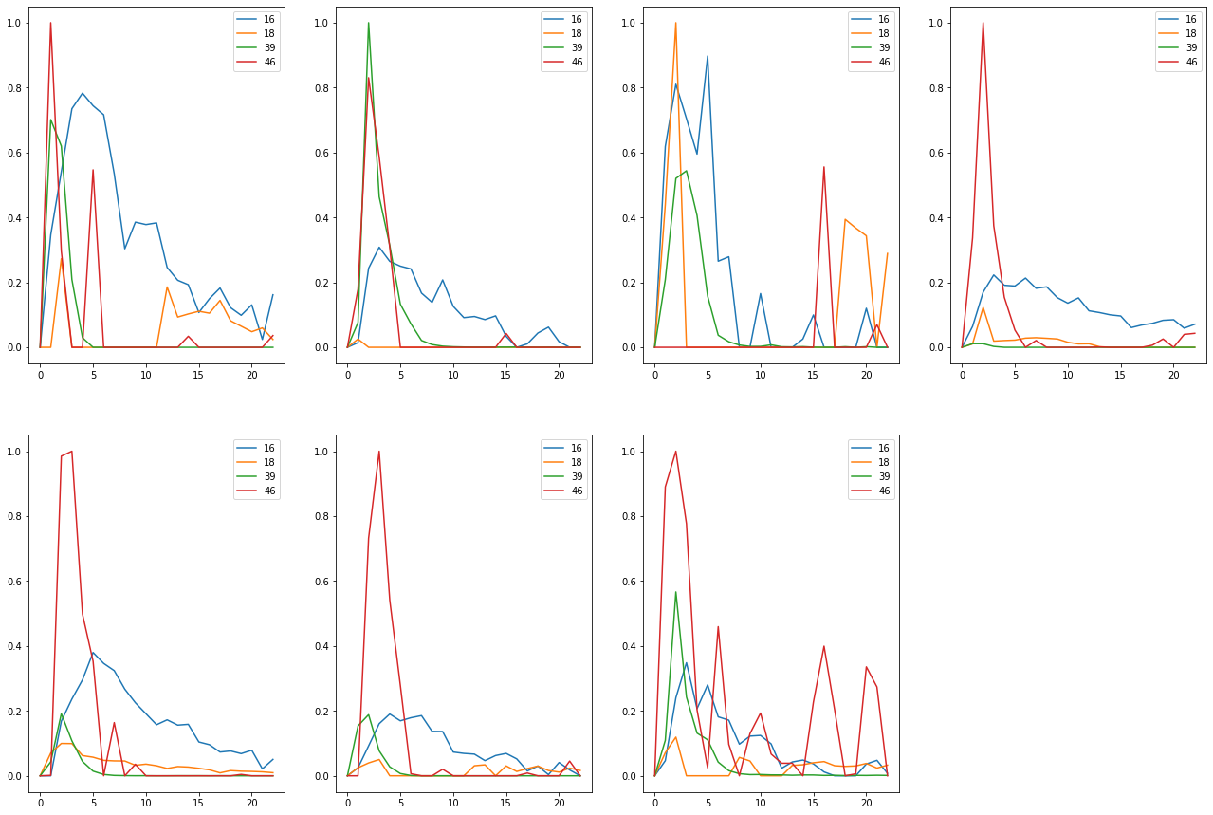

Substrate None

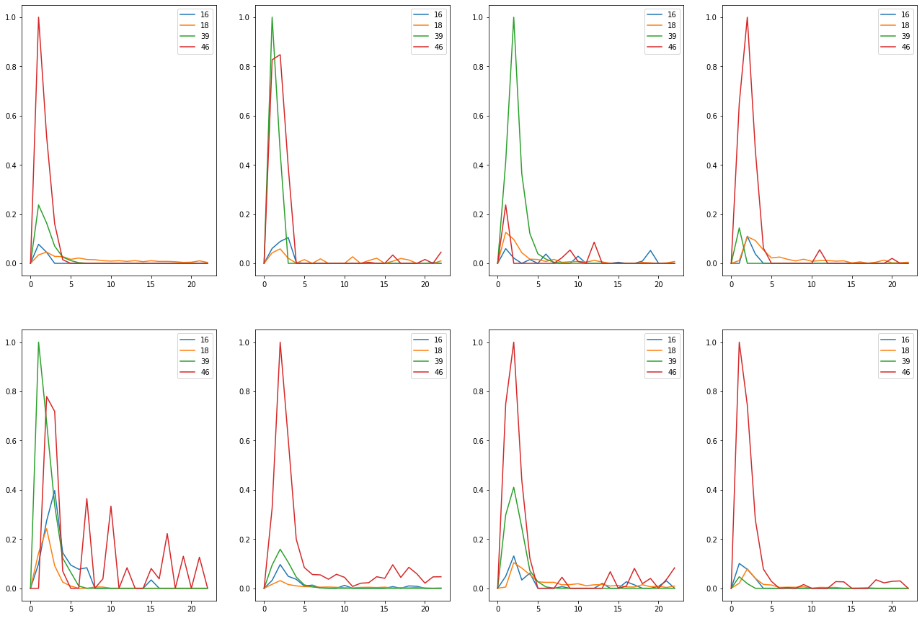

Substrate Per3

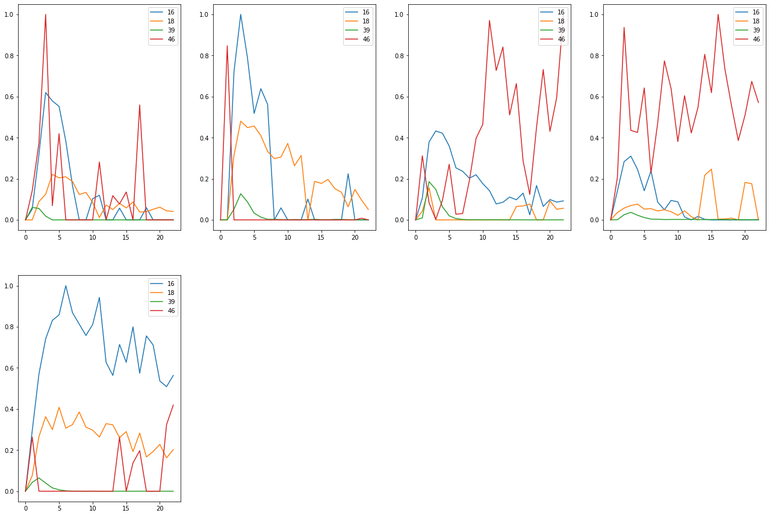

Substrate Per5

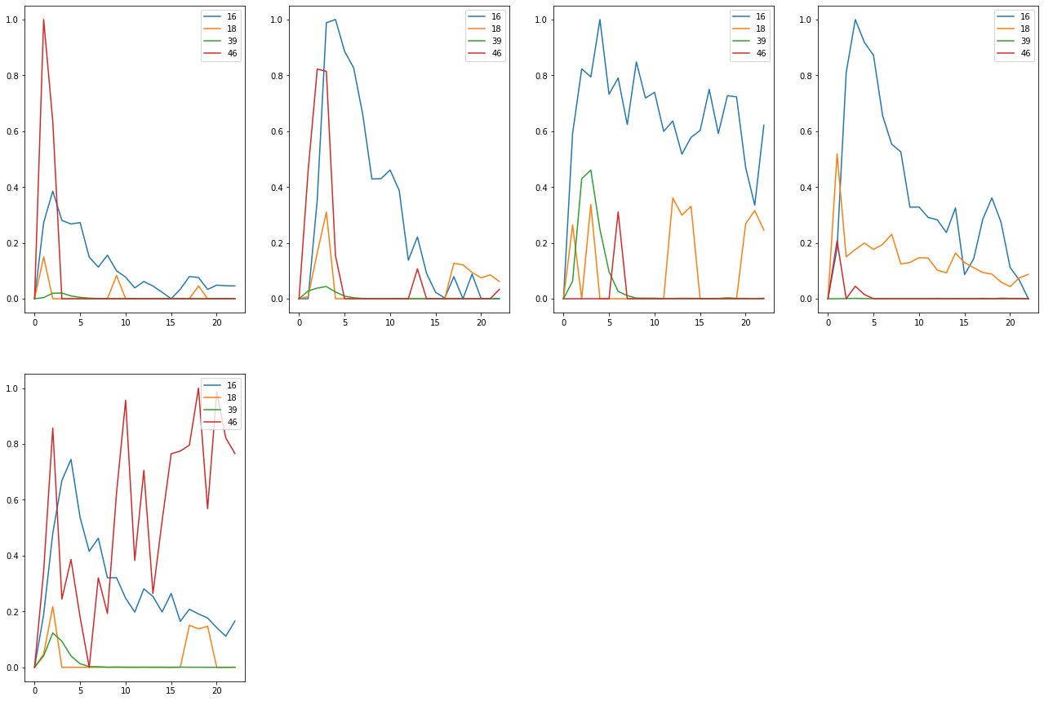

Compound 10  
Substrate BG1

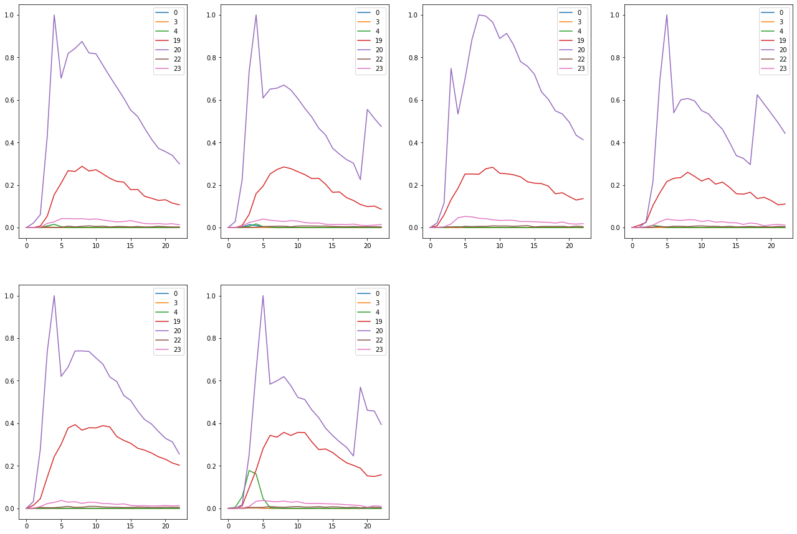

Substrate BG4

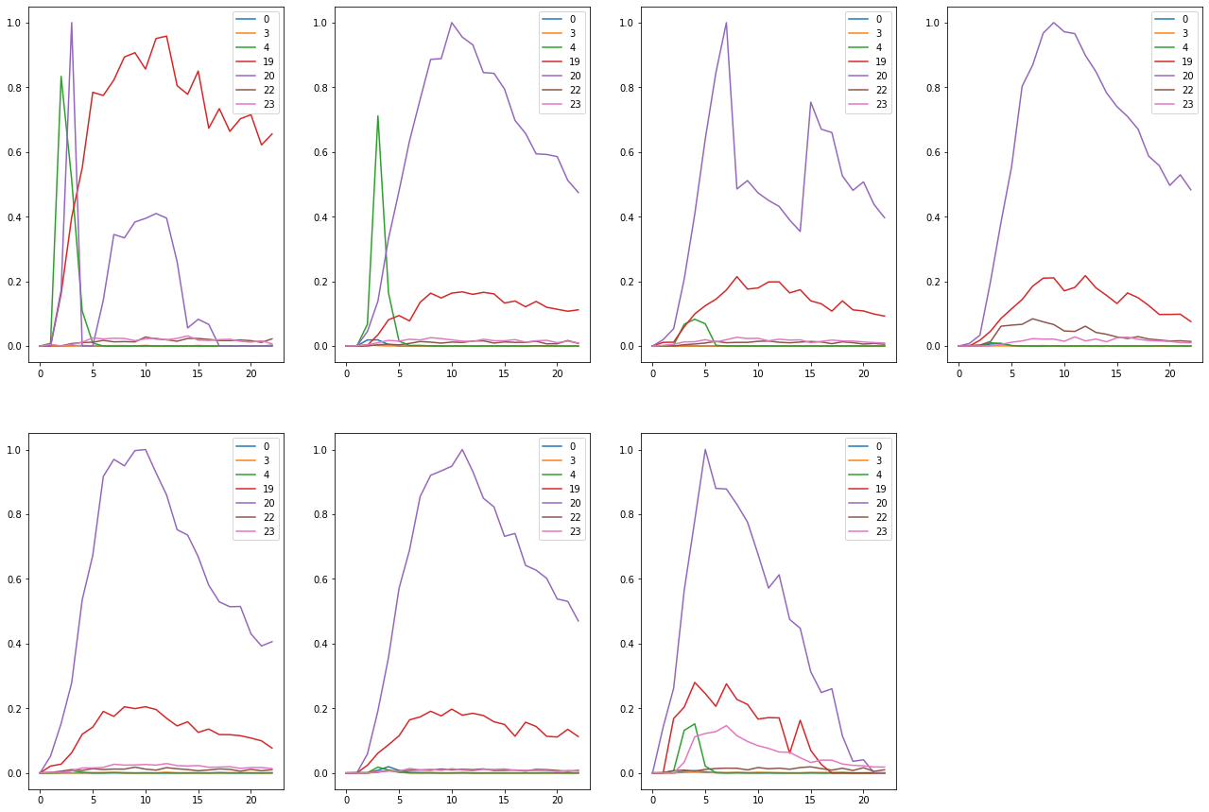

Substrate CB4

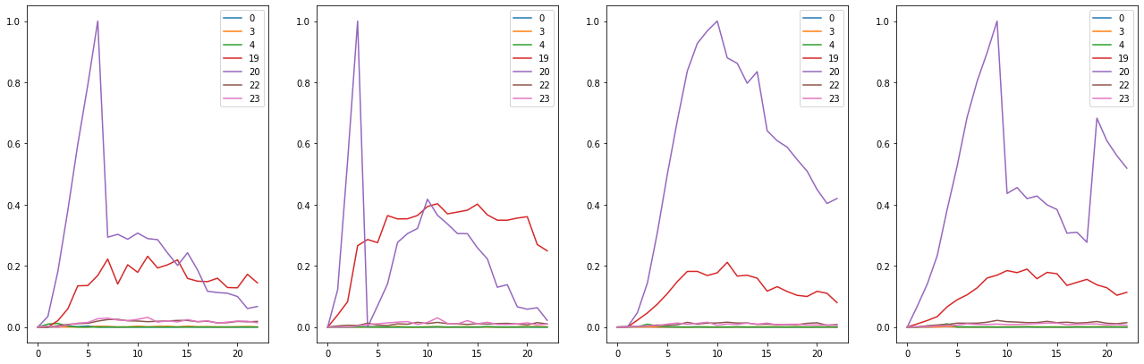

Substrate Med4

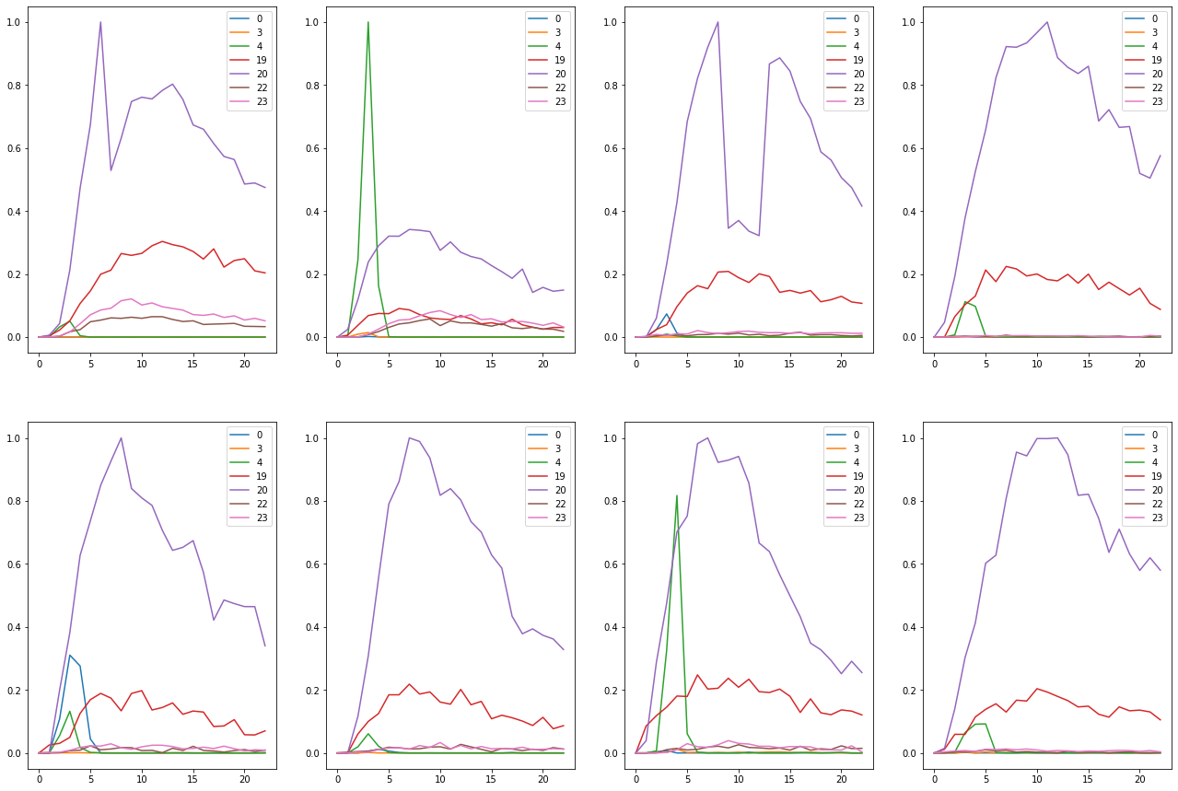

Substrate None

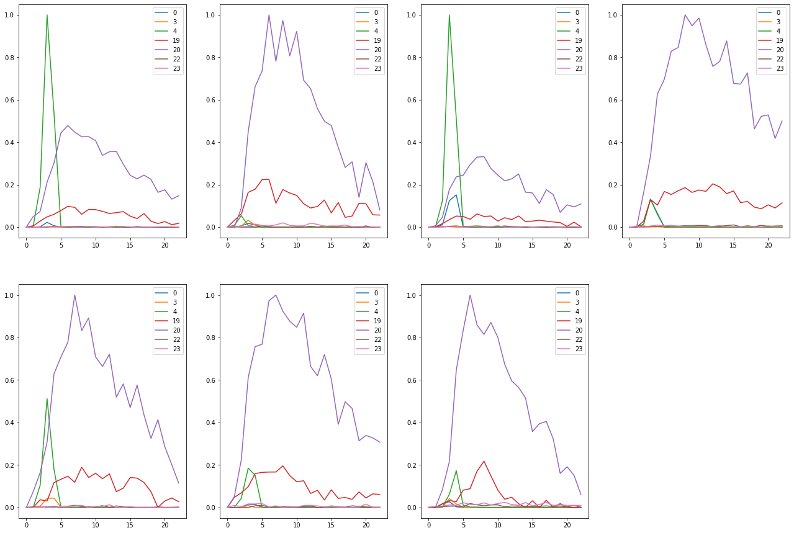

Substrate Per3

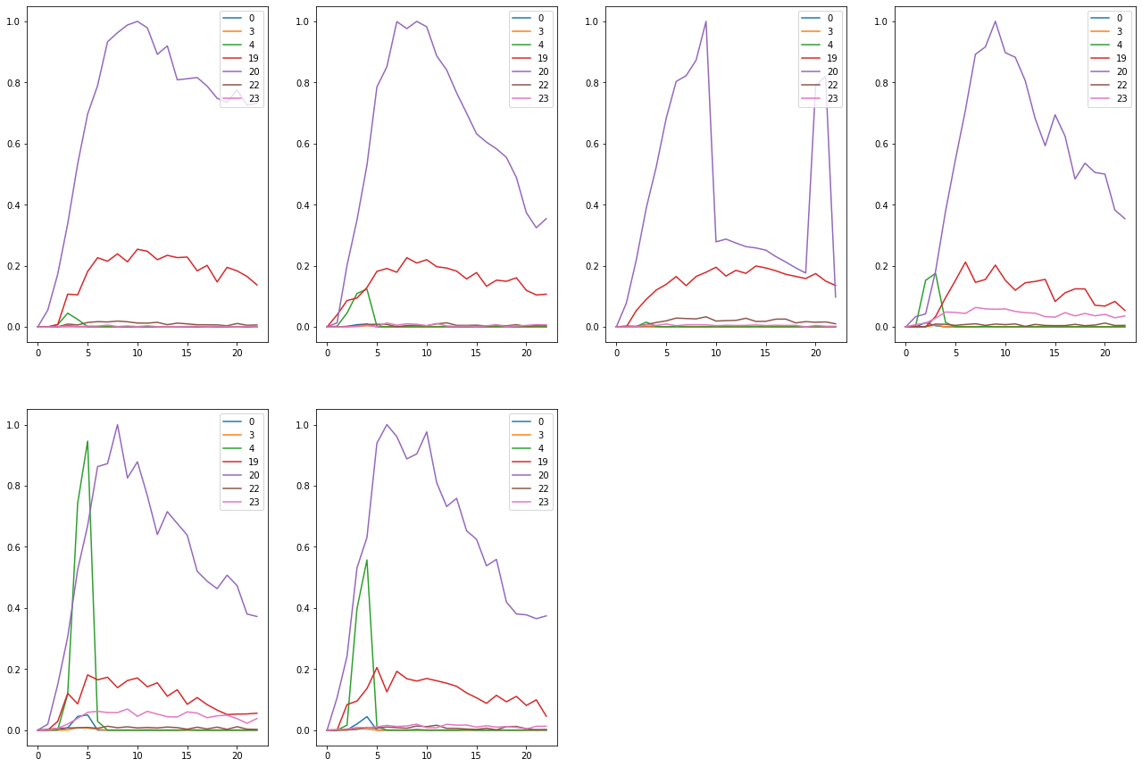

Substrate Per5

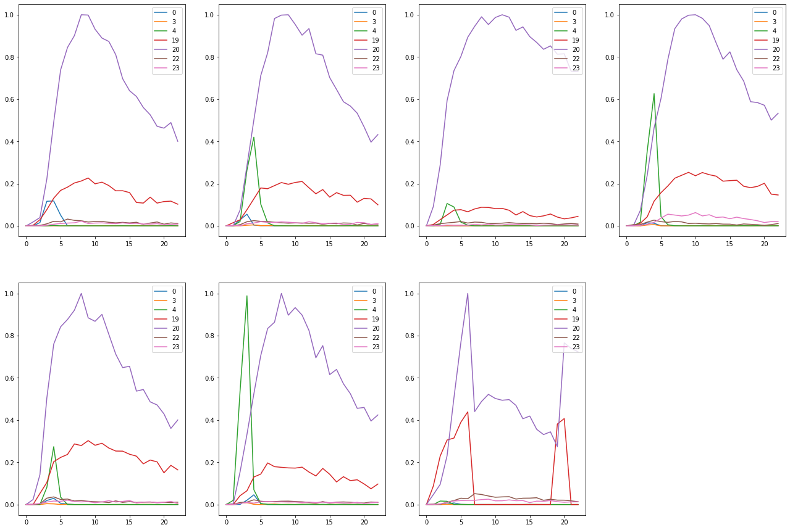

Compound 13  
Substrate BG1

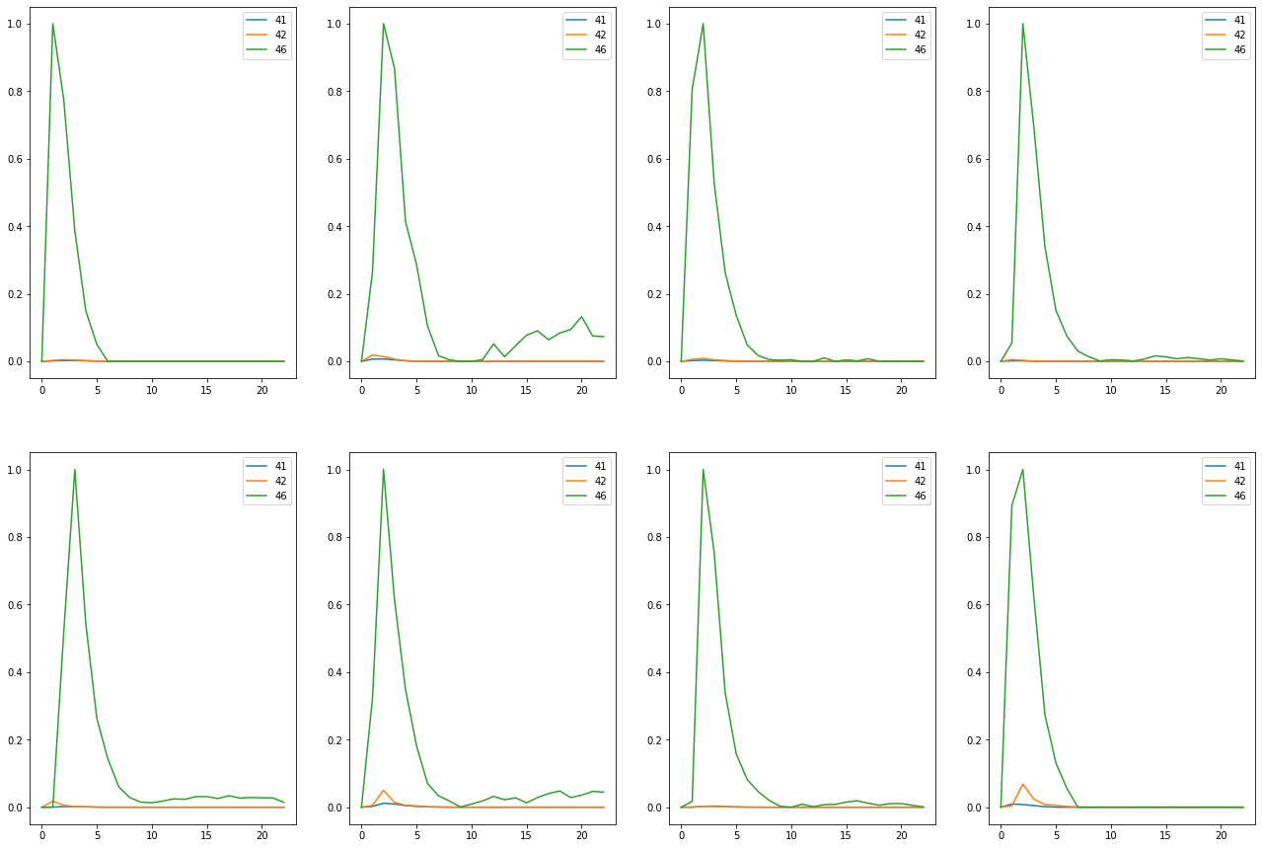

Substrate BG4

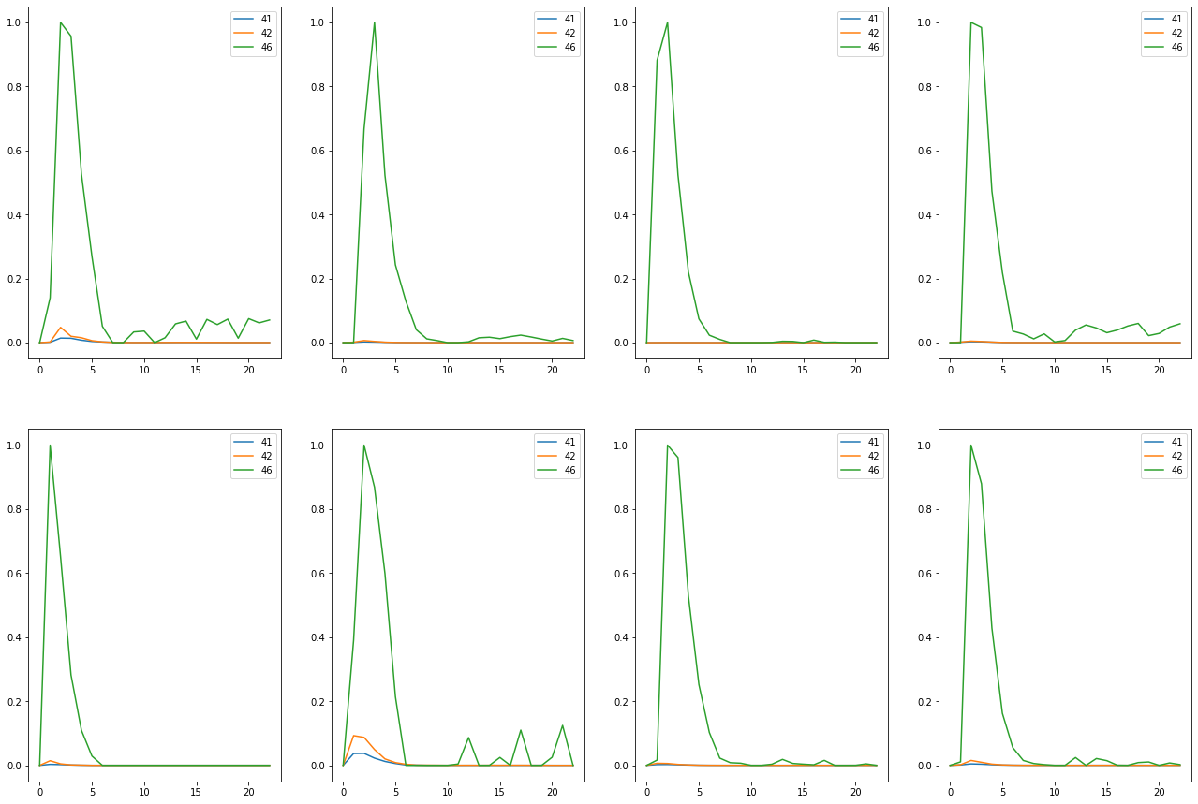

Substrate CB4

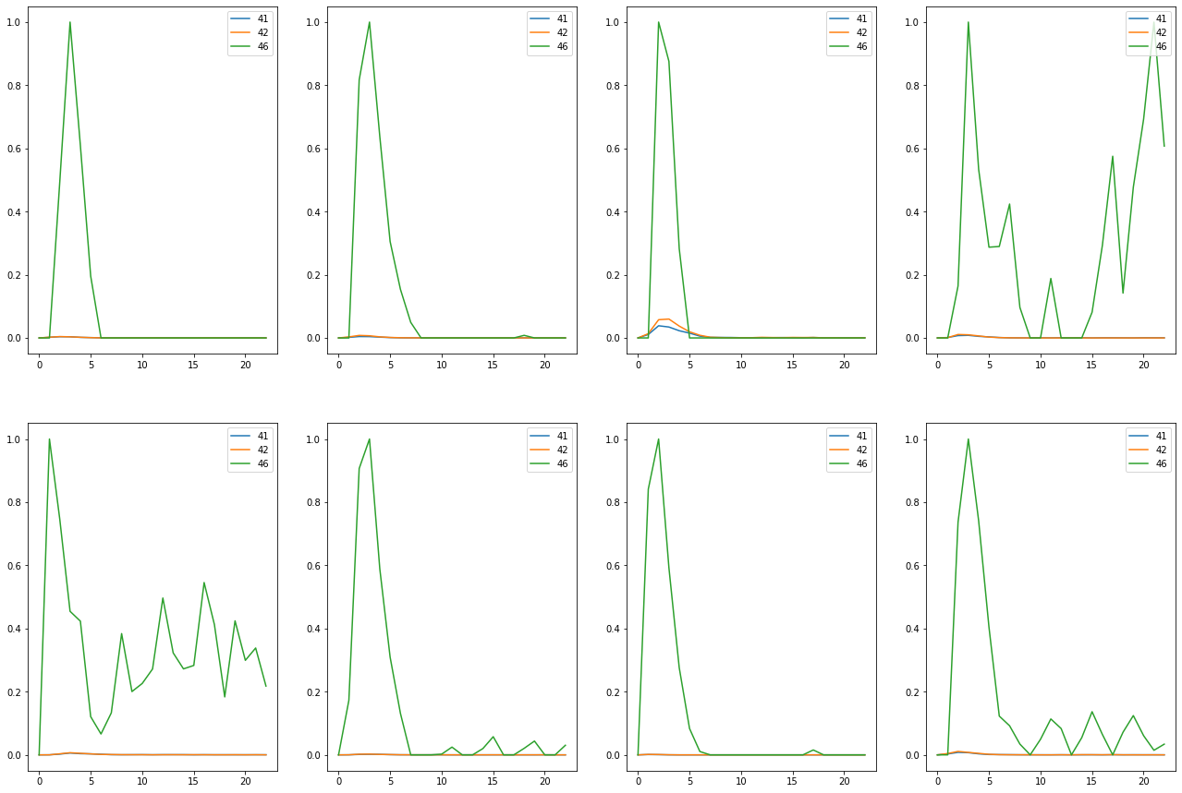

Substrate Med4

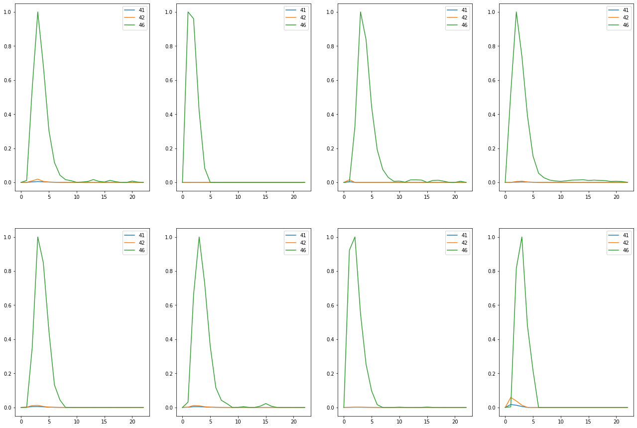

Substrate None

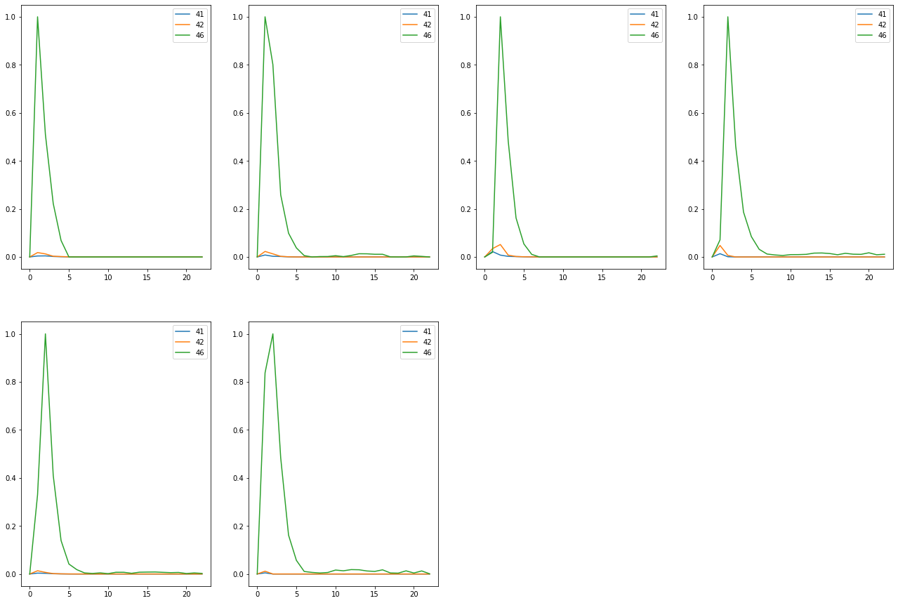

Substrate Per3

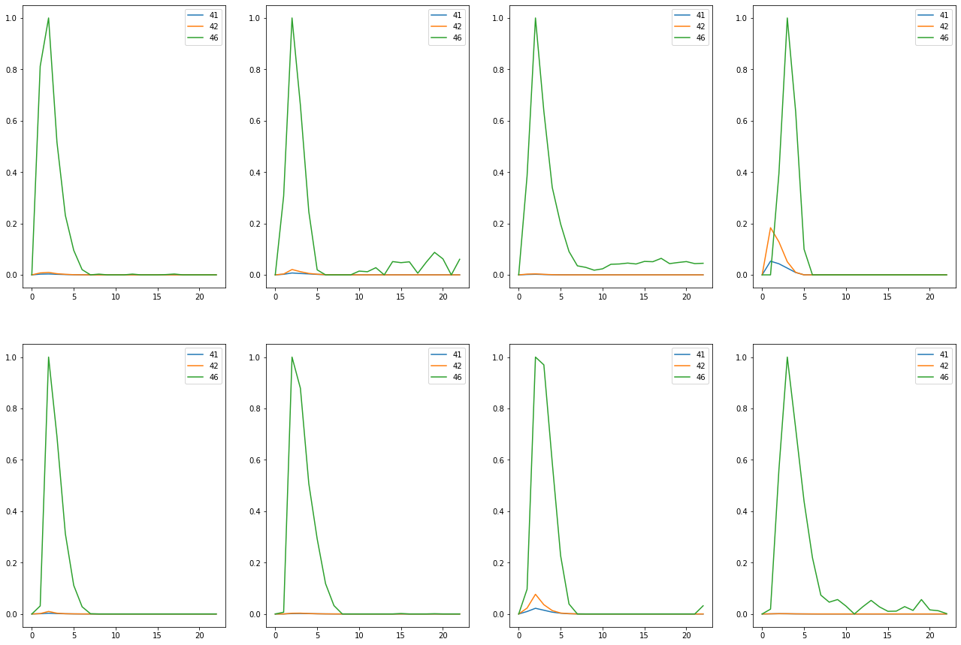

Substrate Per5

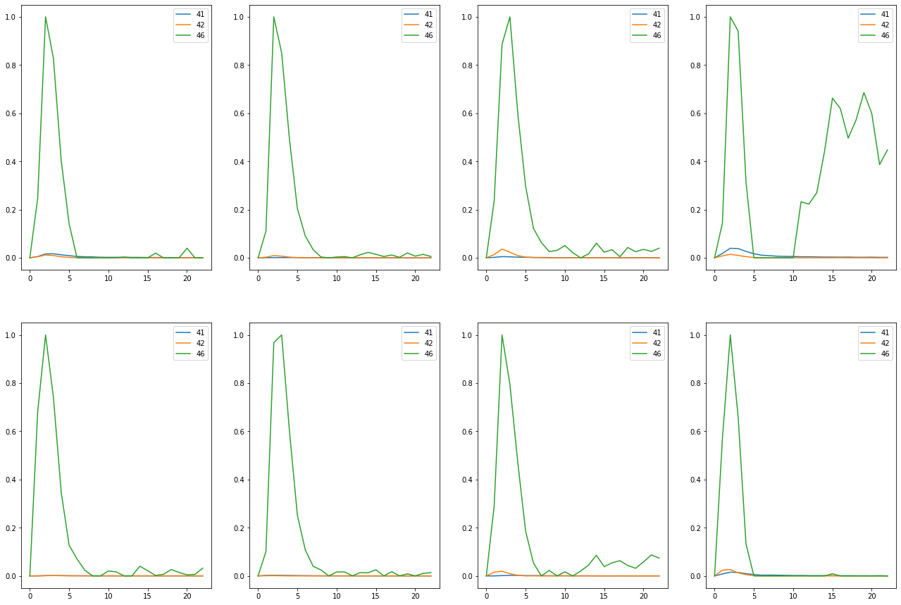

Compound 14  
Substrate None

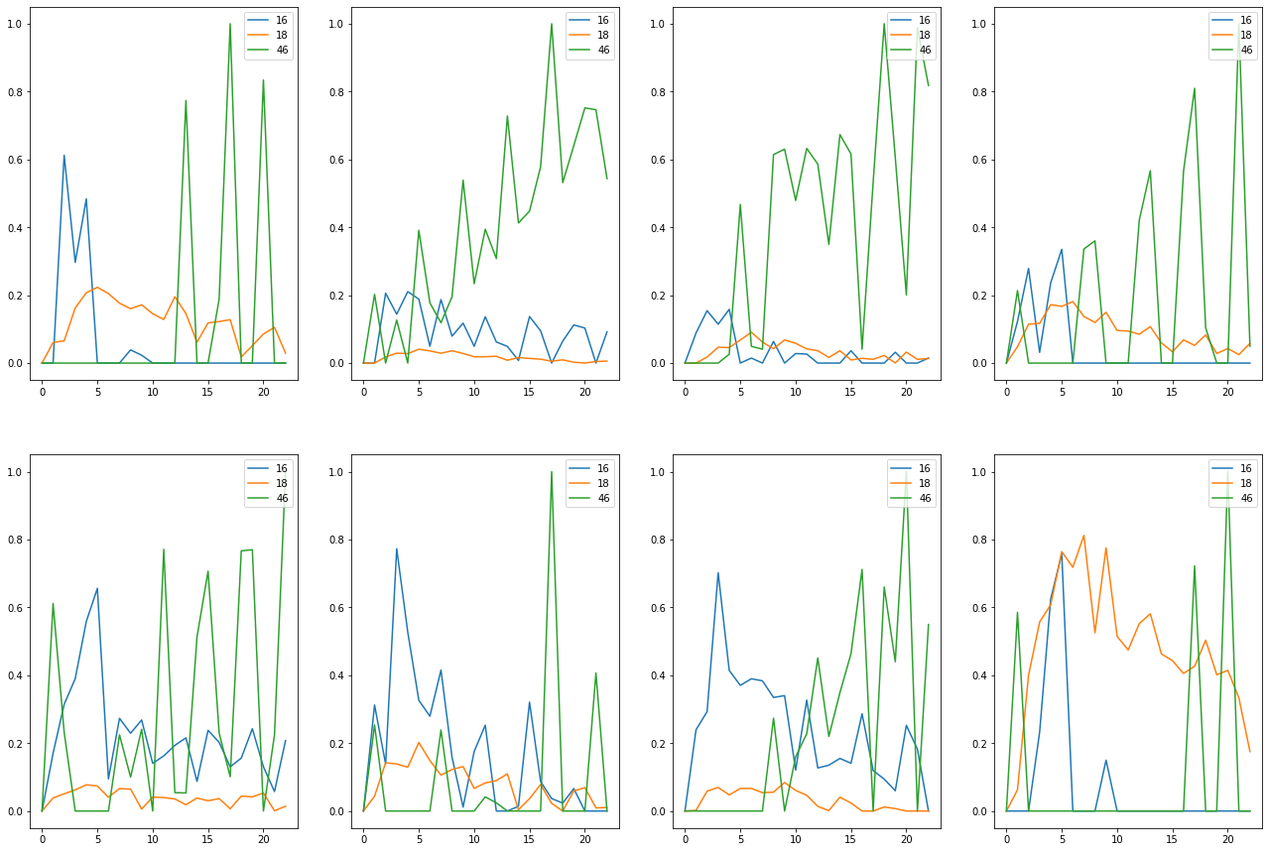

Substrate Per5

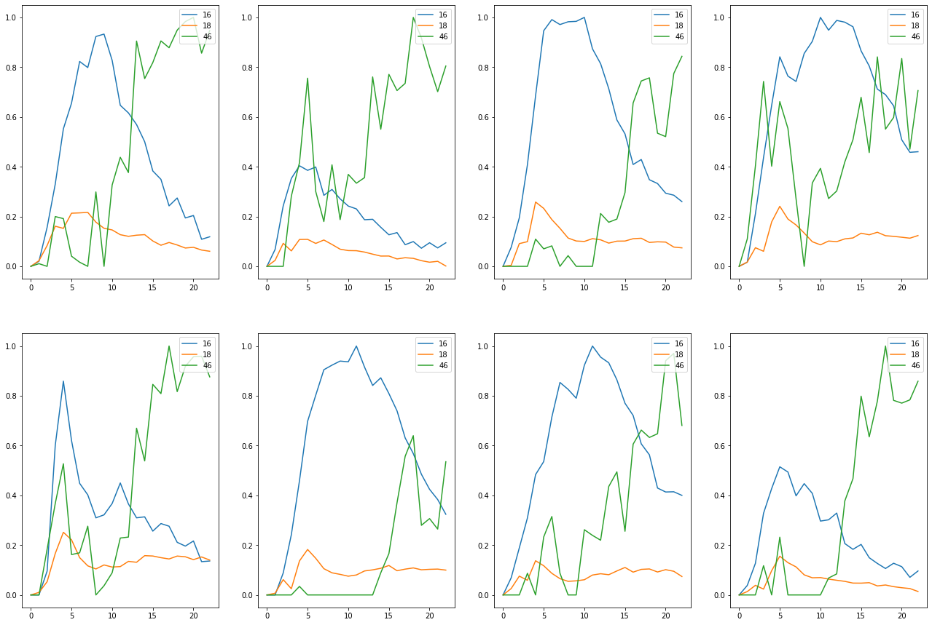

Substrate Teflon

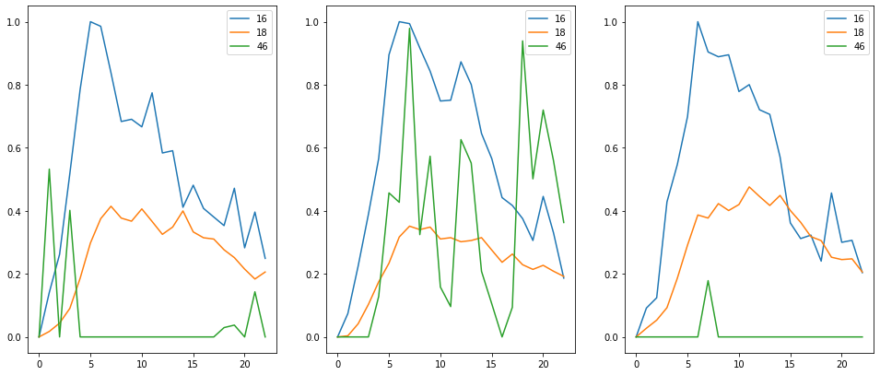

Compound 15  
Substrate BG1

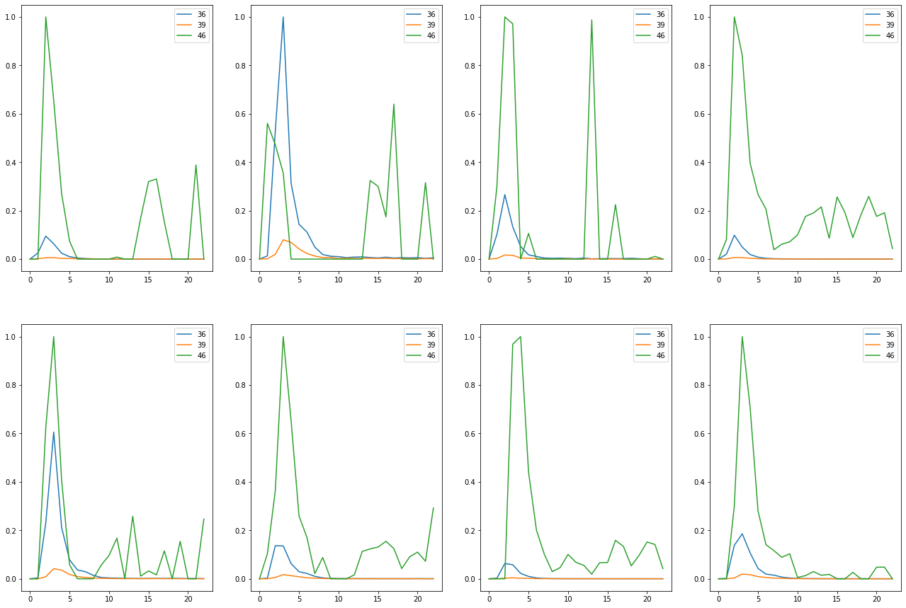

Substrate BG4

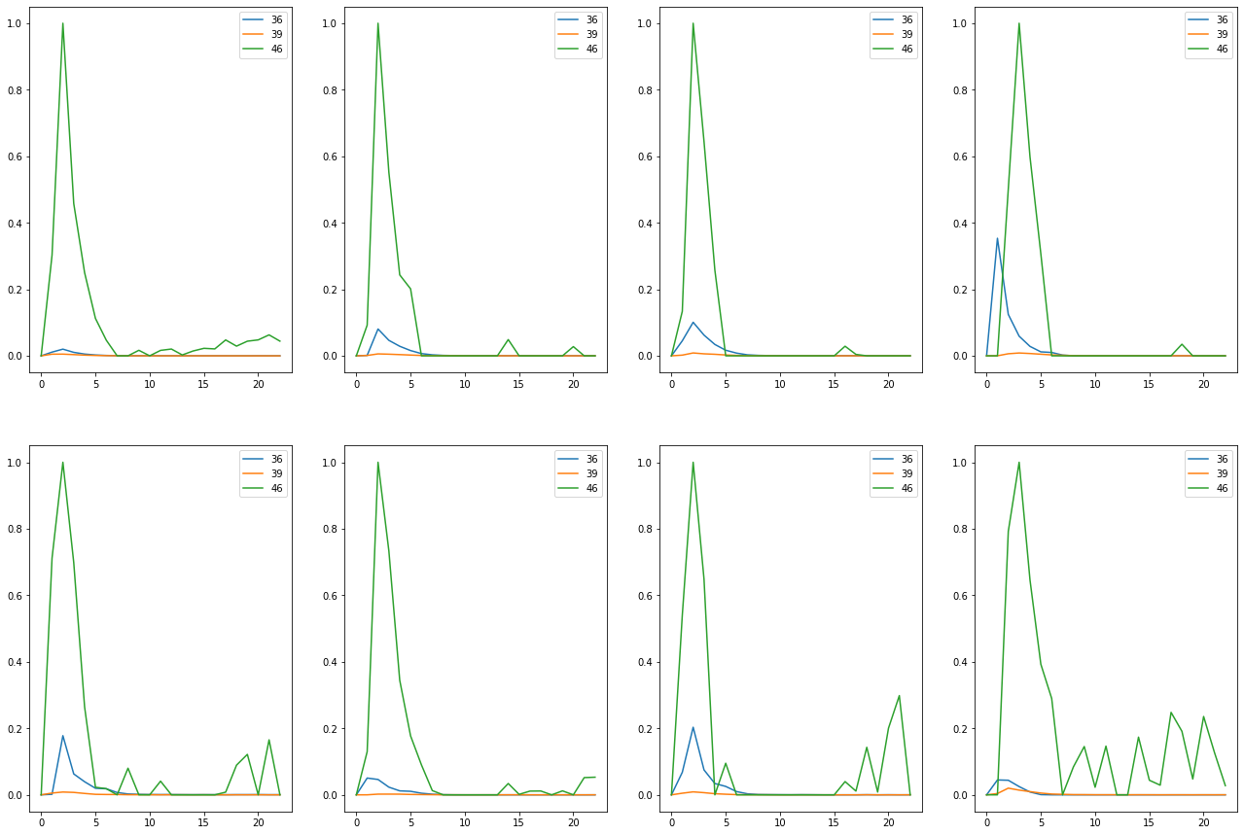

Substrate CB4

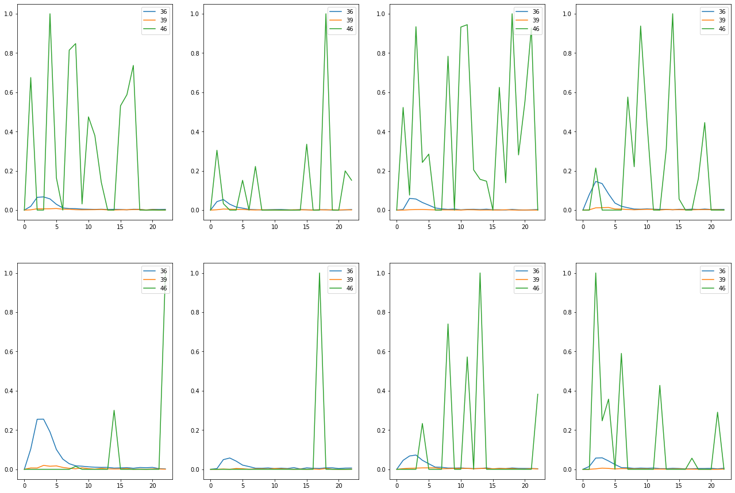

Substrate Med4

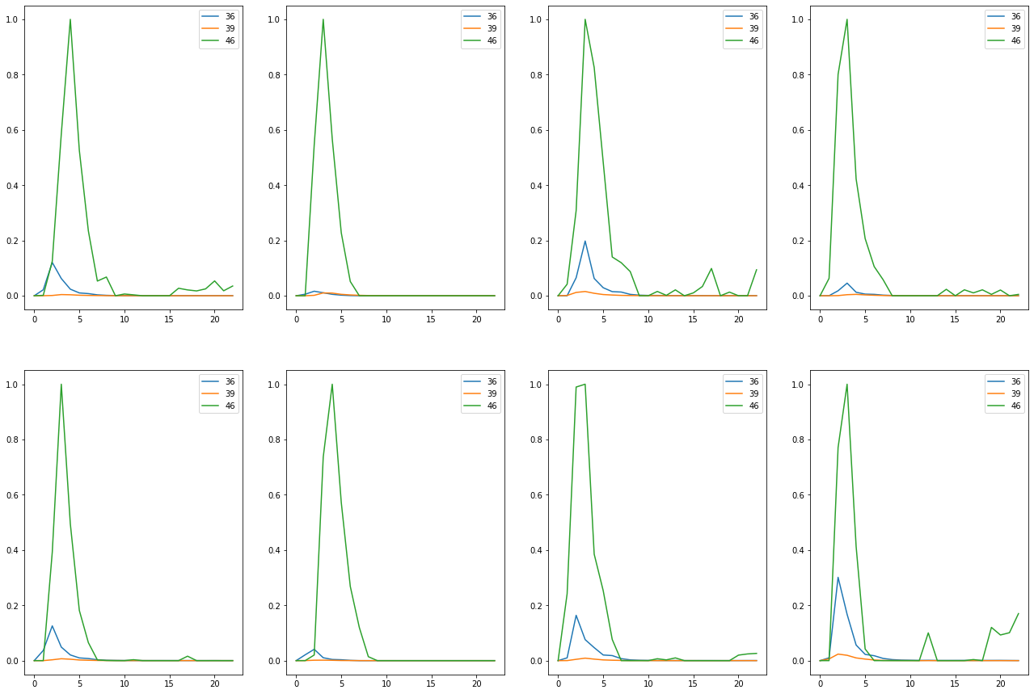

Substrate None

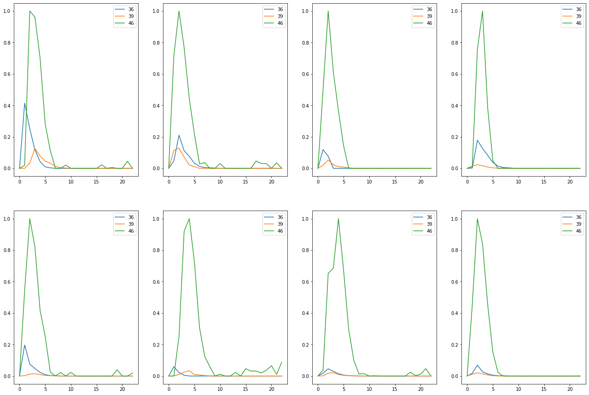

Substrate Per3

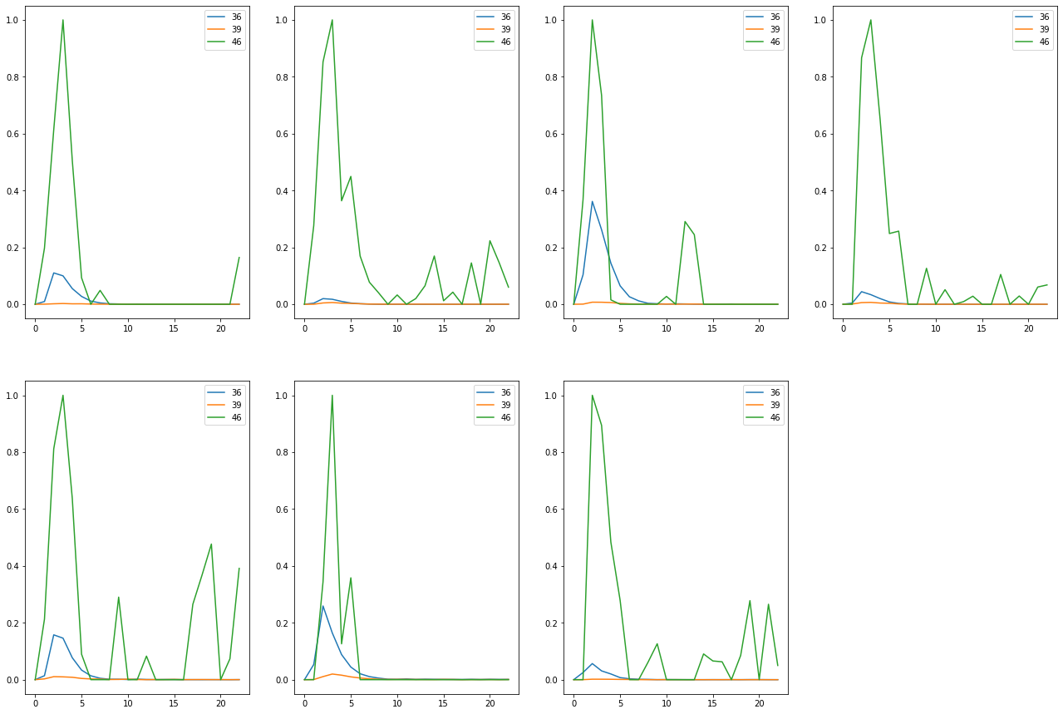

Substrate Per5

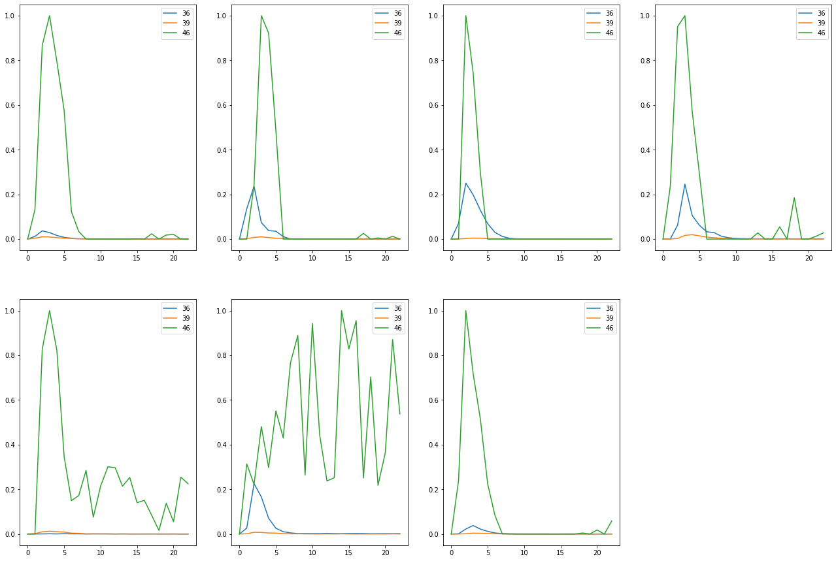

Compound 18  
Substrate BG1

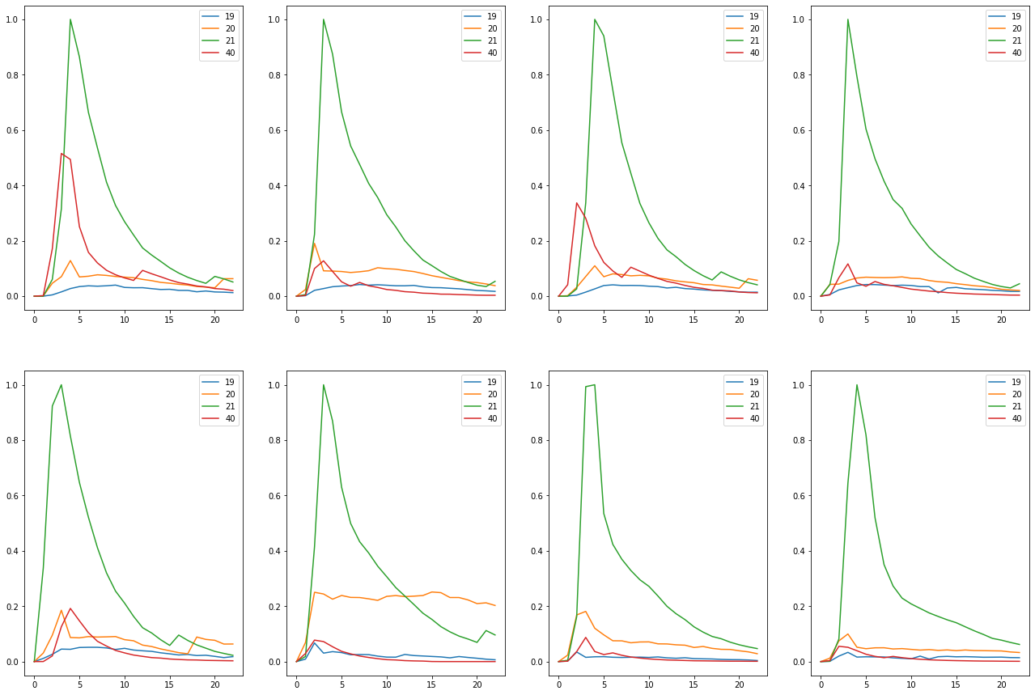

Substrate BG4

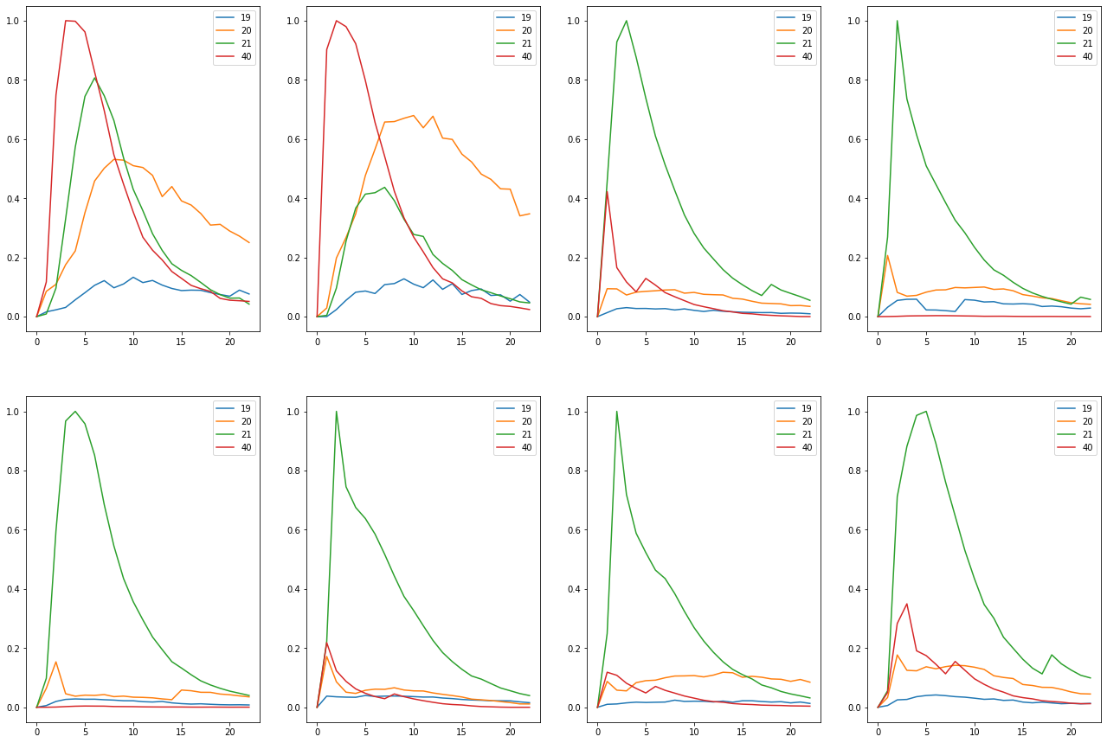

Substrate CB4

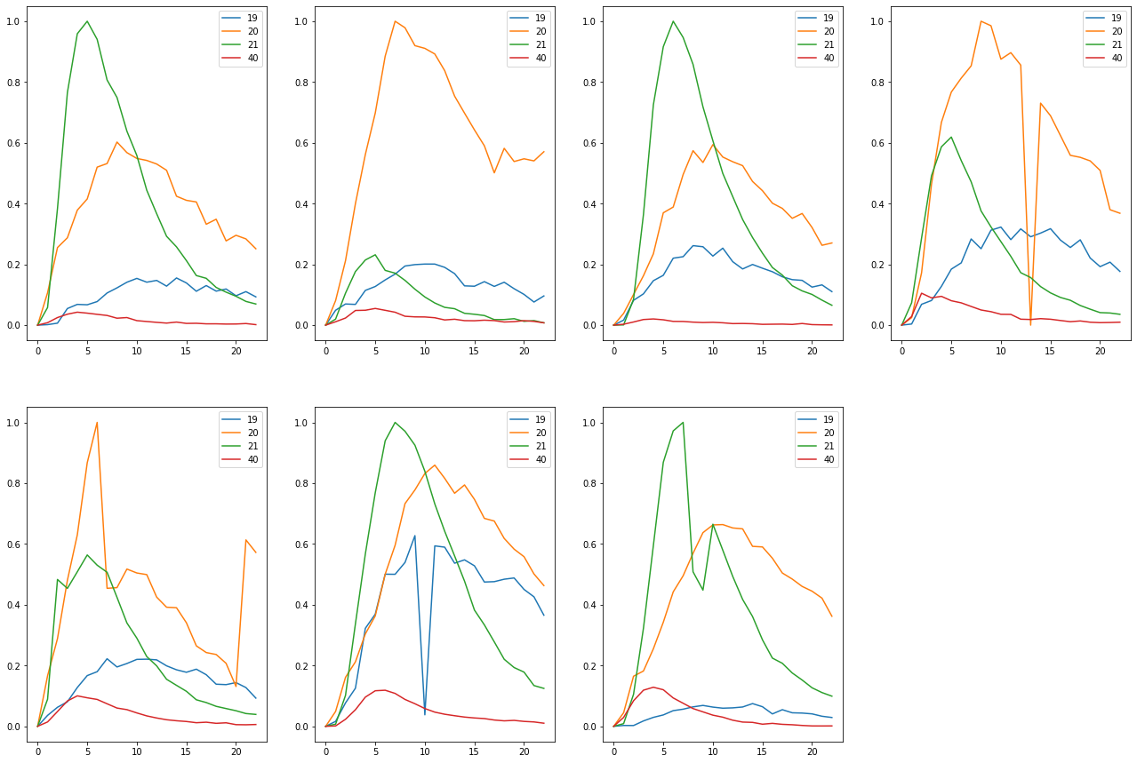

Substrate Med4

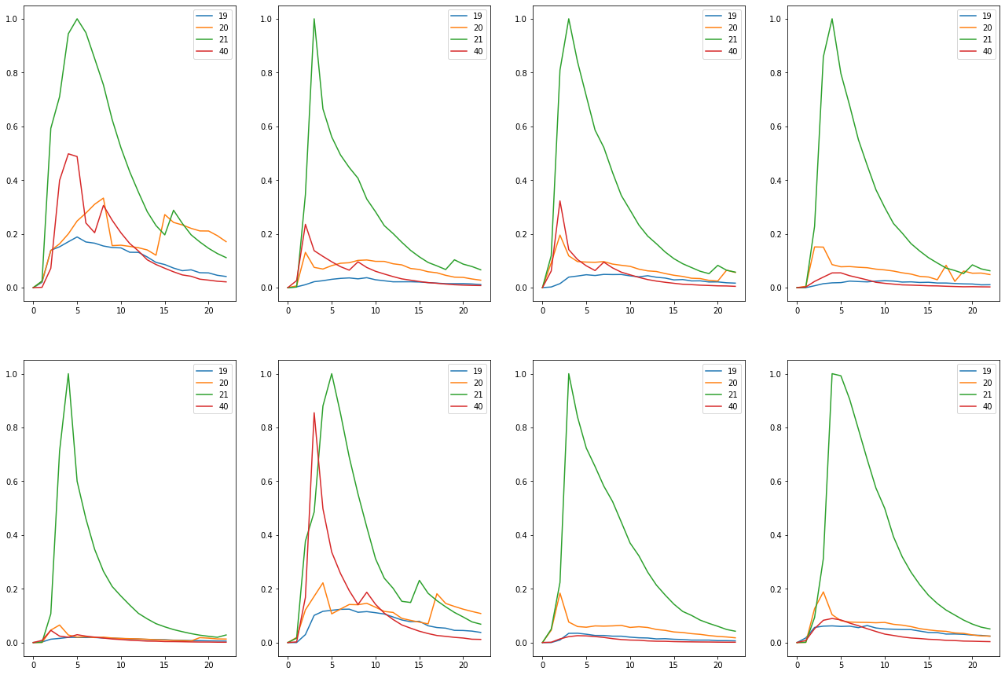

Substrate None

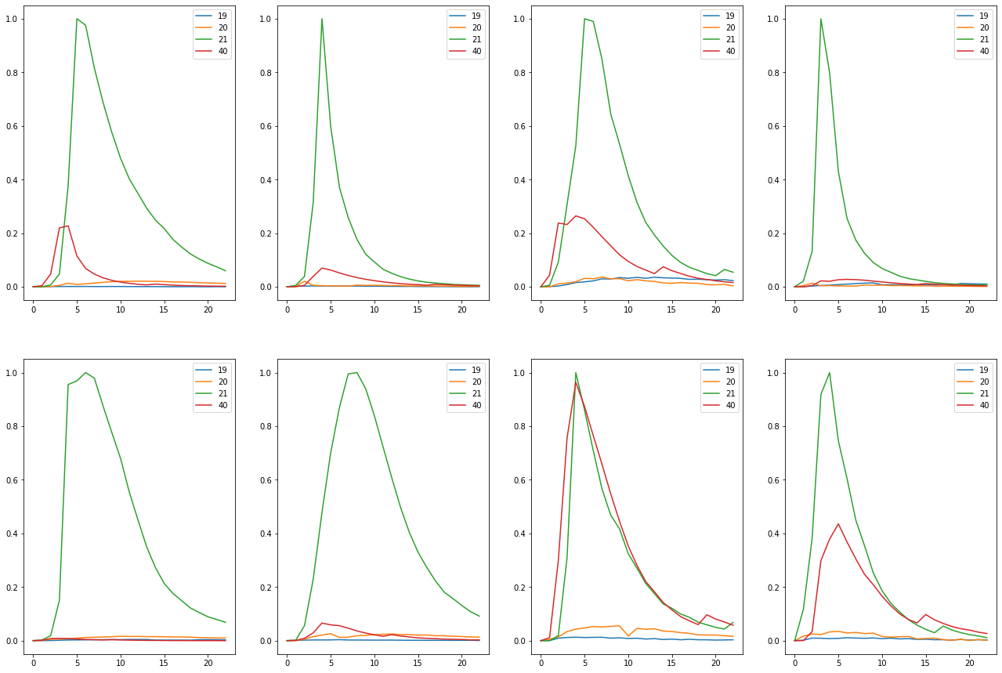

Substrate Per3

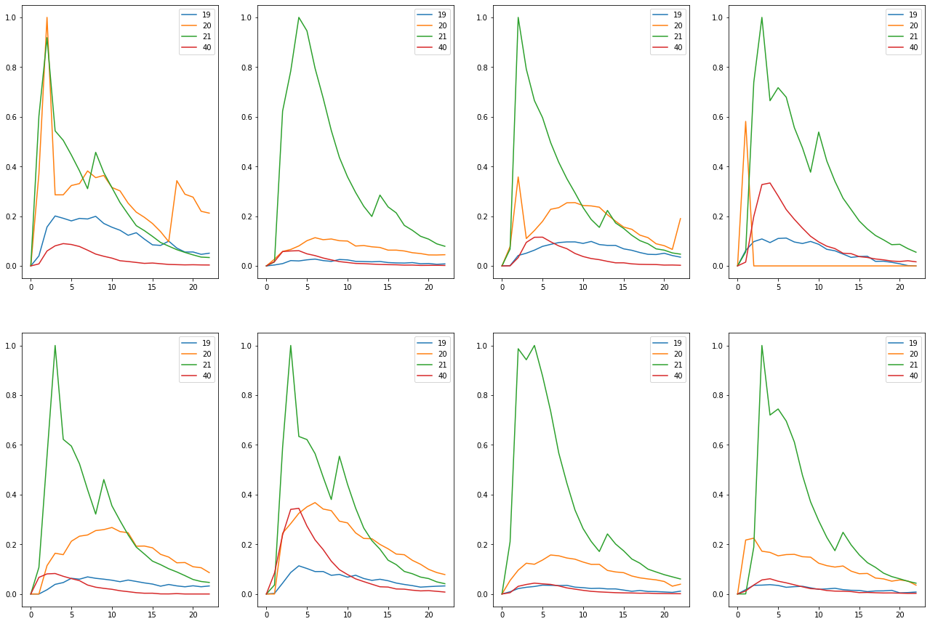

Substrate Per5

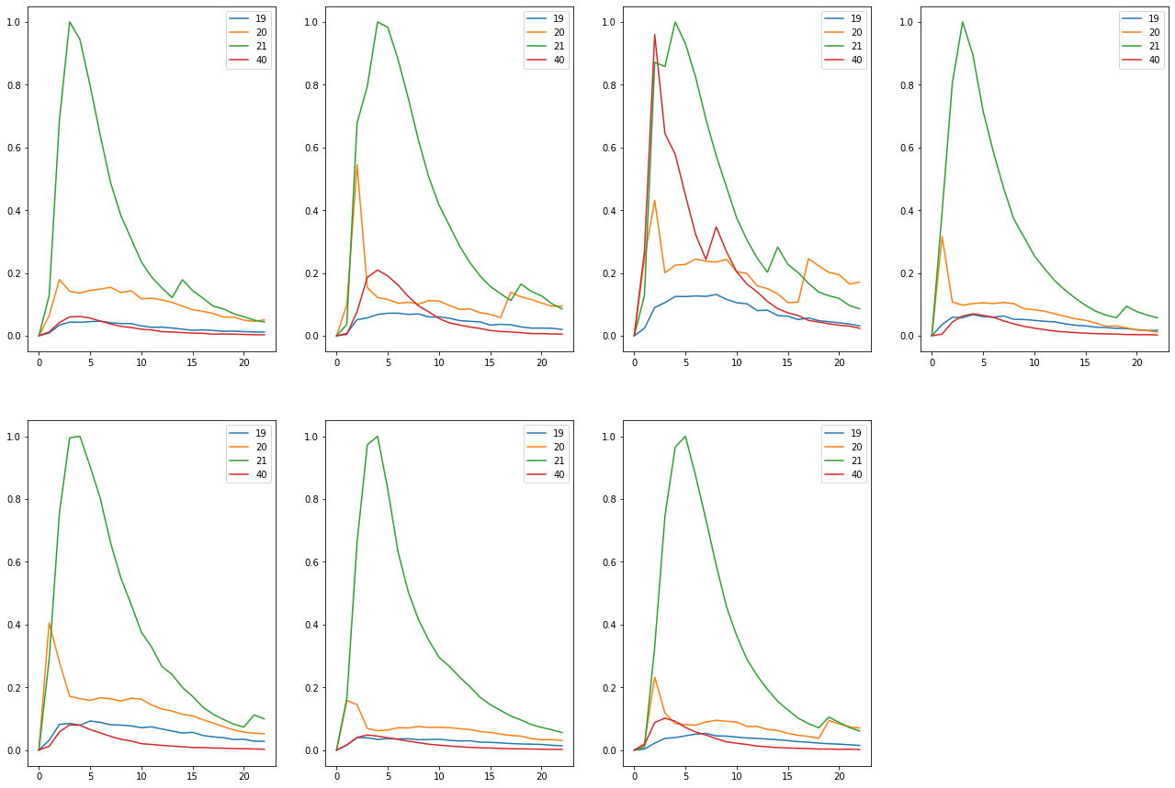

Compound 19  
Substrate None

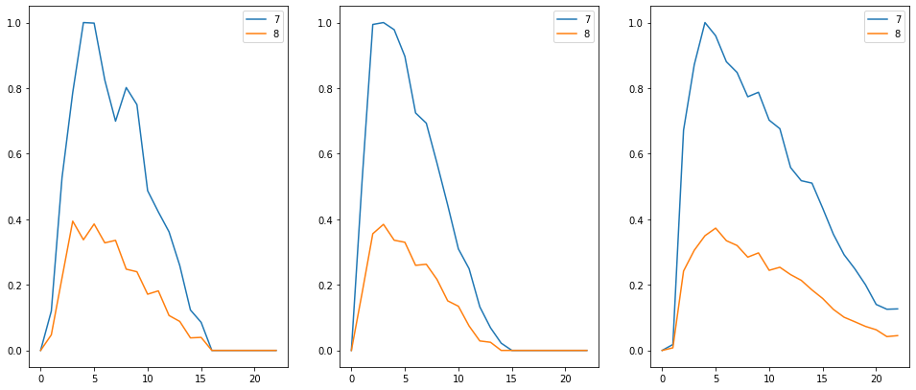

Compound 21  
Substrate None



Compound 22  
Substrate BG1

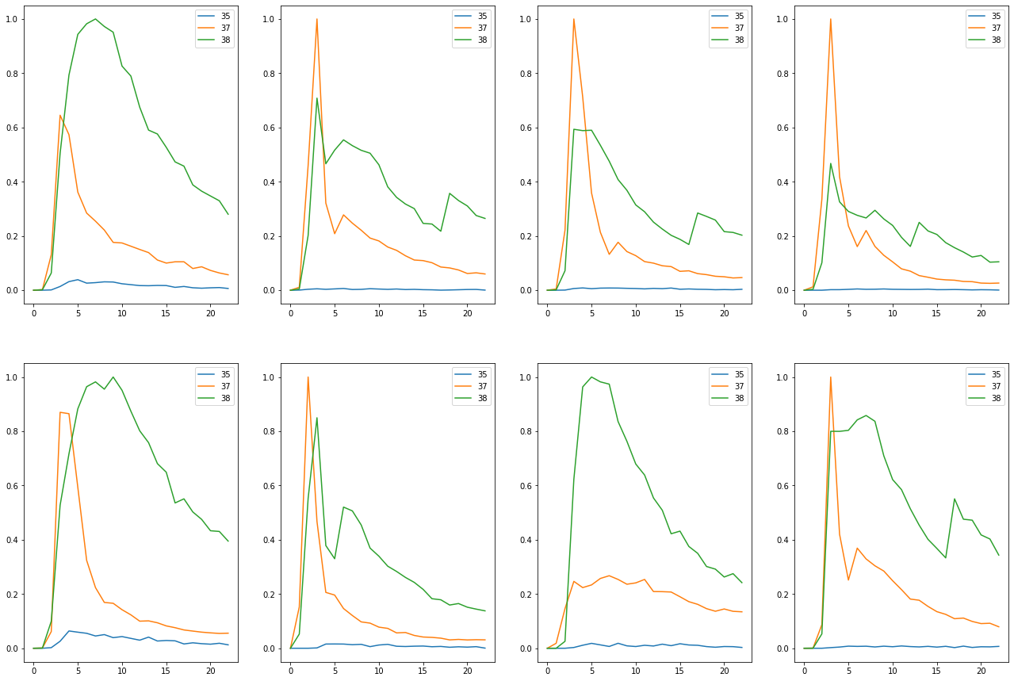

Substrate BG4

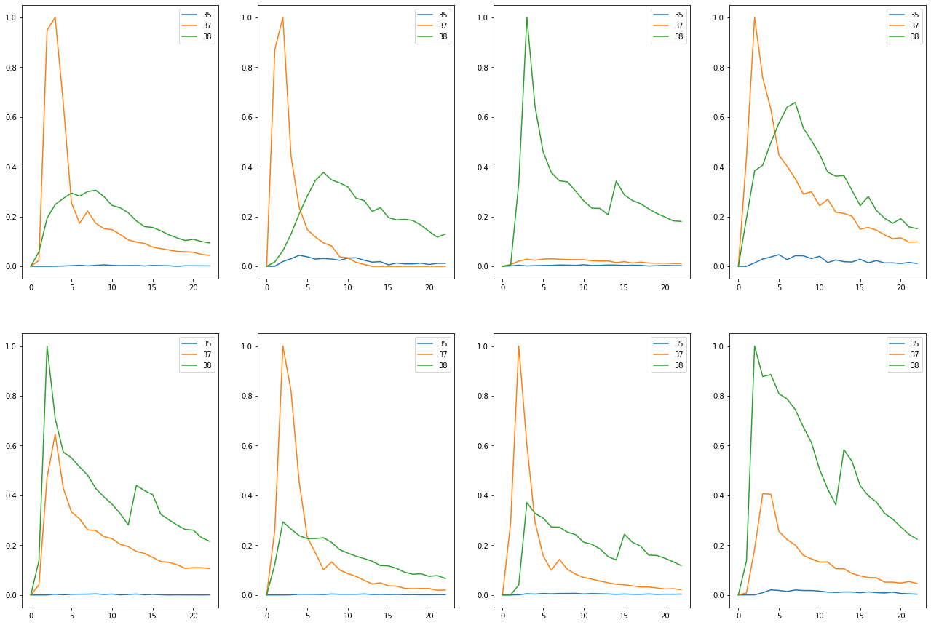

Substrate CB4

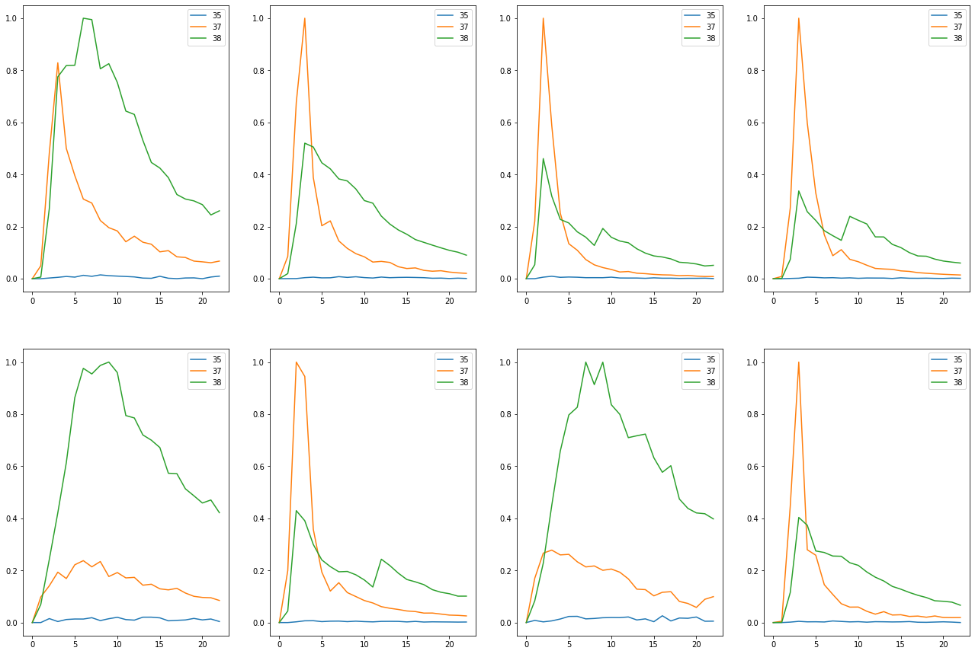

Substrate Med4

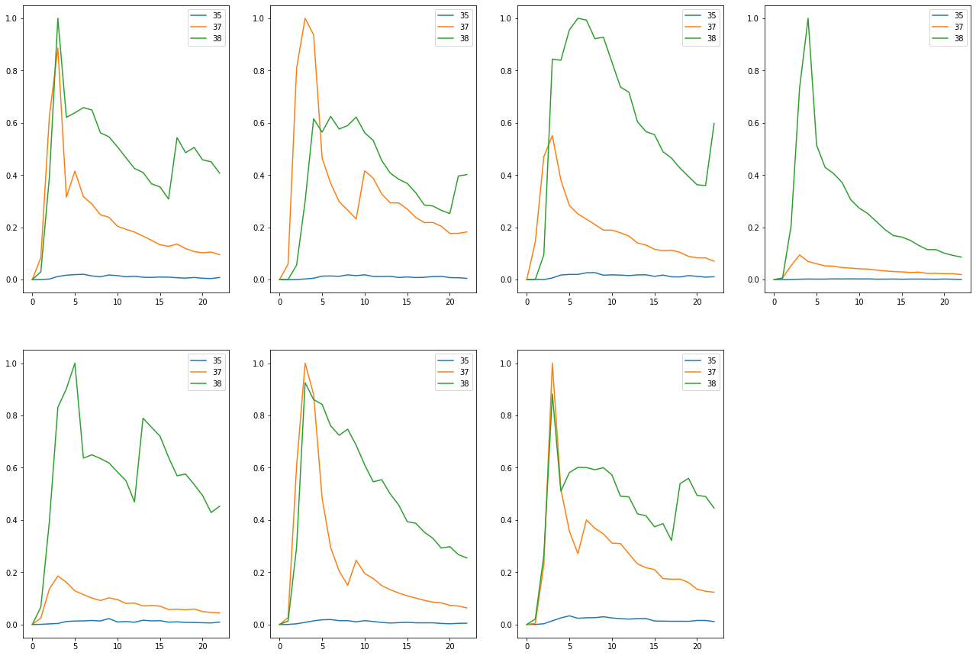

Substrate None

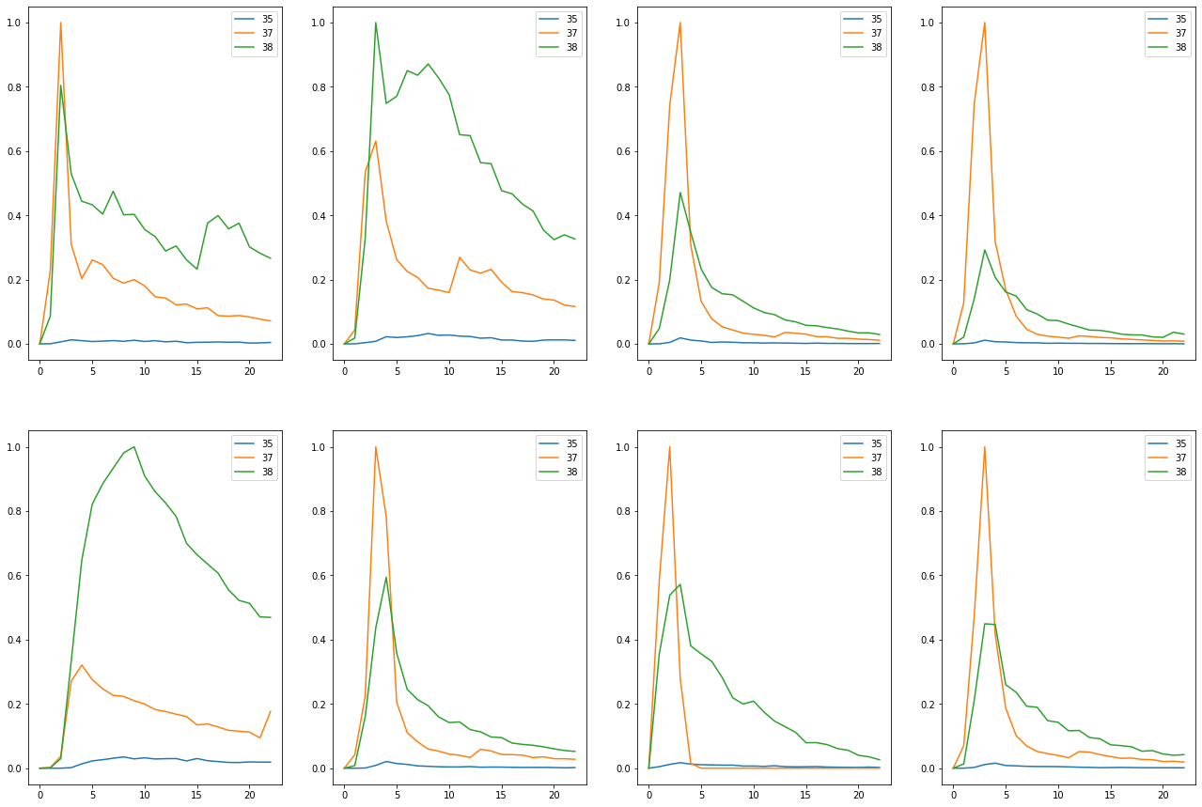

Substrate Per3

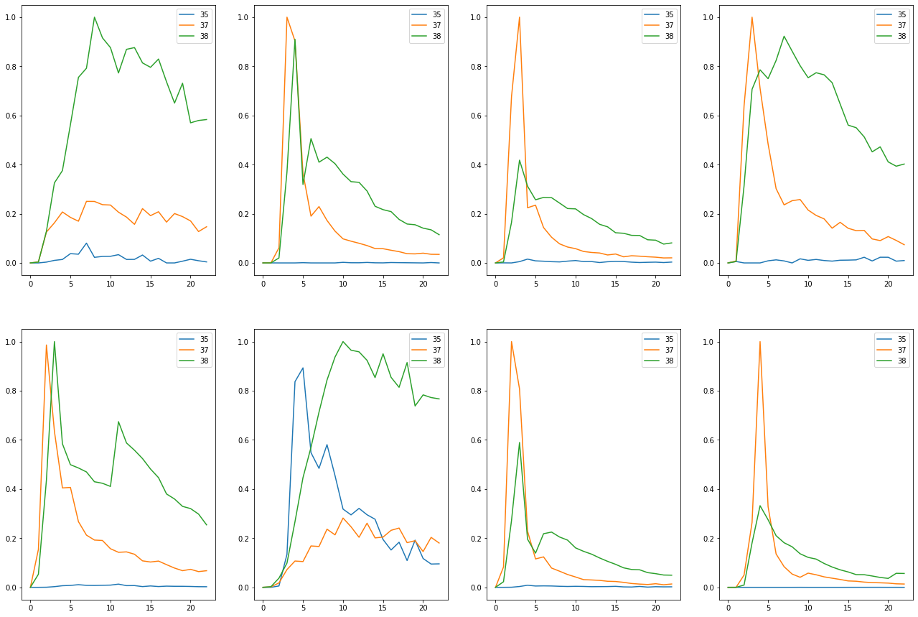

Substrate Per5

